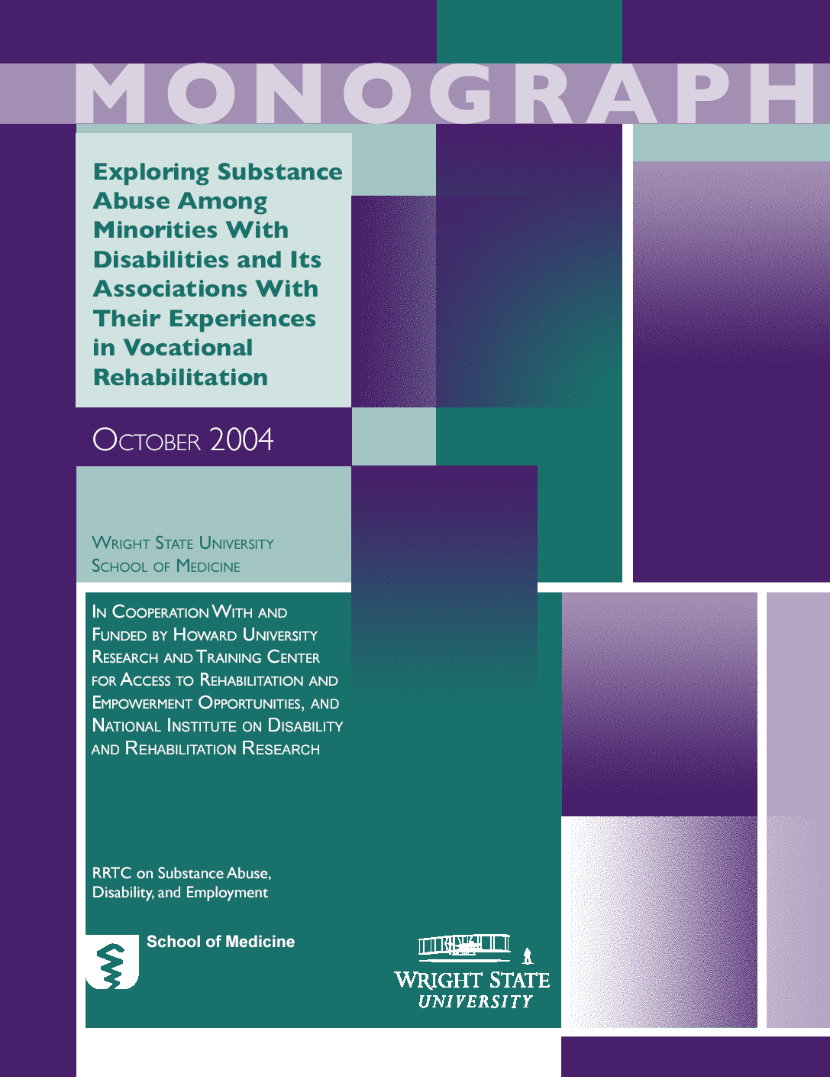

ACKNOWLEDGMENTS

This publication was produced in cooperation with and funded by the Howard University, Research and Training Center for Access to Rehabilitation and Empowerment Opportunity (HURTC) and the National Institute on Disability and Rehabilitation Research (NIDRR), under a subcontract to Wright State University, School of Medicine, Research and Training Center on Drugs and Disability (RRTC) Dayton, Ohio. Dr. M. Gerlene Ross, Director of the Howard University Research and Training Center for Access to Rehabilitation and Empowerment Opportunity (HURTC) provided oversight and she, along with members of her staff (Mr. Lenn Isidore, Ms. Gisele Richard, and Ms. Maima McQueen), provided critical review and substantive and technical editing of this publication. Principal Investigator, Dr. Dennis Moore, Wright State RRTC is grateful to Ms. Alfreda Bell, Dr. Jorge’ Garcia, Dr. Margaret Glenn, Dr. Paul Leung, Mr. Eddie Sample, Dr. Robert Schacht,the late Dr. Sylvia Walker, and Dr. James Weber for their critical review and scientific input in the development of this document.

Suggested citation: RRTC on Drugs and Disability & Howard University Research and Training Center for Access to Rehabilitation and Empowerment Opportunity. (2004). Exploring substance abuse among minorities with disabilities and its associations with their experiences in vocational rehabilitation. Howard University monograph, Washington, D.C.

PUBLIC DOMAIN NOTICE
All material appearing in this volume is in the public domain and may be reproduced or copied without permission from NIDRR. Citation of the source is appreciated.

For questions or comments on this document,
contact Principal Investigator, Dennis Moore, Ed.D. at: sardi@wright.edu

Howard University Research and Training Center for Access
To Rehabilitation & Empowerment Opportunities
Printed 2004

TABLE OF CONTENTS

Executive Summary………………………………………………………………. | 7
Chapter 1 – Background………………………………………………………... | 17
Definitions………………………………………………………………………… | 19
Limitations………………………………………………………………………... | 22
Overview of Databases and Demographic Characteristics………………………. | 23
Demographic Characteristics of AOD Participants……………………………… | 25
Research Questions……………………………………………………………… | 48
Chapter 2 – African American Vocational Rehabilitation Consumers……… | 49
Research Findings
Prevalence of AOD Substance Use/Abuse……………………………………….. | 49
Substance Abuse Diagnosis & Receipt of Services………………………………. | 53
Employment Related VR Outcomes……………………………………………… | 62
Chapter 3 – Asian American Vocational Rehabilitation Consumers………… | 67
Research Findings
Prevalence of AOD Substance Use/Abuse……………………………………….. | 67
Substance Abuse Diagnosis & Receipt of VR Services………………………….. | 70
Employment Related VR Outcomes……………………………………………… | 74
Chapter 4 – Hispanic Vocational Rehabilitation Consumers………………… | 77
Research Findings
Prevalence of AOD Substance Use/Abuse………………………………………. | 77
Employment Related VR Outcomes…………………………………………….. | 90
Chapter 5 – Native American Vocational Rehabilitation Consumers……….. | 95
Research Findings
Prevalence of AOD Substance Use/Abuse……………………………………….. | 95
Substance Abuse Diagnosis & Receipt of VR Services………………………….. | 100
Employment Related VR Outcomes……………………………………………… | 108
Chapter 6 – Discussions/Recommendations…………………………………… | 113
Prevalence………………………………………………………………………… | 113
Type of Service Delivery…………………………………………………………. | 115
Employment Related Outcomes………………………………………………….. | 119
References………………………………………………………………………… | 121

LIST OF TABLES

Chapter 1 - Background
Table 1 Demographic/Background Characteristics of Participants…………… | 28
Chapter 2 – African American Vocational Rehabilitation Consumers
Table 2 Self-Reported Prevalence of Alcohol Use Among African American  VR Consumers………………………………………………………... | 50
Table 3 Self-Reported Prevalence of Illicit Drug Use Among African  American VR Consumers……………………………………………... | 51
Table 4 Prevalence of Substance Abuse Among African American  Consumers of VR Services…………………………………………… | 52
Table 5 “Substance Abuse” Diagnosis and Receipt of VR Services by  African American Applicants………………………………………... | 54
Table 6 Associations of Substance Abuse with Assessment and Restorative  VR Services Received by African American Consumers…………….. | 55
Table 6.a. Associations of Substance Abuse with VR Training Services  Received by African American Consumers…………………………. | 57
Table 6.b. Associations of Substance Abuse with Counseling, Job Finding  & Job Placement VR Services Received by African American  Consumers……………………………………………………………. | 59
Table 6.c. Associations of Substance Abuse with VR Transportation,  Maintenance, and Other Services Received by African American  Consumers (part d)…………………………………………………… | 60
Table 6.d. Associations of Substance Abuse with Number & Variety of VR  Services Received, Average Cost & Average Number of Service  Providers for African American Consumers…………………………. | 61
Table 7 Associations of Substance Abuse and Types of Closures Experienced  by African-American VR Consumers………………………………... | 64
Table 8 Associations of Substance Abuse with Employment Outcomes  Realized by Successfully Closed African-American VR Consumers... | 66
Chapter 3 – Asian American Vocational Rehabilitation Consumers
Table 9 Self-Reported Prevalence of Alcohol Use Among Asian American  VR Consumers……………………………………………………….. | 68
Table 10 Prevalence of Substance Abuse Among Asian American Consumers  of VR Services……………………………………………………….. | 69
Table 11 Associations of Substance Abuse and Receipt of VR Services by  Asian American Applicants………………………………………….. | 70
Table 12 Associations of Substance Abuse with VR Assessment and  Restorative Services Received by Asian American Consumers……... | 72
Table 12.a. Associations of Substance Abuse with College and Other VR  Training Services Received by Asian American Consumers……… | 72
Table 12.b. Associations of Substance Abuse with VR Counseling, Job Finding  & Job Placement Services Received by Asian American Consumers.. | 73
Table 12.c. Associations of Substance Abuse with Transportation, Maintenance  & Other VR Services Received by Asian American Consumers……. | 73
Table 12.d. Associations of Substance Abuse with Average Types and Number  of Different VR Services, Average Cost, & Average Length of Time  for Services Received by Asian American Consumers……………… | 74
Table 13 Associations of Substance Abuse and Types of Closures Experienced  by Asian American Consumers……………………………………… | 75
Table 14 Associations of Substance Abuse with Employment Outcomes  Realized by Successfully Closed Asian American VR Consumers…. | 76
Chapter 4 – Hispanic Vocational Rehabilitation Consumers
Table 15 Self-Reported Prevalence of Alcohol Use Among Hispanic VR  Consumers……………………………………………………………. | 78
Table 16 Self-Reported Prevalence of Drug Use Among Hispanic VR  Consumers……………………………………………………………. | 79
Table 17 Prevalence of Substance Abuse Among Hispanic Consumers of VR  Services………………………………………………………………. | 80
Table 18 Substance Abuse Diagnosis and Receipt of VR Services by Hispanic  Applicants……………………………………………………………. | 81
Table 19 Associations of Substance Abuse with Assessment and Restoration  VR Services Received by Hispanic Consumers……………………... | 83
Table 19.a. Associations of Substance Abuse with VR Training Services  Received by Hispanic Consumers…………………………………… | 85
Table 19.b. Associations of Substance Abuse with Substantial Counseling, Job  Finding & Placement VR Services Received by Hispanic  Consumers…………………………………………………………… | 86
Table 19.c. Associations of Substance Abuse with Transportation, Maintenance  & “Other” VR Services Received by Hispanic Consumers………… | 87
Table 19.d. Associations of Substance Abuse with VR Services Received by  Hispanic Consumers by Average Number of Different Services,  Average Cost, Average Length of Episode & Average Number of  Different Services…………………………………………………… | 89
Table 20 Associations of Substance Abuse and Types of Closures  Experienced by Hispanics Who Received VR Services…………….. | 91
Table 21 Associations of Substance Abuse with Employment Outcomes  Realized by Successfully Closed Hispanic VR Consumers………… | 94
Chapter 5 – Native American Vocational Rehabilitation Consumers
Table 22 Self-Reported Prevalence of Alcohol Use Among Native American  VR Consumers………………………………………………………. | 95
Table 22.a. National Household Survey Report of Illicit Drug Use in the U.S.  Population…………………………………………………………… | 96
Table 23 Self-Reported Prevalence of Illicit Drug Use Among Native  Americans…………………………………………………………… | 97
Table 23.a. National Household Survey Report of Illicit Drug Use in the U.S….. | 97
Table 24 Prevalence of Substance Abuse Among Native American  Consumers of VR Services………………………………………….. | 99
Table 25 Substance Abuse Diagnosis and Receipt of VR Services by Native  American Applicants………………………………………………… | 101
Table 26 Associations of Substance Abuse with Assessment & Restoration  Services Received by Native American Consumers………………… | 103
Table 26.a. Associations of Substance Abuse with VR Training Services  Received by Native American Consumers………………………….. | 105
Table 26.b. Associations of Substance Abuse with Substantial Counseling, Job  Finding & Job Placement VR Services Received by Native  American Consumers……………………………………………….. | 105
Table 26.c. Associations of Substance Abuse with Transportation, Maintenance  & “Other” VR Services Received by Native American Consumers… | 107
Table 26.d. Associations of Substance Abuse with VR Services Received by  Native American Consumers by Average Number of Different  Services, Average Cost, Average Length of Episode & Average  Number & Average Number of Different Services…………………. | 108
Table 27 Associations of Substance Abuse and Types of Closures  Experienced by Native American VR Consumers………………….. | 109
Table 28 Associations of Substance Abuse with Employment Outcomes  Realized by Successfully Closed Native American VR Consumers... | 112

LIST OF FIGURES

Chapter 1 - Background
RRTC Data of Survey Participants
Figure 1.1…………………………………………………………………………. | 26
Figure 1.2…………………………………………………………………………. | 26
Figure 1.3…………………………………………………………………………. | 27
Figure 1.4…………………………………………………………………………. | 27
Demographic Characteristics (Gender)
Figure 2.1…………………………………………………………………………. | 31
Figure 2.2…………………………………………………………………………. | 31
Figure 2.3…………………………………………………………………………. | 32
Figure 2.4…………………………………………………………………………. | 33
Demographic Characteristics (Average Age)
Figure 3.1…………………………………………………………………………. | 34
Figure 3.2…………………………………………………………………………. | 34
Figure 3.3…………………………………………………………………………. | 35
Figure 3.4…………………………………………………………………………. | 35
Demographic Characteristics (Average Years of Education)
Figure 4.1…………………………………………………………………………. | 37
Figure 4.2…………………………………………………………………………. | 38
Figure 4.3…………………………………………………………………………. | 39
Figure 4.4…………………………………………………………………………. | 39
Demographic Characteristics (Martial Status)
Figure 5.1…………………………………………………………………………. | 41
Figure 5.2…………………………………………………………………………. | 42
Figure 5.3…………………………………………………………………………. | 42
Figure 5.4…………………………………………………………………………. | 43
Demographic Characteristics (Employment Status)
Figure 6.1…………………………………………………………………………. | 45
Figure 6.2…………………………………………………………………………. | 45
Figure 6.3…………………………………………………………………………. | 46
Figure 6.4…………………………………………………………………………. | 47

Executive Summary

This report highlights research results from four existing databases. The research was designed to identify characteristics of minority populations served by vocational rehabilitation service programs and the delivery of those services to individuals with disabilities in the United States, with a specific focus upon individuals with disabilities from minority backgrounds having alcohol and substance abuse/use problems. The research data were drawn from extant databases of national and regional scope as follows:

- A 1995 survey conducted by the Rehabilitation Research and Training Center (RRTC) of a sample of 1,876 VR consumers from Illinois, Kentucky, Michigan, and Ohio.
- A 2000 RRTC survey sample of 1,297 VR consumers from Maryland, Massachusetts, Montana, North Carolina, South Dakota and West Virginia.
- An RSA database of 599,372 individual Client Case Service Reports from 51 states and U.S. Territories in the Rehabilitation Services Administration (RSA) R911 Report (1998).
- An RSA database of 604,413 individual Client Case Service Reports from 51 states and U.S. Territories in the Rehabilitation Services Administration RSA
R 911 Report (1999).

There is ample research demonstrating that individuals from ethnic/racial backgrounds, and particularly African Americans, experience a disproportionate number of work related disabling conditions (Krause, Stoddard, & Gilmartin, 1996; U.S. Census Bureau 1997; Walker 2000). Research has also shown that the traditional vocational rehabilitation (VR) program established by the U.S. Congress to ameliorate the barriers to work posed by disabilities has not served ethnic/racial populations as well as it has Caucasian Americans (Walker, et. al. (1995), Ross & Biggi (1989). More specifically, earlier research has shown that African Americans and other minority group members are more likely to be declared ineligible for services, more likely to receive fewer training services, and more likely to be closed without being rehabilitated or becoming employed (Zawaiza, et. al., 2000). Policy makers are cognizant that the intent of the law is not always realized in its implementation. The federal government develops and promulgates policies governing the vocational rehabilitation (VR) program; however, the implementation of policies falls under the purview of the individual states. Therefore, it comes as no surprise that there is historical disparity in the delivery of vocational rehabilitation services in regard to gender/race/ethnicity and other demographic variables, contrary to the ideals intended in the VR regulations.

This report looks at the national vocational rehabilitation system to explore some of these known inequities in the delivery of VR service as related to minority individuals with substance abuse problems. It investigates the patterns of substance abuse that exist for VR consumers of minority backgrounds and it examines correlates of drug/substance abuse and use as it relates to the outcomes realized by these participants in the VR program.

RESEARCH DESIGN

The research design called for an examination of the independent variables of 1) race/ethnicity, and 2) substance use/abuse in relation to multiple dependent variables expressed as vocational rehabilitation services or outcomes (e.g., assessment, training, employment, etc.). Data were drawn from two epidemiological survey studies conducted by the Wright State University Research and Training Center on Drug and Substance Abuse, the Rehabilitation Services Administration R911 Report of participants in the national, federal/state vocational rehabilitation program (1998 and 1999), and the National Household Survey Report of Illicit Drug Use in the U.S. Population (1991).

Data analysis consisted of descriptive statistics based on frequency counts of the occurrence of events in the databases and the application of Chi-square to determine the significance of relationships between variables. Within ethnic/racial group and between ethnic/racial group comparisons were made as well as comparison of ethnic/racial groups to their respect general populations. Thus, the data reflect both comparisons between non- alcohol and drug VR consumers and VR consumers with alcohol and drug problems or combinations thereof and comparisons between VR consumers, with and without AOD problems, and the profile of drug/substance abuse in the general population in the U.S. for each specific minority group.

Survey Design

The 1995 RRTC Epidemiology study was a two-stage survey. The first stage was based on a 116-item questionnaire. Stage two consisted of a 44-item questionnaire. This survey dealt with variables such as substance use/abuse, vocational rehabilitation involvement/outcomes, disability information, demographic data, and psychosocial data.

The 2000 RRTC Epidemiology study was a two-stage survey with essentially the same design as the 1995 study described above. This second study differed from the first one in that it included 7 additional items dealing with HIV-related risk behaviors.

The RSA data sets are compiled on an annual basis and are inclusive of all consumers served by VR agencies across the U.S. and its territories. Each record contained within the 1998 RSA data set included several demographic/background variables, descriptions of primary and secondary disabling conditions, employment and related service information upon admission, descriptions of VR services received, and closure statuses, including employment-related information (such as earnings, hours worked per week, etc.) at closure.

The 1999 RSA data set was identical in design to the 1998 RSA Report described above.

The National Household Survey Report of Illicit Drug Use in the Population (1991) is an existing database used in this research for comparison of substance use/abuse between ethnic/racial AOD disability groups in this research (RRTC and RSA databases) and AOD use/abuse among like ethnic/racial minority groups in the general population of the U. S.

Sampling Design

Given that the purpose of this report was to investigate a link between substance use/abuse problems among minority VR consumers and their receipt of VR services, existing data from samples of the four most historically underserved minority groups (African Americans, Hispanics, Asians, and Native Americans) were examined.

Of the African American participants, about 46% were females and the average age was 35.5 years. They had completed about 11.5 years of education on average and between 60 and 63% were single, while approximately 13% were married. Thirteen percent (13%) were employed at the time of intake into the VR program.

Among the Asian VR consumer sample, the male to female ratio was 44% to 56%. The average age was 36 years and the average level of educational achievement was 11.7 years. Between 58% and 59% were single while about 26% were married. More than 14% were employed at intake into the VR program. Approximately, 43.5% of the Hispanic VR sample was female and 56.5% male, with an average age of 36.5 years. About 50.5% of these participants were single and 28% married, with an average of 10.8 years of formal education. Eighteen (18%) reported being employed upon entering the VR program.

Approximately 45% of the Native American VR sample was female and 55% were male. The average consumer was 36.4 years old and had completed 11.5 years of education. Forty-eight (48%) were single, 21% were married, with approximately15.3% employed at intake into the VR program.

It should be noted that this study reflects the weaknesses of the variables defined in the databases upon which it was based. One such weakness is the inadequate amount of data available for analysis within the two RRTC Epidemiology Studies. This lack of sufficient data decreases the reliability of these data sets. Although the RSA data sets contain a profusion of data relative to the RRTC study, it is not without its own limitations. For example, only those individuals who have been successfully closed from VR have employment-related outcomes noted in the RSA databases. There is no record of those consumers who applied but were not accepted into the program, no record of those who have a written rehabilitation plan but received no services, and no inclusion of consumers who have received services but were not closed as successfully employed.

Organization of Findings

The findings are presented according to the following research questions in each chapter:

- How prevalent within lifetime, past year, past month, is alcohol use among minority consumers and how do those prevalence rates compare with the rates observed for the general minority population?

- How prevalent within lifetime, past year, past month, is illicit drug use among minority consumers and how do those prevalence rates compare with the rates observed for the general minority population?

- How pervasive is substance abuse or dependence (alcohol, illicit drugs, or both) among minority consumers of VR services.

- Is substance abuse or dependence related to whether or not VR services are ever received by minority applicants?

- For minority consumers who actually receive VR services, is substance abuse related to the type(s) of services they receive?

- For minority consumers who actually receive VR services, is substance abuse related to whether or not their Individualized Plan for Employment (IPEs) are implemented prior to closure, they receive services but are not successfully closed (i.e., not rehabilitated), or they receive services and are successfully closed (i.e., successfully rehabilitated)?

- Is substance abuse or dependence related to the employment related outcomes realized by ethnic/racial minorities who participate in VR and are successfully closed?

Methodology and Operational Definitions

Two methods were used to determine substance abuse/dependence across the four data sets. The first involved a frequency count and analysis of self-reported data contained in the RRTC Epidemiology data sets. The second was based on a frequency count of consumer participation in various aspects of the vocational rehabilitation program using substance abuse/dependence classifications based on state agencies’ designations. These data were contained within the RSA databases.

The following is a list of definitions of the essential terms used in this report.

VR Consumer
This term is used to denote a person with a disability who is in the process of utilizing the assessment, planning, and service provision capabilities of the State Federal VR Program.

Use vs. Abuse
The distinction between substance use and substance abuse is considered to be one of degree. The latter appears to be considered a greater degree of substance consumption than the former. For the purposes of this report, the term “abuse” is treated as equivalent to a clinical diagnosis of a chemical dependency problem whereas a “use” problem is assumed to have been identified by someone (e.g., a family member, police officer, co-worker, or oneself).

Substance Abuse as a Disability vs. Substance Abuse as a Co-Existing Problem
The National Institute of Disability Rehabilitation Research (NIDRR) officially considers Substance Abuse a disability in its own right. Some individuals have this disability as well as other handicaps (e.g. hearing impairment, blindness, etc) and they are classified as having substance abuse as a co-existing problem.

Individualized Plan for Employment (IPE)
This is a written report that identifies the potential goals, services, and service providers of the consumer. The consumer develops it with assistance from the Rehabilitation Counselor.

Successful Closure
A consumer is declared as being successfully closed if he/she is (1) Declared eligible to receive VR services; (2) Received appropriate assessment and related services; (3) Had a program for rehabilitation services formulated; (4) Completed the aforementioned program; (5) Received counseling; and (6) Has been determined to be suitably employed for a minimum of 90 days.

Non-Successful Closure
This conclusion is made if it has been determined that a successful employment outcome cannot be reached or in the event that employment was obtained without the contribution of VR services.

Findings

The minority-specific rates from the 1995/2000 RRTC Epidemiology studies indicated that self-reported “in recovery from alcoholism/drug addiction” for VR consumers was roughly comparable in 1995 for African American, Hispanic, and Native American respondents. The rates of substance use were considerably higher (two to three times higher) than estimates derived from the Household Drug Use Survey for racial groups with similar age distributions.

It is important to point out that the self-reported category of "in recovery" reflects a lifetime history, whereas the VR diagnosis would be more closely tied to conditions existing at the time of VR application. Therefore, the self-reported "in recovery" rates for substance dependence may over-represent the prevalence of active substance use disorders for VR consumers.

According to the 1999 RSA R911 Report, 24% of African American consumers were coded with a primary or secondary (or both) Alcohol or Drug (AOD) diagnosis; Native Americans were coded with these conditions in 23% of the cases; Hispanics were coded as AOD in only 11% of the cases (less than half the self-reported “in recovery” rate), and, Asian Americans were coded with AOD disabilities in 6% of the cases.

African Americans, Asian Americans, and Hispanics were at least twice as likely to be diagnosed with a disability associated with illicit drug use than with alcohol, but the opposite pattern was found to be the case for Native Americans. Approximately 20 to 33% of all AOD diagnoses across minority groups involved a diagnosis of both alcohol and illicit drug dependence in combination.

Lifetime, year, and last month use of alcohol was generally lower for African American and Hispanic VR consumers than for persons of their same race within the general population. On the other hand, the last year and last month illicit drug use among VR consumers of these two groups were considerably higher than the estimates for their minority peers in the general population.

There were several differences in the amount and type of VR service delivery that occurred for members of minority groups, dependent upon whether there was an AOD diagnosis. For instance, African Americans with a lifetime history of AOD problems received more services than the general population of African Americans; but the same did not hold true for African Americans who reported use in the past year and month. Native Americans with no AOD problem were less likely to receive services than were those with a co-occurring or singular AOD problem. This did not hold true for Native Americans with a sole disability of alcoholism. Consumers with an alcohol alone problem were least likely to receive services.

It is also apparent that consumers from minority backgrounds with substance abuse disabilities appear to receive specific services at a higher rate. African American, Hispanic and Native American consumers received more assessment services. This might be explained by the need for more information about the disease and its implications for employment.

African Americans received less college or university training if they had a diagnosed substance abuse disability, but they were more likely to receive adjustment training and vocational or business school training. This same pattern held true for consumers of Hispanic and Native American heritage, with the exception of college or university training. Consumers with AOD problems received college or university training services at a similar rate. Similarly individuals from these three ethnic/racial minority groups diagnosed with a substance abuse disability were less likely to receive on the job training than their no AOD abuse counterparts.

With regard to counseling services, Hispanic consumers with AOD problems had a distinct advantage. They received more counseling services than those without the diagnosis. However, the same cannot be said for African Americans, Native Americans or Asian Americans. At the same time, there was an interesting trend among VR programs to provide transportation and maintenance services to African American, Hispanic, and Native American consumers with an AOD disability.

The number of services provided to African American consumers with AOD problems was significantly less than the number of services received by no AOD problem African American consumers. Ethnic/racial AOD consumers were also involved in the VR service program for a much shorter period of time (over 3 months), but they received services from more providers. Native American consumers with substance abuse problems received similar treatment. Funds were expended at a lower rate for African American and Native American individuals with AOD problems as compared to their non-AOD peers. Consumers with AOD problems of Hispanic origin had a slightly different experience. They received as many services as their peers without AOD disabilities but had similar experiences to those of African Americans and Native Americans with AOD problems regarding length of involvement in the VR service program, funding received, and number of vendors.

The percentage of successful closures for consumers with substance abuse-related diagnoses was somewhat surprising. Consumers from all minority groups who reported problems with AOD were more likely to be competitively employed and to report that their primary source of income at closure was their own earnings. They experienced a larger increase in weekly earnings from intake to closure, and they worked more hours per week at closure. They were less reliant upon public assistance and were as likely to have medical insurance at closure as the rest of the population that reported no problems with AOD.

Recommendations

Investigation of multiple variables associated with the receipt of VR services by ethnic/racial minority groups with disabilities in this research disclosed a number of issues to be addressed in order to enhance services for minority consumers with AOD problems and increase equal opportunity for participation and success in the VR service program. For example, the high rate of illicit drug use for African American and Hispanic consumers with disabilities in the past year and past month may be a significant impediment to the successful delivery of VR services, particularly since employers are increasingly using drug testing in the workplace. Moreover, recent drug use appeared to affect counselors’ limitation of on-the-job training and career-oriented training services for substance use/abuse consumers. Counselors may have been exhibiting sensitivity to employer issues around drug use/abuse and employer use of drug testing. However, the net effect of these concerns means reduced opportunities for AOD consumers to become engaged in quality job placements. To respond to this issue, it is recommended that the VR system use “just cause” or disability-related random drug testing procedures. This process is a relatively cost-effective way to address an issue that is a significant barrier to greater successful outcomes for minority consumers with illicit drug problems. The process would not be used to exclude individuals found to be positive for illicit drugs but to inform counselors of the drug using status of a consumer in order to provide appropriate and cost-effective services.

The RSA databases are composite databases of consumers served by all VR programs in U.S. states and territories; however, VR policies and procedures may vary from state-to-state or territory. Consequently, analysis of RSA service delivery variables does not allow one to uncover potential reasons for the observed statistics. Therefore, a rigorous research project to assess the impact of VR policies and procedures in states and territories on employment outcomes for minority consumers with disabilities, with a particular focus on AOD consumers with disabilities, is recommended. Such research would allow examination of the impact, for example of confounding factors in the analysis of service delivery like the implementation by some state agencies of an "Order of Selection” policy. This policy limits services to people considered less significantly disabled when a state lacks resources to serve all individuals with disabilities. Research should be conducted to determine if and why alcoholism or drug addiction is not considered a significant disability in states implementing an “Order of Selection” as compared to states where “Order of Selection” is not being applied. This may reveal better understanding of the complex issues related to alcohol and drug dependency and disability that significantly impact the lives of people, whatever the drug of choice.

Another recurring procedure practiced by some state agencies is to require a set time of abstinence before allowing a substance use/abuse person to receive services. The intent is to limit abuse of resources by such consumers. However, this practice is potentially discriminatory and may be counterproductive to helping people of minority backgrounds with substance abuse disabilities achieve employment and independence. This research has demonstrated that AOD consumers given substantially less VR support than their no AOD peers are good candidates for successful vocational rehabilitation. Thus, a more reasoned approach for determining an appropriate time for initiating service delivery to support AOD consumers’ VR treatment plans and recovery could be developed from a research project focused on an intervention that involves people with substance abuse problems, treatment professionals, and VR professionals. This practice could be piloted as an informal practice in local or district VR offices to demonstrate its influence on equal access to services and employment opportunities for AOD consumers regardless of service delivery sites. The research could be supported by a meta analysis of the literature outlining effective treatment practices, providing a basis for relevant evidence-based decision-making by counselors and other professionals for AOD consumers.

It was evident that across the board, fewer VR case service dollars were spent on minority consumers with AOD problems and even fewer case service dollars for college/university training for such consumers. It would be useful to establish if the rate of funding for this type of training for AOD consumers is similar among all minority VR consumers and comparable to that provided to majority group consumers. In regard to equal opportunity, access to this type of training significantly impacts the quality of employment and life choices for individuals with disabilities. The exclusion of certain ethnic/racial minorities from this type of training may be based on the needs of the individuals and recommendations of treatment teams. However, it may also be based on practitioner bias about the disability and the perceived capabilities of consumers, from a cultural, disability, or combined context. Qualitative research using the input of consumers with AOD problems would allow VR programs to better understand and build appropriate arguments for the type of services needed to maximize opportunities for employment of AOD consumers with disabilities. .

Vocational rehabilitation counseling services are considered the bedrock of vocational rehabilitation programs. The research showed that no AOD consumers were significantly more likely to receive this service than any minority AOD consumers in this research. Further inquiry regarding this service is recommended to understand the outcomes of the service and how those outcomes relate to employment of individuals with disabilities and their related impact on employment of individuals with substance abuse problems. This information could inform VR counselors and AOD practitioners in developing more comprehensive and responsive treatment modalities and may very well shed light on how this service supports consumer progress, treatment, and recovery, preventing relapse and inappropriate use of services. This is important to ensure that VR services for persons with AOD disabilities are sufficient to decrease the chances of a counterproductive “revolving door” service pattern. The explanation for this service delivery pattern is unclear, and further research would be needed to ensure people are receiving sufficient services to be successfully employed and maintain that status.

Finally, the observed discrepancies between self-reported AOD problems and state VR diagnosed AOD problems of ethnic/racial minorities suggests that the State Federal VR Program may need to more aggressively partner with programs or services competent in (1) integrating VR services and a vocational focus with treatment and aftercare; and (2) intervening earlier in the disability to make referrals to treatment systems. These responses especially need to be contextualized for people of all minority backgrounds. Cross-disciplinary professional competency and service integration must be built-in at all levels, throughout the hierarchy of VR programs.

This research produced evidence that expenditure of resources to assist minority AOD populations represents an effective use of VR case service dollars related to the resulting high percentage of successful closures. Future studies should focus on the quality and longevity of competitive employment obtained by VR consumers with substance abuse/dependence histories and why bias and disparities in VR service delivery persist for ethnic/racial minority AOD consumers despite changes in law and professional practice mandated by the federal government.

LIST OF TABLES

List of Figures

Chapter 1 - Background

Previous research has clearly shown that individuals from traditionally underserved racial and ethnic populations, especially African-Americans, tend to have disproportionately high rates of disabling conditions (Krause, Stoddard, & Gilmartin, 1996; U.S. Census Bureau, 1997). The rate of work-related disability among minorities tends to be higher than that of the general population (Krause, Stoddard, & Gilmartin, 1996; Smart & Smart, 1997) and African-Americans are more likely to be disabled than Caucasians, with a higher percentage of significant disability. Other studies indicate that (a) there is a larger percentage of African-American than Caucasian Vocational Rehabilitation (VR) applicants declared ineligible for services (Capella, 2002; Feist-Price, 1995; Wilson, 2000; Wilson, 2002); (b) that of those determined eligible for VR services, a larger percentage of African-American than Caucasian consumers is closed without being rehabilitated (Moore, 2001; Moore, Feist-Price, & Alston, 2002); (c) that VR consumers from traditionally underserved populations are provided fewer training services than Caucasian consumers (Feist-Price, 1995); and (d) that with regard to employment outcomes, Caucasian VR consumers had a higher rate of competitive employment than their non-Caucasian counterparts (Capella, 2002; Olney & Kennedy, 2002). These facts demonstrate that inequities exist in the system of vocational rehabilitation service delivery; however the real reasons for these inequities are unclear. Are these barriers the result of a pattern of bias that has existed for this population in many areas of their lives, an inability to deliver culturally competent services, or the result of other circumstances or problems?
While there is a number of mitigating factors to be explored in examining recognized inequities of minority participation in the vocational rehabilitation (VR) service delivery system, equal opportunity merits prime consideration. Equal opportunity as a potential barrier to vocational rehabilitation success is a problem that cuts across age, race, socio-economic strata, and gender. This problem is further exacerbated for people whose lives have been negatively impacted by the use of alcohol and other drugs (AOD).

A great deal of what we know about the prevalence of drug abuse in the United States has been gleaned from national surveys (National Household Survey of Drug Abuse (NHSDA), treatment programs, the criminal justice system, emergency rooms and the like. These studies have not focused specifically on individuals with disabilities participating in the vocational rehabilitation program. Yet a number of studies have shown that there are strong links between drug abuse and several sociodemographic factors, including sex, race, education, age, and socio-economic status (Kallan, 1998; Blades, 1997; and Menz, 1989).
Research undertaken by the Rehabilitation Research and Training Center (RRTC) on Drugs and Disability (1996, 2002) and others (e.g., Worrall & Vandergoot, 1982) disclosed that people are going to be less successful in receiving and benefiting from VR services if they are experiencing problems with substance abuse. Specifically, for African Americans with substance abuse problems, there exists some evidence that age and educational levels impact outcomes for African Americans to a greater extent than it does for Caucasian participants with similar disabilities (Sample, Li, & Moore, 1997).
The purpose of this monograph is to describe the patterns of substance use and abuse observed across each of four designated groups of minority VR consumers; and (b) to increase understanding of how substance abuse impacts those minority consumers’ participation in the VR service delivery system as well as the outcomes realized from that involvement.
The associated intents are (a) to describe the patterns of substance use and abuse that exist for VR consumers who are African American, Hispanic, Asian and Native American; and (b) to increase understanding of the impact of disability on access to and receipt of (VR) services as well as the ultimate outcomes realized by minority consumers from such services.

Definitions

The first independent variable is the primary variable, minority status (race/ethnicity). Certainly, there are myriad issues surrounding the definition of this critical variable (e.g., self-reported designations, different racial and ethnic categorization schema, and the issue of multiple designations/classifications; however, given that the data analyzed in this study already exist, the current effort is directly dependent upon the operational definitions employed by the framers of the databases selected for analysis in this research. For the purposes of this monograph and in keeping with the available dataset populations, four specific minority groups are included: Group I, African-Americans; Group II, Asian/Pacific Islanders; Group III, Hispanics, and Group IV, Native Americans. The sample sizes in some of these categorical groups (e.g., Asians) may be quite small in some data sets used for purposes of this research, in consequence constraining some of the subsequent analyses.
A second key independent variable is substance use/abuse. There are several issues of concern regarding the use of this terminology that require clarification:

- Use vs. Abuse - In this document both substance use and abuse are considered, with the distinction between the two being based directly upon the operational definitions employed in the databases under consideration. In several of the databases, data are available delineating “use” (e.g., particularly in those databases dealing with certain demographic data and with prevalence rate estimates), while other databases include only “abuse” data, treat abuse as equivalent to being clinically diagnosed as a “chemically dependent” disability problem. It is assumed that the difference between “use” and “abuse” is one of degree, and the extent to which “use” is identified by someone (e.g., a family member, police officer, co-worker, or oneself) as a problem for the individual in question.

- Alcohol vs. Other Substance Use/Abuse - Patterns of alcohol use/abuse by VR consumers appear to differ from patterns of illicit drug use. As a result, alcohol use/abuse and its relationships with other demographic and VR-related experiential variables may well be quite different from such relationships among illicit drug users.

- Substance Abuse as a Disability vs. Substance Abuse as a Co-Existing Problem - Over the past several years the State-Federal VR Program and other government agencies have given increasing recognition to chemical dependency (or substance abuse) as a disability in its own right. In consequence, more VR consumers are being classified as having a chemical dependency disability in the current environment than a decade or two ago. In fact, the National Institute on Disability & Rehabilitation Research (NIDRR) identified substance abuse/dependence as part of its “Emerging Universe of Disability” (1999 and 2003). It should be noted that a substance abuse disability may or may not co-exist with another disability. In this monograph, substance abuse is operationally defined as both a disability in its own right as well as a co-existing disability.

These variables are analyzed against specific program activities of each state-federal vocational rehabilitation program in the United States. The terms utilized in this study related to VR program components are taken from the Vocational Rehabilitation Act of 1973, as Amended, 1978, 1992, and 1998 and are defined below:

- Eligibility – Determination of an applicant's eligibility for VR services is based on specific criteria: (1) The applicant has a physical or mental impairment; and, (2) The applicant's physical or mental impairment constitutes or results in a substantial impediment to employment for the applicant; and, (3) The individual can benefit in terms of an employment outcome from the provision of rehabilitation services; and, (4) The applicant requires VR services to prepare for, enter into, engage in, or retain employment consistent with the applicant's strengths, resources, priorities, concerns, abilities, capabilities, and informed choice.

- Intake – Individuals apply for VR services in a process of intake. As soon as possible after referral, an initial interview is scheduled with the individual and, as appropriate, the individual's representative. The necessary application forms are completed and the individual enters a process of evaluation to determine eligibility for services.

- Individualized Plan for Employment- (IPE) The Rehabilitation Counselor develops a collaborative relationship with the consumer with a disability and assists the consumer in identifying goals, services, and service providers. These are written in an Individualized Plan for Employment.

- Successful Closure – The Rehabilitation Counselor closes an individual’s record of services as “rehabilitated” when the individual: (1) was declared eligible for services; (2) received appropriate assessment and related services; (3) had a program for rehabilitation services formulated; (4) completed the program; (5) received counseling; and, (6) has been determined to be suitably employed for a minimum of 90 days.

- Non Successful Closure – When, following certification of eligibility for rehabilitation services, it has been determined that a successful employment outcome cannot be achieved or that employment resulted without VR services having contributed to that outcome, the record of services will be closed as “non-rehabilitated.”

- Order of Selection – Agency representatives determine whether resources are going to be available to provide vocational rehabilitation or independent living rehabilitation services to all eligible individuals throughout the program year. If not, consistent with State and federal laws and regulations, the leadership may establish restrictions regarding priority categories for selecting the order in which otherwise eligible individuals may be served. Priority may be given to eligible applicants with the most significant disabilities.

- VR Consumer – This term is used to denote a person with a disability who elects to use the assessment, planning, and service provision capabilities of the State-Federal VR Program.

Limitations

A major limitation of the research in this document is that it is based upon analyses of several existing databases. As a result, the variables defined by those databases and their weaknesses can be expected to directly impact the quality of the reported results. For example, in a number of instances the sample sizes available for analysis, especially for the two Epidemiology Studies, are quite small, which has implications for the “power” of any associated statistical analyses as well as the “stability” of any associated descriptive statistics. Also, in the case of the RSA 911 Databases, the data dealing with employment-related outcomes are available only for consumers whose cases are successfully closed from VR and not for (1) consumers who apply but are not accepted into the program, (2) consumers who have a written rehabilitation plan but received no services, and (3) consumers who have received services but are not closed as successfully employed.
With respect to gender, the researchers noted the lack of data in the existing databases related to sexual preference (e.g., Lesbian, Gay, Trans-sexual, and Bi-sexual individuals with disabilities) within the ethnic/racial minority group substance abuse databases. Consequently, the socio-demographic patterns disclosed in regard to substance abuse disability, gender and other sociodemographic variables may be skewed by this sub-population that remains hidden within the larger minority group designations. In addition, this research only pertains to a specific subset of the available data related to minority VR consumers.
No attempt is made to compare the findings with representatives of the majority culture. In fact, in keeping with the purposes of the research, every effort is made to minimize, if not completely eliminate, such comparative assessments. As noted earlier, the purpose is (a) to describe the patterns of substance use and abuse observed across each of the four designated groups of minority VR consumers; and (b) to increase understanding of how substance abuse impacts those minority consumers’ participation in VR, along with the outcomes realized from that involvement.

Overview of Databases and Demographic Characteristics

The analyses undertaken as part of the current effort involved four different databases. Each involved individuals who were served by the national State-Federal Program of Vocational Rehabilitation at different points in time. The four databases are listed below.

- 1995 Epidemiology Study. This study was a two-stage survey of 1,876 VR consumers (respondents to the initial stage of the RRTC survey) from Illinois, Kentucky, Michigan, and Ohio (RRTC on Drugs and Disability, 1996, 2002). The initial survey was based on a 116-item questionnaire (“Medication and Other Drug Use Survey,” RRTC on Drugs and Disability, 2002). The second stage (initial follow-up) involved a 44-item questionnaire (“Follow-up Survey: Medication and Other Drug Use”, RRTC on Drugs and Disability, 2002). Those instruments included items dealing with the following key sets of variables: substance use/abuse; vocational rehabilitation involvement/outcomes; disability information; and demographic, psychosocial, and other background data.

- 2000 Epidemiology Study. This study was a two-stage survey of 1,297 VR consumers (respondents to the initial RRTC questionnaire) from Maryland, Massachusetts, Montana, North Carolina, South Dakota, and West Virginia (RRTC on Drugs and Disability, 2002). The instruments were the same as those described for the 1995 Study (Stages 1 and 2), with one exception. The initial questionnaire used in the 2000 study included seven (7) additional items relating to HIV-related risk behaviors.

- 1998 Rehabilitation Services Administration (RSA-911) Data Set. This data included a collection of 599,372 individual Client Case Service Reports from all 51 states and U.S. Territories for FY 1998 (RSA, 1998). Each record included several demographic/background variables, descriptions of primary and secondary disabling conditions, employment and related information at application, descriptions (plus costs) of VR services received, and closure status as well as employment-related information (such as earnings, hours worked per week, etc.) at closure.

- 1999 Rehabilitation Services Administration (RSA-911) Data Set. This data included a collection of 604,413 individual Client Case Service Reports from all 51 states and U.S. Territories for FY 1999 (RSA, 1999). These records paralleled those included in the 1998 RSA R911 Data Set.

The two RRTC and two RSA R911 databases differed in a number of significant ways, providing a rationale for including both sets of databases in this analysis. Several of the more salient of those differences were:

Features of RRTC Databases |  |  | Features of RSA-911 Databases
- | Multiple items dealing with substance use/abuse issues plus designation re: classification as “chemically dependent” |  | - | Single variable dealing with substance use - classified as having an alcohol or drug related disabling condition only
- | Includes multiple psychosocial variables (e.g., self-concept, temper management) and a number of other background variables |  | - | Does not include any psychosocial variables and limited number of background and demographic variables
- | Limited to just a few states (based on convenience samples of states) |  | - | Covers all states/territories and is a fairly exhaustive listing of all cases served
-  - | Difficult to discern involvement in VR (i.e., services received) and related outcomes  Based on self-report of consumers with substance abuse disability |  | - | Covers a number of critical VR services, along with related cost estimate, plus important outcome (closure) data; however, these data are limited to consumers who participated formally in VR and/or who were formally closed from the Program only

Demographic Characteristics of AOD Participants

The following graphics display demographic characteristics of consumers in the target population for calendar years 1995, 2000, 1998 and 1999. Data for 1995 and 2000 were derived from RRTC databases while data for 1998 and 1999 were derived from RSA databases.
Of the total number of participants (Figures 1.1- 1.4) for both RRTC (1995 and 2000) and RSA (1998 & 1999) databases, the data sets show that the majority of participants in RRTC and RSA minority consumer samples are African American. Hispanics make up the second largest group in the RSA data sets; however, Native Americans comprised the second largest group in the RRTC data sets. While a greater number of Native Americans than Asian Americans comprised the RRTC data samples, a greater number of Asian Americans than Native Americans were represented in the RSA samples (Figures 1.3-1.4).

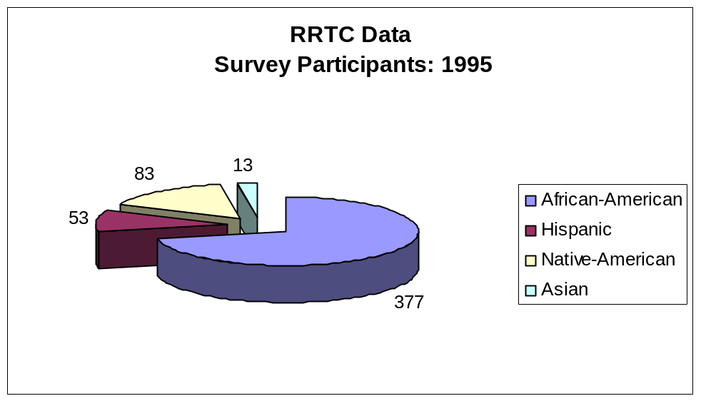

Figure 1.1

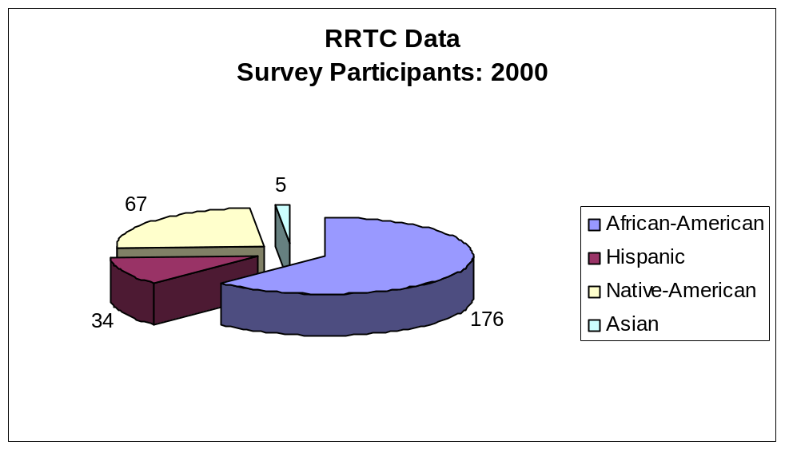

Figure 1.2

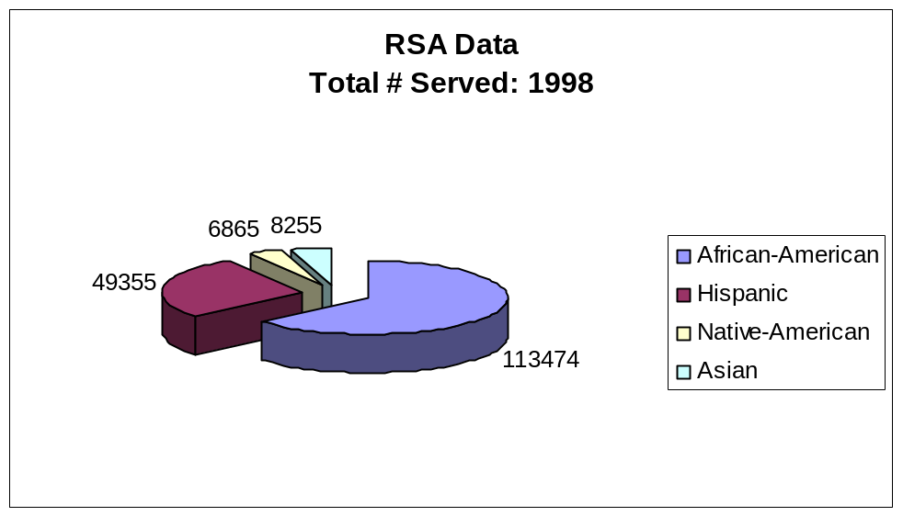

Figure 1.3

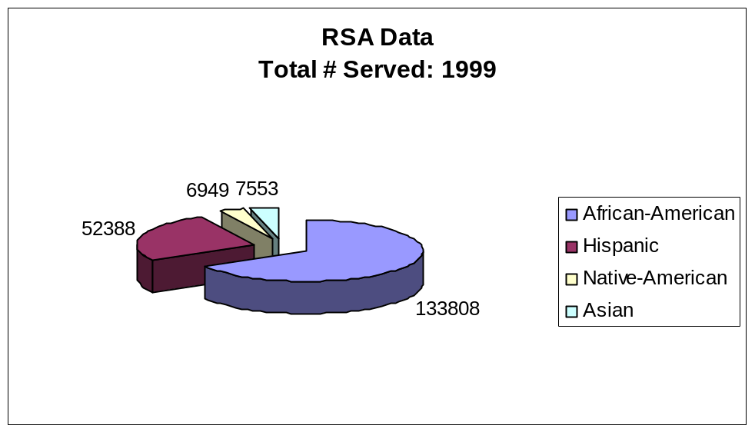

Figure 1.4

In regard to the high prevalence of drug and alcohol abuse among African Americans as compared to other ethnic/racial minority group individuals, these data are similar to data from the Center for Disease Control and Prevention (CDC) regarding HIV/AIDS, showing that “although African Americans made up 13% of the population, they represented 48% of all reported AIDS cases in 1998 CDC, 1999).”
The initial question posed relative to the four selected data sets was, “Who were the minority VR consumers included in each of the databases, in terms of their basic background/demographic characteristics?” The descriptive information related to that question is summarized in Table 1:

Table 1. Demographic/Background Characteristics of Participants
 |  | Databases
 | Minority | RRTC Epidemiology Studies |  |  |  | RSA 911 Data Sets
Characteristics | Groups | 1995 |  | 2000 |  | 1998 |  | 1999
Numbers of Minority | African-American | 377 |  | 176 |  | 113,474 |  | 133,808
Subjects | Asian | 13 |  | 5 |  | 8,255 |  | 7,553
 | Hispanic | 53 |  | 34 |  | 49,355 |  | 52,388
 | Native American | 83 |  | 67 |  | 6,865 |  | 6,949
Gender | African-American | 48.5/51.5 |  | 61.9/38.1 |  | 45.1/54.9 |  | 45.2/54.8
(% Female/% Male) | Asian | 38.5/61.5 |  | 0.0/100.0 |  | 43.6/56.4 |  | 44.3/55.7
 | Hispanic | 51.9/48.1 |  | 61.8/38.2 |  | 43.3/56.7 |  | 44.0/56.0
 | Native American | 47.0/53.0 |  | 49.3/50.7 |  | 44.7/55.3 |  | 45.1/54.9
Age | African-American | 35.4/10.9 |  | 36.8/10.7 |  | 35.4/11.7 |  | 35.7/11.9
(Average/Stan. Dev.) | Asian | 31.0/12.0 |  | 30.2/10.6 |  | 36.0/13.3 |  | 36.1/13.0
 | Hispanic | 30.1/12.0 |  | 32.7/12.5 |  | 35.6/13.1 |  | 35.7/13.2
 | Native American | 40.0/12.6 |  | 40.5/12.8 |  | 36.1/11.9 |  | 36.6/12.0
Years of Education | African-American | 12.3/2.5 |  | 12.7/2.0 |  | 11.5/2.0 |  | 11.5/2.2
(Average/Stan. Dev.) | Asian | 14.2/3.4 |  | 12.7/2.1 |  | 11.5/3.2 |  | 11.7/3/0
 | Hispanic | 12.0/3.4 |  | 11.8/2.2 |  | 10.8/3.0 |  | 10.8/3.0
 | Native American | 12.0/2.1 |  | 11.7/2.9 |  | 11.5/2.1 |  | 11.5/2.3
Marital Status (% Single, | African-American | 57.8/10.6/31.6 |  | 58.0/16.5/25.5 |  | 63.6/12.7/23.8 |  | 63.4/12.7/23.9
% Married, % Other) | Asian | 84.6/15.4/0.0 |  | 100.0/0.0/0.0 |  | 58.3/26.9/14.8 |  | 59.0/25.1/15.9
 | Hispanic | 63.0/22.2/14.8 |  | 55.9/26.5/17.6 |  | 50.2/28.2/21.6 |  | 50.7/27.6/21.7
 | Native American | 62.7/19.3/18.0 |  | 32.8/31.3/35.9 |  | 47.9/21.1/31.0 |  | 48.3/21.4/30.3
Employment Status | African-American | 16.9/83.1 |  | 42.0/58.0 |  | 12.6/87.4 |  | 13.5/86.5
(% Employed*/% Other) | Asian | 30.8/69.2 |  | 40.0/60.0 |  | 14.1/85.9 |  | 14.4/85.6
 | Hispanic | 22.2/77.8 |  | 50.0/50.0 |  | 17.5/82.5 |  | 18.0/82.0
 | Native American | 25.3/74.7 |  | 34.3/65.7 |  | 15.3/84.7 |  | 15.3/84.7
* Employed full and/or part-time.

The presented information shows that the number of cases addressed in the two RRTC databases was much smaller than the number of cases covered by the RSA databases. This indicates that any RSA-based statistic will be more stable and probably more reliable than those based on the RRTC databases. In general the statistics based on the RRTC databases appear to be more “variant” than are those in the RSA databases. For example, the percentages of females in the 2000 RRTC database are noticeably higher than the corresponding percentages in the other three databases (See Figure 2.2.). At the same time, it appears that there is considerable similarity across the four samples with regard to several of the demographic characteristics but considerable dissimilarity on other such characteristics. To wit, the percentages of males and females show definite consistency in percentages across minority groups, especially in the RSA R911 data sets (Figures 2.3-2.4).
It is important to note that RSA R911 data sets address a considerably larger number of cases and are therefore far more reliable than the data retrieved from the RRTC data sources. Similarities are also noted in the average ages of the consumers (Figures 3.1-3.4) as well as the average number of years of education they had received (Figures-4.1-4.4). However, two marked dissimilarities exist in the data concerning the marriage and employment statuses of the groups. A far smaller percentage of African American consumers are married than consumers of any other minority group (Figures 5.1-5.4).
Research has demonstrated a relationship between marital status and successful vocational rehabilitation outcomes (Kallan, 1998), an important point to bear in mind when vocational rehabilitation outcome data for consumers with substance abuse problems are analyzed. According to the National Household Survey on Drug Abuse (NHSDA, 1991), marital status impacts socio-dynamic aspects related to social support, health behaviors and economics, thereby, placing single/non-married individuals at significantly greater risk for substance abuse. By virtue of that fact alone, one might expect a higher rehabilitation success rate for married consumers.

Figures 2.1 to 2.4 below show the proportion of consumers from Groups I, II, III, and IV reflected in the sample of consumers from each ethnic/racial group based on the two different databases from which data were extracted. RRTC data (See Figure 2.1 and 2.2.) reveal a decrease in the percentage of African American males in the sample from 1995-2000 and an increase in the percentage of African American females in the sample for the same time period. Surprisingly, the percentages of African American female substance abuse consumers increased by nearly 13% while the percentages of African American males decreased by greater than 23%.

Data for the Hispanic cohort in the RRTC data sample (See Figures 2.1-2.2.) reveal a consistently high percentage of Hispanic females for 1995 (61.9%) and 2000, (61.8%). The percentage of Hispanic males in the RRTC sample was 10% lower in 2000 (38.2%) as compared to 1995 (48.1%). Figures 2.1-2.2 also reveal that the percentage of Native American males in the RRTC sample decreased by slightly more than 12% from 1995 to 2000. At the same time, the percentage of Native American females increased by approximately 2%.

Asian Americans represented the smallest cohort of the RRTC samples Asian males represented 61.6% of the 1995 Asian sample; Asian females represented 38.6%. Interestingly, the 2000 RRTC Asian sample was 100% male.

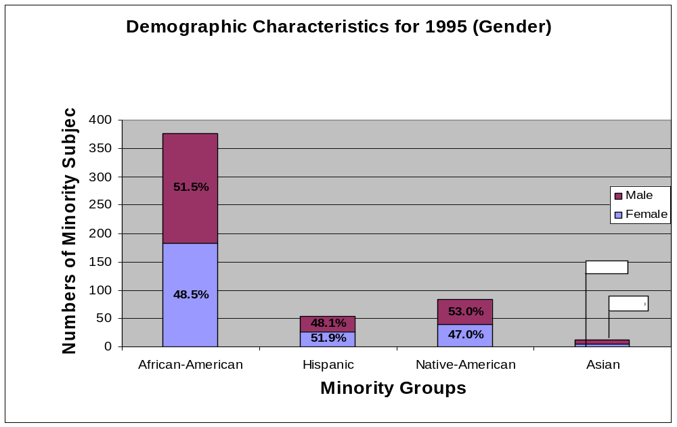

Figure 2.1

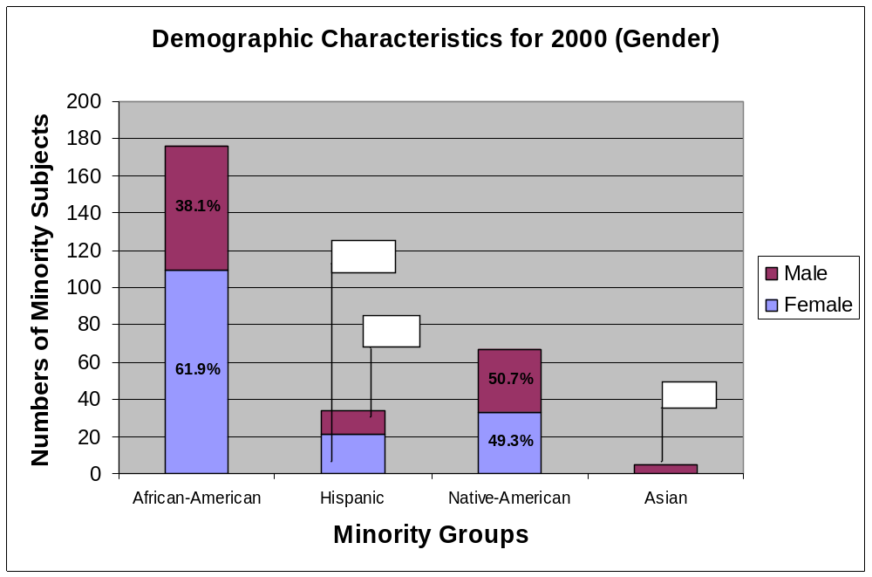

Figure 2.2

The RSA database (See Figures 2.3 and 2.4) for 1998 and 1999 revealed consistently similar percentages of males and females across all ethnic groups. The percentage of males in the sample ranged from a high of 56.7% for Hispanic males to a low of 55.3% for Native American males in 1998 and a high of 56% for Hispanic and a low of 54.8 for African American males in 1999. Demographic RSA data for females showed percentages ranging from a high of 45.1% for African American females to a low of 43.3 for Hispanic females. The percentage of Native American females differed by +1.6 percentage points between 1998 and 1999, at 44.7% and 46.1% for those two years, respectively. Similarly, the percentage of Asian females differed by + .7% over the two year period, with percentages of 43.6% and 44.3% for the two years, respectively. Percentages for males and females for 1998 and 1999 in the RSA data sets differed by +/- 2 percentage points for each of the four-ethnic/racial groups included in the study.

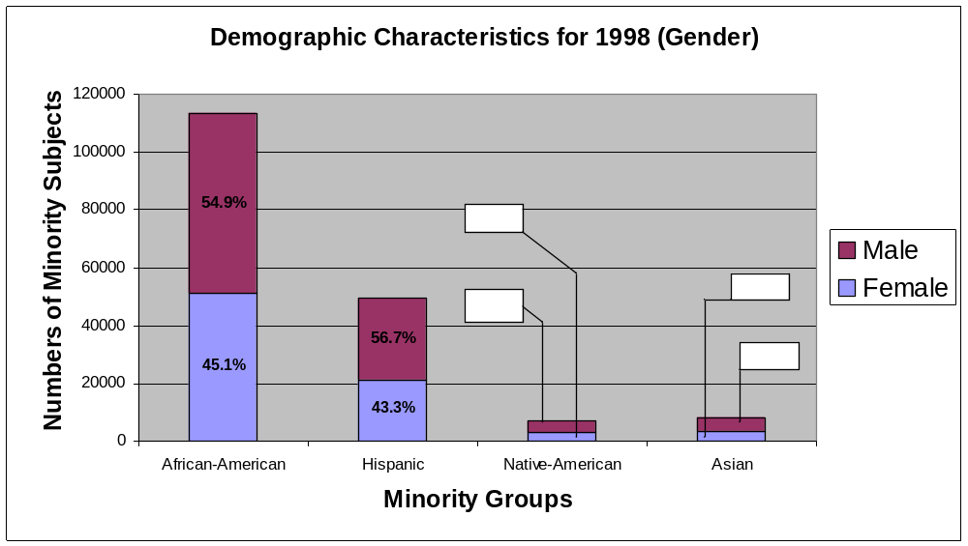

Figure 2.3

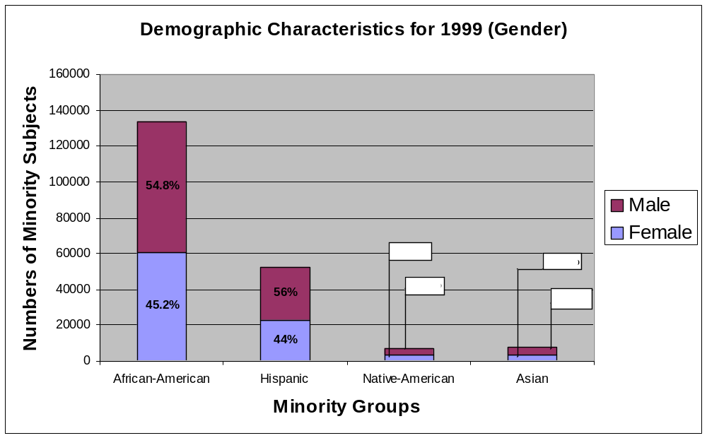

Figure 2.4

In order to gain understanding of the relationship between age and drug use/abuse in regard to race/ethnicity, data from both database sets were analyzed. A review of data from the National Household Survey of Drug Abuse (NHSDA), a yearly survey of the non-institutionalized U.S population aged 12 and older, showed that “age-specific drug use rates generally peak in the late teens and the twenties, with the highest rates for cocaine use appearing in the 18-34 year age group.” Figure 3.1 to 3.4 below display data pertaining to the average ages of VR consumers being studied compared to their corresponding ethnic group members.
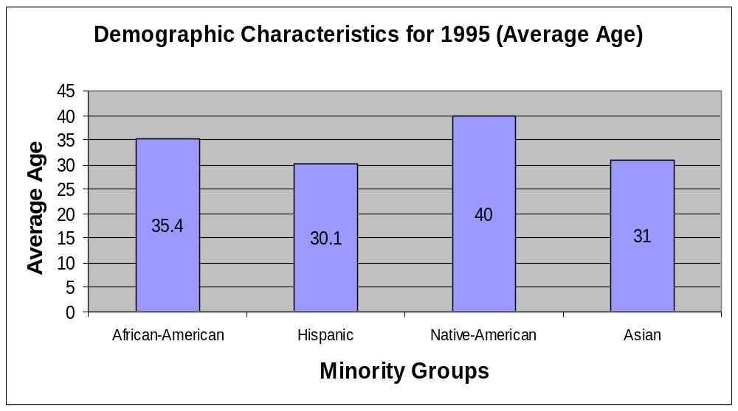

Figure 3.1

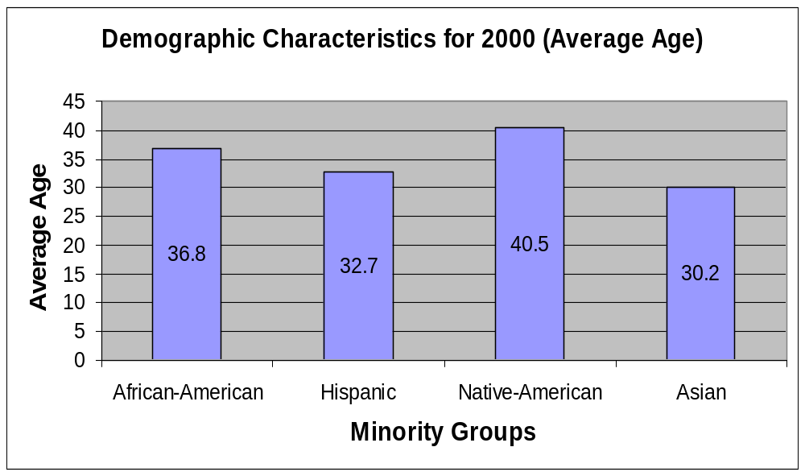

Figure 3.2

As can be seen in Figures 3.1 and 3.2 (from 1995 to 2000), little change occurred in the average ages of African American consumers participating in the RRTC studies. The average age of the African American VR consumer was 35.4 years in 1995, with a 1.4-year age increase in 2000. Average ages for the aforementioned years were similarly consistent among Groups II, III and IV. The average Hispanic age for 1995 and 2000 was 30.1 and 32.7 respectively. The Native American average was 40.0 in 1995 with an increase of 0.5 for the year 2000 while Asian consumers had a median age of 31 in 1995 and 30.2 in 2000. These data show Native Americans with AOD problems as older, on average, than members of any other ethnic/racial group.

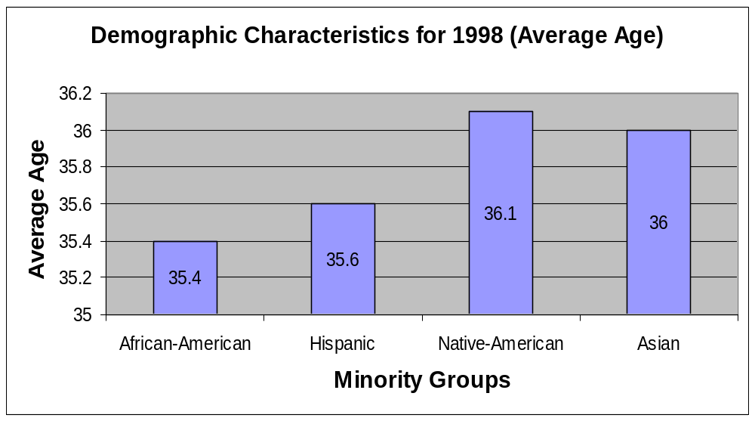

Figure 3.3

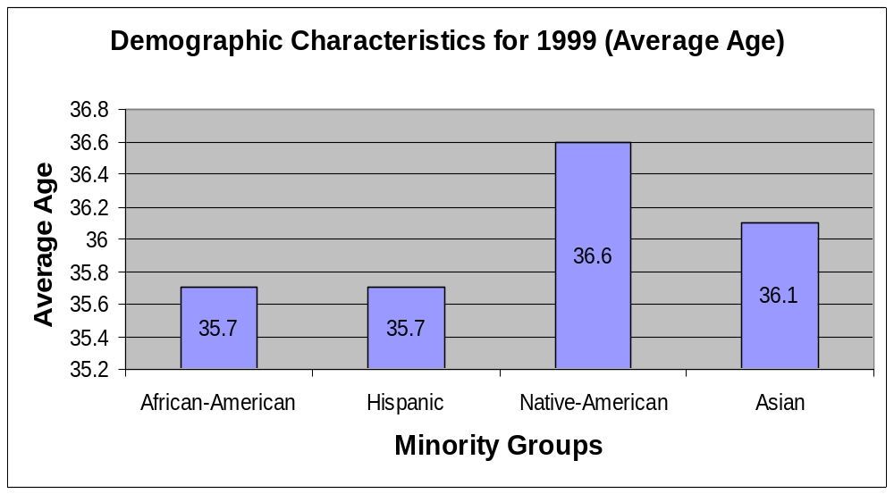

Figure 3.4

The RSA databases depicted in Figures 3.3 and 3.4 above yielded nearly identical age data results for the years 1998 and 1999. African American subjects being studied in the years 1998 and 1999 were of the respective average ages of 35.4 and 35.7. The mean age of the Hispanic VR consumer in 1999 was also 35.7, only a 0.1-year age increase over 1998. The Native American data reveals a 0.5-year difference in average age between 1998 and 1999, 36.1 in the former and 36.6 in the latter. The average age of Native Americans in the RSA data samples was more closely aligned with the average age range of other ethnic/racial groups. Asian consumers provide comparable close results in average age for the two years, with the average age being 36.0 in 1998 and 36.1 in 1999.
Similar conclusions about age may be drawn from analysis of the RRTC and RSA data as the figures from both sources were unvarying on the variable of age. These statistics are also consistent with figures obtained from the Centers for Disease Control and Prevention showing a significantly larger number or individuals with HIV/AIDS between the ages of 25-44, with an average age of 35.6 across minority groups. Both HIV/AIDS and drug and substance abuse involve risk-taking behaviors. Risk-taking behaviors and the consistency in age between the two groups suggest the probability of overlap of these two populations, though no conclusions to that effect can be drawn from the data reviewed for this research.

Figures 4.1- 4.4 below display data pertaining to the average years of education for VR consumers in the samples. The average number of years of education is charted for each minority group sample. This demographic variable, too, has been linked to successful employment outcomes for consumers of VR services. In fact, data show that individuals with secondary and post secondary education status are more likely to have successful outcomes than those lacking such credentials (Kallan, 1992). In general, earlier studies have shown that, higher levels of education tend to be associated with less drug and substance abuse as well as less persistence of use Kallan, 1992). Blades (1997) disclosed that the greatest disparity related to success in vocational rehabilitation outcomes occurs among those exhibiting low levels of educational achievement. Examination of educational data for AOD consumers in the RRTC and the RSA data sets, proved consistent with the findings of Kallan (1992, Blades (1997) and others. As will be seen later in this paper, consumers in these databases had the equivalent of a tenth grade education or better and tended to have greater successful outcomes than did no AOD consumers.
Data from the years 1995 and 2000 show only slight differences between ethnic/racial groups in the number of years of education. African American subjects had received an average of 12.3 years of education in 1995, with a slight increase to 12.7 years in 2000. The other groups, however, showed a decrease in that same time frame. The Hispanic figures dropped slightly from 12.0 to 11.8 and the Native American group decreased from 12.0 to 11.7. The largest decrease was noted among the Asian vocational rehabilitation consumer population that exhibited 14.2 years of education in 1995 but showed a 1.5-year decrease to 12.7 in 2000.

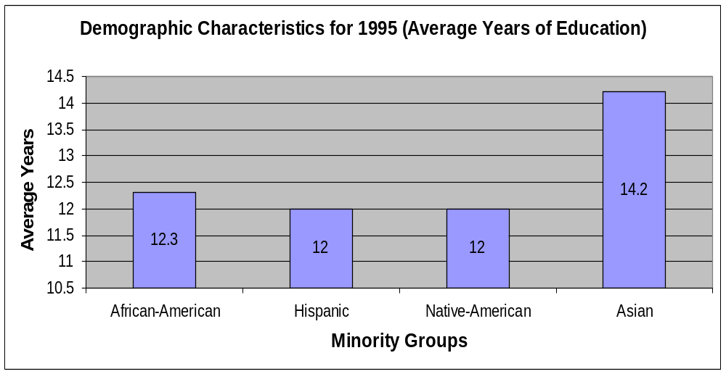

Figure 4.1

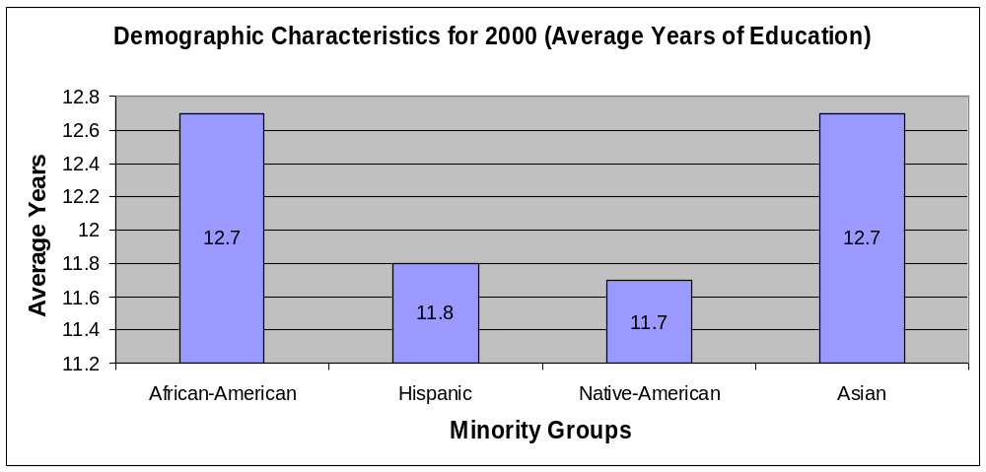

Figure 4.2

The RSA education data obtained for calendar years 1998 and 1999 (Figures 4.3 and 4.4) were almost identical to the data obtained in the RRTC databases (1995 and 2000). African American and Native American groups had both obtained an average of 11.5 years of education for each of the years in question. Hispanic consumers had an average of 10.8 years of education in 1998, with no difference in the following year. Asian consumers exhibited a slight difference in average years of education for these two years (1999 and 1998), with 11.5 in 1998 and 11.7 in 1999.

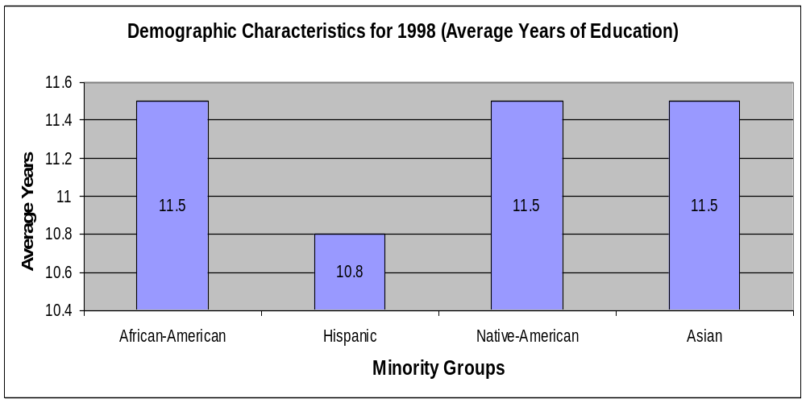

Figure 4.3

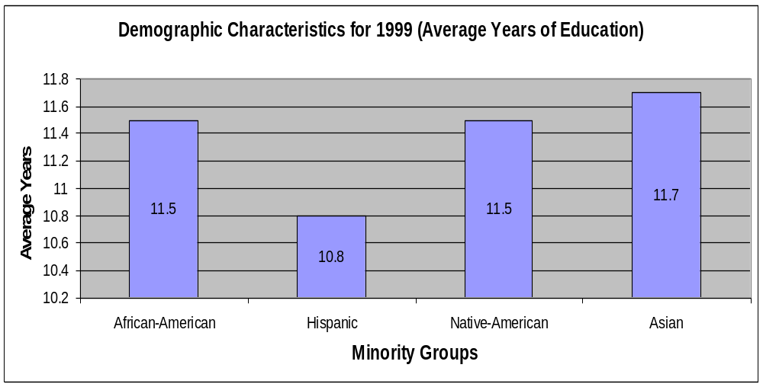

Figure 4.4

Marital status in regard to successful vocational rehabilitation outcomes for consumers may have some bearing on whether or not consumers are consistent and persistent in pursuing realistic vocational rehabilitation goals. It reflects social dimensions, such as health behaviors, social support, and economic dimensions (Kallan, 1992). In addition, NHSDA data show that nonmarried persons are at significantly higher risk for drug abuse and are at higher risk for all-cause mortality in demographic studies.
Figures 5.1-5.4 depict the marital status of consumers in the samples. These charts show the number of consumers being studied from each of the minority groups as well as the percentages married, single, or “other.” The category other represents no designated response relative to marital status.
As can be seen in Figures 5.1-5.2 representing RRTC data, more than half (57.8%) of African American consumers were single and 10.6% were married in 1995. In 2000, the data evidenced a marginal rise in the percentage of African Americans classified as single from 57.8 to 58%, but the percentage married increased substantially from 10.6% to 16.5%. The percentage of single Hispanic consumers decreased from 63.0 in 1995 to 55.9 in 2000 while the percentage married increased from 22.2 in 1995 to 26.5 in 2000.
There was a marked decrease in the percentage of single Native Americans. Slightly fewer than two-thirds (62.7%) of Native Americans was single in 1995; however, the percentage of single Native Americans in 2000 (32.8%) was almost half the percentage indicating single status in 1995, with a shift from a 3:1 to a 3.2 ratio in regard to single status. The respective percentages of single Native Americans in the 1995 and 2000 databases were 19.3% and 31.3%. Interestingly, in 1995, 84.6% of the Asian consumers studied were single; whereas in the year 2000, all of the Asian consumers in the RRTC survey were single.

The RSA single vs. married figures for the 1998 and 1999 periods were relatively close for all four ethnic/racial groups. The data showed 63.6% of African American consumers were single in 1998 and 12.7% married. Data from the 1999 RSA data set compared to that of 1998 yielded figures that were nearly identical. There was a 0.2% decrease in the singles category for African Americans in 1999 and no difference in the percentage of subjects who were married for 1999 compared to the preceding year.

Slight, non-significant differences in marital status occurred for Hispanic consumers between 1998 and 1999. The RSA data for Hispanic consumers showed, 50.2% single and 28.2% married in 1998. In 1999, RSA data revealed 50.7% of Hispanic consumers was single and 27.6% were married. In the Native American group, 47.9% were single and 21.1% married in 1998. Similar figures were obtained for the following year, with 48.3% of the Native Americans indicating single and 21.4% indicating married. The percentage of single Asian consumers in 1998 was 58.3% while 26.9% were married. In 1999, 59.0% of the Asian subjects were single and 25.1% were married, indicating little change in single vs. married status for the Asian/Pacific Islander ethnic/racial group.

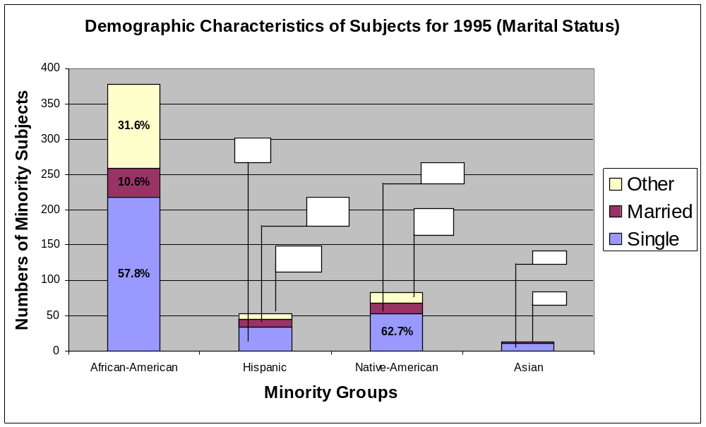
Figure 5.1

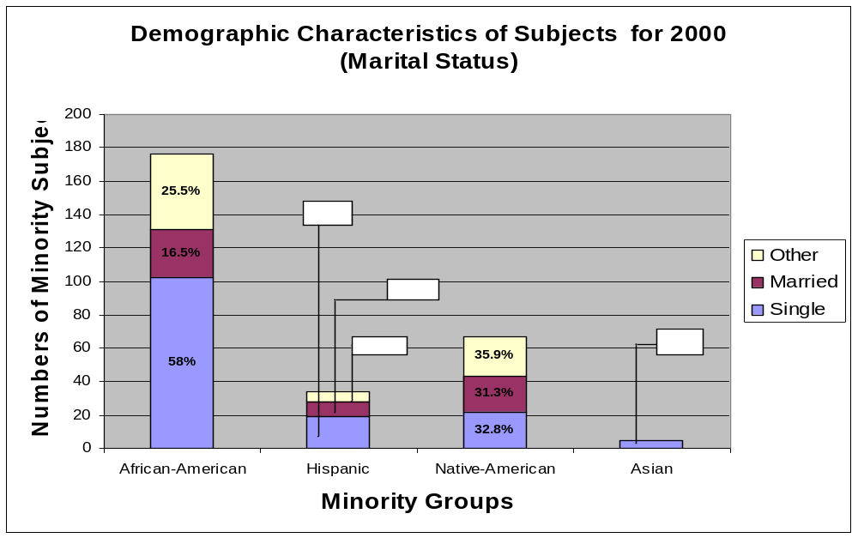

Figure 5.2

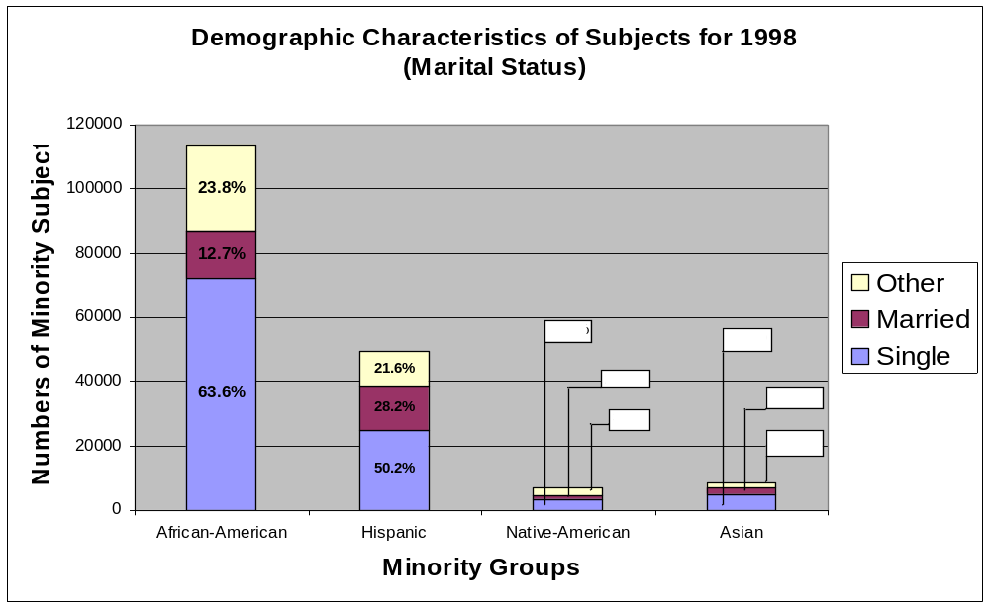

Figure 5.3

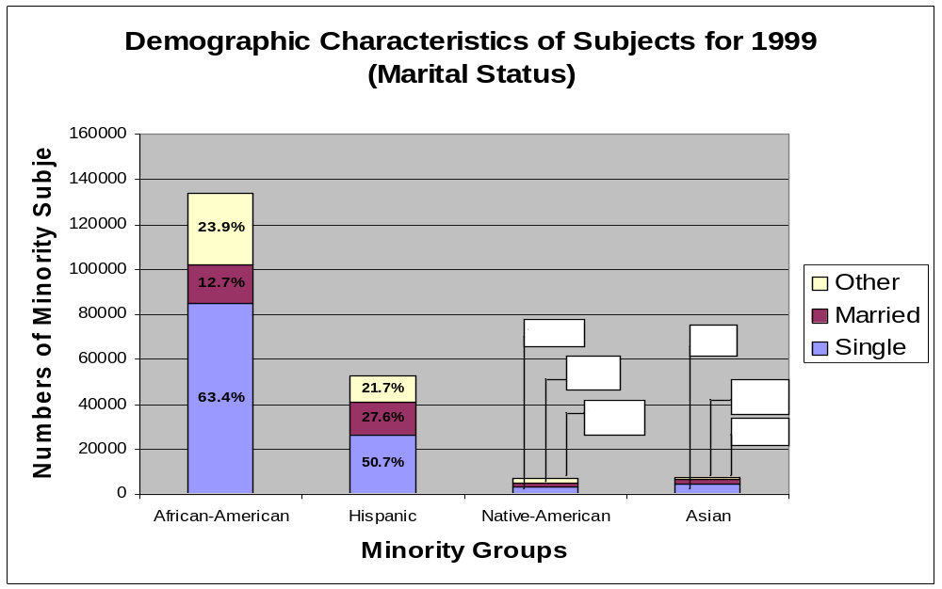

Figure 5.4

Viewed in the larger context of individuals accepted for VR services, research has demonstrated that marital status varies by gender as well as race/ethnicity in the general population of VR consumers. Menz (1989) disclosed that men seeking VR services were more likely to be single (54.4%) than married (32.6%) upon entering the VR system while women were more likely to be widowed, separated or divorced (30.8%). Moreover, women were more likely to enter the VR system at an older age (45 years) as a result of deteriorating economic conditions and changed marital status while men more likely entered the system between the ages of 16 and 34 years. It will be important to keep this information in mind in interpreting vocational rehabilitation outcome data for each racial/ethnic group.
The ultimate goal of vocational rehabilitation is to assist individuals with disabilities to become employed and enhance the quality of their lives. Figures 6.1-6.4 show the employment status of participants for each of the four minority groups being discussed.
Examination of the RRTC data collected from 1995 revealed that only 16.9% of African American VR consumers reported being gainfully employed. This percentage was considerably lower than that of any of the other minority groups in question. However, there was a significant increase in the percentage of African Americans indicating employment for in the year 2000. In that year 42% of the African American participants reported being employed. The 1995 RRTC data showed the employment rate at 22.2% for Hispanic consumers and at 25.3% for Native Americans. The corresponding employment rates for Hispanics and Native Americans in the RRTC 2000 database were 50.0% and 34.3%, respectively. Slightly more than thirty percent (30.8%) of the Asian consumers had jobs at the time of the 1995 survey. That number increased to 40% in 2000. All four of the minority groups being studied in the RRTC databases showed a substantial increase in reported employment rates over those two years.
It is important to note that increased employment of AOD consumers involved in the RRTC databases occurred in the year 2000, subsequent to Amendments (1992 and 1998) to the Rehabilitation Act of 1973 and the introduction of Section 21 into the law, placing specific emphasis on effecting changes in the VR system to better serve minority individuals with disabilities and on systemic changes to improve the overall effectiveness of the vocational rehabilitation service program. To draw any conclusions regarding a connection between these changes in federal/state policies and the increased employment of minority AOD individuals would be purely speculative based on this research; however, the data do suggest a need for further study relative to policy changes and vocational rehabilitation outcomes for minority consumers with disabilities.

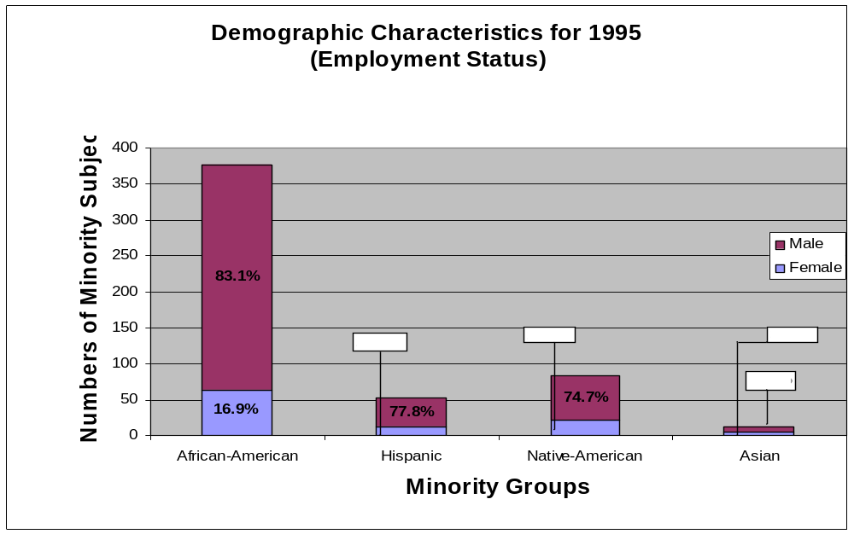

Figure 6.1

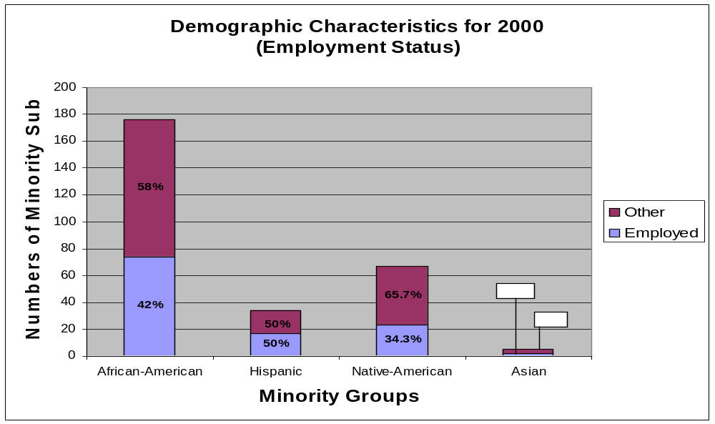

Figure 6.2

In contrast, the RSA data obtained from 1998 and 1999 (Figures 6.3 and 6.4, below) showed little change in the rate of employment for any ethnic/racial minority group. The RSA data showed slightly more than twelve percent (12.6%) of African Americans were employed in 1998 while 13.5% were employed in 1999, an increase of only 0.9%. In contrast, 17.5% of the Hispanic population was employed in 1998, with a slight 0.5% increase in the following year. Data for Asian consumers show 15.3% were employed in each of the two years studied based on RSA data, an employment rate of 14.1% in 1998 and 14.4% in 1999. Interestingly, the employment rate for African Americans lagged behind all other minority groups for both RSA data sets (1998 & 1999), with 12.6% and 13.5%, respectively (See figures 6.3-6.4, below.).
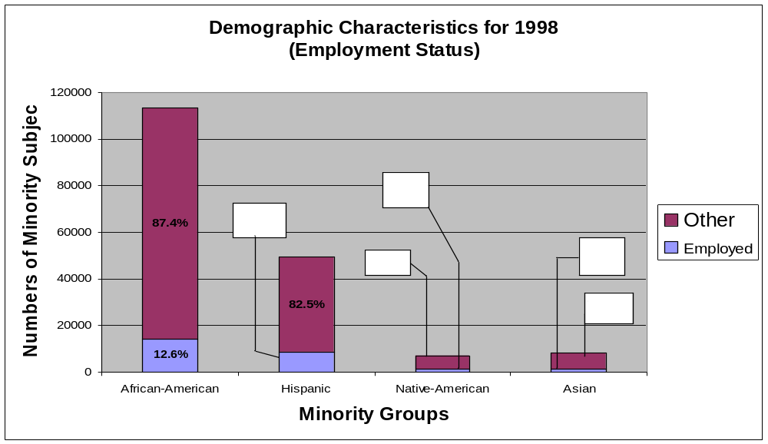

Figure 6.3

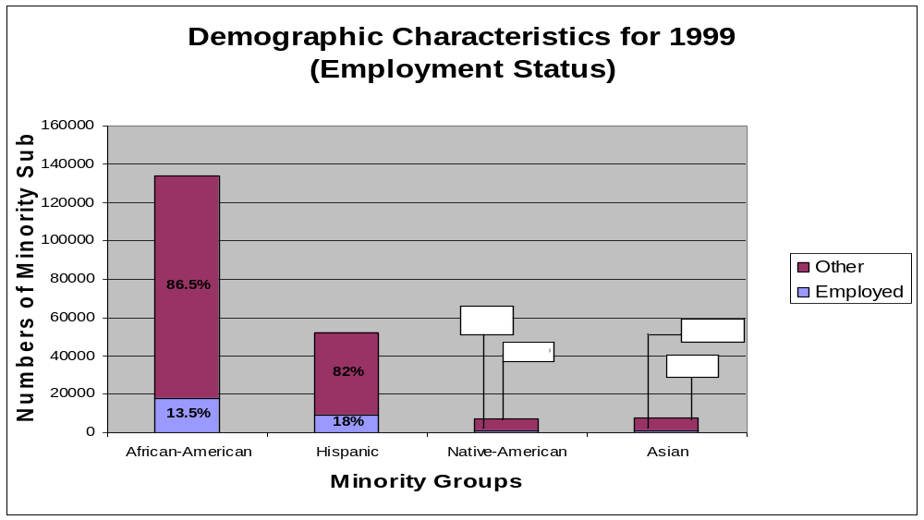

Figure 6.4

In summary, the RRTC and RSA demographic data sets revealed the following for the four-ethnic/racial groups:

- Group I: African-American VR Consumers - slightly less than 50% (about 46%) of the sampled consumers were females, while just over 50% (e.g., roughly 54%) were males; their average age was 35.5 years; on average they had completed 11.5 years of education; the majority were single (60% to 63%), while about 13% were married; and approximately 13% were employed at intake into the VR program.

- Group II: Asian VR Consumers - approximately 44% of this population were females, 56% males; their average age was 36; on average they had completed 11.7 years of formal education; 58% to 59% were single, while about 26% were married; and over 14% were employed at intake into the VR program.

- Group III Hispanic VR Consumers - females comprised 43.5% of this group and 56.5% were males; they had an average age of about 35.6 years; had completed an average of 10.8 years of education; 50.5% were single and 28% married; 18% reported being employed at the time of intake into the VR program.

- Group IV: Native American VR Consumers - generally, approximately 45% were females and 55% males; they were on average 36.4 years old; they had completed an average of 11.5 years of education; 48% were single, and 21% were married; 15.3% reported being employed at the time they participated in an intake session.

Research Questions

A series of seven research questions were addressed during the course of the minority group-by-minority group analyses involving the four selected databases. That series is as follows:

- How prevalent, lifetime, past year, past month, is alcohol use among (Groups I, II, III and IV) consumers and how do those prevalence rates compare with the rates observed for the general population of (Groups I, II, III and IV)?

- How prevalent, lifetime, past year, past month, is illicit drug use among Groups I, II, III, and IV) consumers and how do those prevalence rates compare with the rates observed for the general population of (Groups I, II, III, and IV) members?

- How pervasive is substance abuse or dependence (alcohol, illicit drugs, or both) among (Groups I, II, III, and IV) consumers of VR services?

- Is substance abuse or dependence related to whether or not VR services are ever received by (Groups I, II, III, and IV) applicants?

- For (Groups II, III, IV, and I) consumers who actually receive VR services, is their substance abuse related to the type(s) of services they receive?

- For (Groups I, II, III, and IV) consumers who actually receive VR services, is substance abuse related to whether or not IPEs are implemented prior to closure, receipt of services without successful case closure (i.e., not rehabilitated), or receipt of services leading to successful case closure (i.e., successfully rehabilitated)?

- Is substance abuse or dependence related to the employment-related outcomes realized by (Groups I, II, III, and IV members) who participate in VR and are successfully closed?

Each of the subsequent chapters of this monograph will focus on one of four identified ethnic/racial minority groups, with the exception of Chapter Six, which provides a discussion and summary of the research.

Chapter 2 - African American VR Consumers

African-Americans, as shown in Table 1 and Figures 1.1-1.4, represented the largest group of minority consumers considered in this research project. This particular group represented almost two-thirds of the total AOD consumers identified across the four databases. This observation is consistent with the results of the National Household Survey of Drug Abuse (NHSDA) showing that African Americans tend to use drugs more heavily and frequently and to experience greater adverse outcomes than other minority individuals; however their overall lifetime prevalence of drug abuse tends to be lower.

Research Findings

The question-by-question results observed for the samples of African-American consumers were as follows:

Prevalence of AOD Substance Use/Abuse

2.1 How prevalent – lifetime past year, past month - is alcohol use among African-American consumers and how do those prevalence rates compare with the rates observed for the general population of African-Americans?

The results summarized in Table 2 indicate that the average self-reported lifetime prevalence rate of alcohol use by African-American VR consumers in the RRTC database was 83 to 84%; the past year rate was 52%; and the past month rate was 32%. The lifetime prevalence rates were slightly higher when compared to the corresponding rates for the general population of African-Americans across the nation indicated in the U. S. 1994 or 1998 Household Survey (NCHDA). The past year rate was lower and the past month prevalence rates were significantly lower. These results suggest that, overall; African-American VR participants consumed equal or lesser amounts of alcohol, as did their peers in the general population of African Americans.

Table 2. Self-Reported Prevalence of Alcohol Use Among African-American VR Consumers
 |  |  | 1995 RRTC Epidemiology Study |  |  | 2000 RRTC Epidemiology Study
 |  |  | Observed Preva- |  |  | Observed Preva-
Dependent Variable** |  |  | lence Rate |  | Test Statistic | lence Rate |  | Test Statistic
Lifetime Alcohol Use |  | Observed Consumer Prevalence Rate | .82 |  | Χ² = 1.0 | .85 |  | Χ² = 4.8*
 |  | General Population) (1994 or 1998 Household Survey Rate- | (.80) |  |  | (.78)
Past Year Alcohol Use |  | Observed Consumer Prevalence Rate | .55 |  | Χ² = 3.2 | .49 |  | Χ² = 1.8
 |  | General Population (1994 or 1998 National Household Survey Rate | (.60) |  |  | (.55)
 |  | )
Past Month Alcohol |  | Observed Consumer Prevalence Rate | .37 |  | Χ² = 16.9* | .27 |  | Χ² = 19.5*
Use |  | General Population (1994 or 1998 National  Household Survey Rate) | (.48) |  |  | (.44)
* Significant at α = .05 level. ** The first waves of data for the 1995 and 2000 Epidemiology Studies were collected in 1994 and
1998, respectively; furthermore, both of those samples as well as the comparison samples from the National Household Drug Use
Survey was restricted to adults 18 and older.

2.2. How prevalent – lifetime, past year, past month- is illicit drug use among African-American consumers and how do those prevalence rates compare with the rates observed for the general population of African-Americans?

The observed lifetime self-reported prevalence of illicit drug use was 59% for African-American consumers of VR services participating in the RRTC study. Their past year and past month rates for illicit drug use were approximately 24% and 14%, respectively. All three rates were greater than the corresponding rates reported for the general population of African-Americans. In most cases, the rates reported by the VR consumers were significantly greater than the rates reported for the general population of African Americans.
These findings suggest that African-American VR consumer’s utilized illicit drugs more frequently than did members of the general African-American population and may in part explain the significant presence of secondary disabilities among African Americans (Thornhill, 1998). A more detailed analysis of prevalence rates across different types of drugs such as marijuana, inhalants, cocaine, crack, hallucinogens, heroin, stimulants, and sedatives/tranquilizers completed by the RRTC on Drugs and Disability (2002) suggests that this rate differential is fairly consistent across all considered drug types.

Table 3. Self-Reported Prevalence of Illicit Drug Use Among African-American VR Consumers
 |  |  | 1995 RRTC Epidemiology Study |  |  | 2000 RRTC Epidemiology Study
 |  |  | Observed Preva- |  |  | Observed Preva-
Dependent Variable** |  |  | lence Rate |  | Test Statistic | lence Rate |  | Test Statistic
Lifetime Drug Use |  | Observed Prevalence Rate | .55 |  | Χ² = 89.5* | .63 |  | Χ² = 61.1*
 |  | General Population (1994 or 1998 National Household Survey Rate) | (.32) |  |  | (.35)
Past Year Drug Use |  | Observed Prevalence Rate | .24 |  | Χ² = 47.5* | .23 |  | Χ² = 17.7*
 |  | General Population (1994 or 1998 National Household Survey Rate) | (.12) |  |  | (.13)
Past Month Drug Use |  | Observed Prevalence Rate | .14 |  | Χ² = 24.6* | .14 |  | Χ² = 2.8
 |  | General Population (1994 or 1998 National Household Survey Rate) | (.07) |  |  | (.08)
* Significant at α = .05 level. ** The first waves of data for the 1995 and 2000 Epidemiology Studies were collected in 1994 and
1998, respectively; furthermore, both of those samples as well as the comparison samples from the National Household Drug Use
Survey was restricted to adults 18 and older.

2.3. How pervasive is substance abuse or dependence (alcohol, illicit drugs, or both) among African American consumers of VR services?

Substance abuse/dependence, as shown in Table 4, was determined in two ways across the four sets of data. The first instance involved self-reported addiction data collected in the two RRTC Epidemiology Data Sets. This data suggested that 31% to 32% of the African-American VR consumers surveyed reported being either an alcoholic or addict in recovery. The second approach to identifying substance abuse/dependence was through a state agency designation.
In the case of the RRTC Epidemiology Studies, the data suggested that 24% of VR consumers of African-American background were identified as having a chemical dependency/substance abuse problem. That estimate is similar to the combined percentages for “Alcohol,” “Illicit Drug,” and “Alcohol & Drug Dependence” estimates (5%, 14%, and 5%) derived from the two RSA R911 Databases in Table 4. Hence, it appears that approximately 25% of African-American VR consumers were designated as having a chemical dependency problem. The difference between this rate and the 30⁺% observed for the self-report estimate in the RRTC data may be explained by differences in the timeframes underlying the two estimates. The self-reported estimates were lifetime while the RSA estimates may be more related to “current status.”

Table 4. Prevalence of Substance Abuse Among African-American Consumers of VR Services
Database | Dependent Variable | Statistics | Observed Value
1995 EPI | Self-Reported Alcoholic or Addict in Recovery | Prevalence Rate | .32
RRTC |  | 95% Confidence Interval | .27 to .36
2000 EPI | Self-Reported Alcoholic or Addict in Recovery | Prevalence Rate | .31
RRTC |  | 95% Confidence Interval | .24 to .38
1995 EPI | Coded as Having “Chemical Dependency” Disability | Prevalence Rate | NA*
RRTC |  | 95% Confidence Interval | NA*
2000 EPI | Coded as Having “Chemical Dependency” Disability | Prevalence Rate | .24
RRTC |  | 95% Confidence Interval | .18 to .31
98 RSA 911 | Alcohol Dependence | Prevalence Rate | .05
 | Illicit Drug Dependence | Prevalence Rate | .14
 | Alcohol & Drug Dependence | Prevalence Rate | .05
 | No Substance Dependence | Prevalence Rate | .76
99 RSA 911 | Alcohol Dependence | Prevalence Rate | .05
 | Illicit Drug Dependence | Prevalence Rate | .14
 | Alcohol & Drug Dependence | Prevalence Rate | .05
 | No Substance Dependence | Prevalence Rate | .76
* Acceptable estimates could not be generated due to systematic missing data on the Dependent Variable for this sample.

Substance Abuse Diagnosis & Receipt of Services

2.4. Is a substance abuse or dependence diagnosis by VR related to receipt of VR services by African-American applicants?

The two sets of statistical results summarized in Table 5 suggest that, on average, 80 to 82% of the African-American consumers who entered the VR system received some services before their cases were closed. Overall, those results show that (a) consumers with either an alcohol or drug problem and a secondary or co-existing disability (87.1%); and (b) consumers with a problem with both alcohol and drugs without a co-existing disability were more likely to have received services than a consumer with a disability and no alcohol or other drug (AOD) problem (81.0%); and (b) consumers with an alcohol problem were less likely to have received VR services (71.3%) than a person with a disability and no AOD problem (81%).
While it appears that consumers with drug problems alone (78.1%) would be less likely to receive services at the same level as consumers with no AOD dependencies (81%), that was not the case. The associated difference for the two groups was not statistically significant. Similarly, it might appear that a consumer with a drug abuse problem alone (78.1%) would be less likely to receive VR services than a person with no AOD dependence (81.0%); yet, the associated difference was not statistically significant.
In general terms, these findings may reflect the educational attainment of this cohort of consumers since the majority had at least two to three years of high school education. As such, consumers with substance abuse problems may fare better in accessing and using vocational rehabilitation services to their advantage than other individuals with disabilities and lower educational achievement.

Table 5. “Substance Abuse” Diagnosis and Receipt of VR Services by African-American Applicants
Database | Groups | % Receiving VR Services | Test Statistic
RSA 911 | (1) No AOD Dependence (“Control” Group) | 81.0
 | (2) Co-Occurring Alcohol Dependence | 87.1
 | (3) Co-Occurring Illicit Drug Dependence | 87.3 | Χ² = 720.1*
 | (4) Alcohol Dependence Alone | 71.3 | (1<2,3,6;1>4,5)
 | (5) Illicit Drug Dependence Alone | 79.1
 | (6) Alcohol & Illicit Drug Dependence Alone | 88.9

* Significant at α = .05 level (with related follow-up comparisons with “Control” Group (i.e., Group #1) each run at α = .01 level).

1998 + 1999 RSA 911 Case Service Data

2.5. For African-American consumers who received VR services, was substance abuse related to the type(s) of services they received?

The analyses reported in Tables 6 and 6a-d are based upon the 80 to 82% of African American consumers (from Table 5) who received some type of service or services via the VR program. Generally, those analyses involved comparisons between the service participation rates reported for consumers with no AOD problems and the comparable rates for the consumers in the other five comparison groups with some type of AOD problem.
Overall, the results of the analyses for the 17 service-related variables considered indicated that having a substance abuse problem was differentially related to the type(s) of VR services received by African-American consumers. Tables 6 and 6a-d address types of services (designated in items a-m) available to consumers participating in state/federal vocational rehabilitation programs. The data displayed revealed the following:
- Assessment Services (Table 6): Consumers with no AOD dependence were less likely to have received such services than consumers with either a co-occurring alcohol or drug dependence problem. However, they were more likely to have received such services than consumers with an alcohol alone, drug alone or alcohol & drug dependence problem.
- Restoration Services (Table 6): Consumers with no AOD dependence (but some other type of disability or disabilities) were significantly less likely to have received this type of service than were consumers with an AOD problem. Research conducted by Thornhill, et.al, (1998) demonstrated a strong link between AOD problems and secondary physical (amputations, paraplegia, etc.) and other disabilities occasioned by drug and alcohol abuse and concomitant social ills. Interpretation of these data must be viewed in the context of that fact, suggesting perhaps a greater need on the part of AOD consumers for these services as a result of the adverse impact of drugs.

Table 6. Associations of Substance Abuse with Assessment and Restorative VR Services Received by African-American Consumers
 |  | Comparison Group Averages
 |  | (1) | (2) | (3) | (4) | (5) | (6)
 |  | No Substance | Co-occurring | Co-occurring | Alcohol | Drug | Alcohol &
Dependent |  | Dependence | Alcohol | Drug | Dependence | Dependence | Drug
Variable | Database | (Control) | Dependence | Dependence | Alone | Alone | Dependence
% Received Assessment | RSA 911 | 74.7 | 78.1 | 77.9 | 64.8 | 63.2 | 67.0
Services |  | Χ² = 755.5* (1<2,3;1>4,5,6)
% Received Restoration | RSA 911 | 20.8 | 24.4 | 25.0 | 29.3 | 25.7 | 30.2
Services |  | Χ² = 426.9* (1<2,3,4,5,6)
* Significant at α = .05 level (with related follow-up comparisons with “Control” Group each run at α = .01 level).
1998 + 1999 RSA 911 Case Service Data

- College or University Training (Table 6.a): Consumers with no AOD disability were significantly more likely to have received this type of service than consumers with either a co-occurring drug dependence or drug dependence (alone) problem, while consumers from the other groups were as likely to have received these services. These data suggest a bias against consumers with drug or co-occurring drug problems in regard to college/university training.

- Vocational/Business School Training (Table 6.a): Consumers with no AOD dependence problems were less likely to have received this type of service than were consumers with an AOD problem, with all AOD groups differing significantly from the “no AOD dependence” group except the “alcohol dependence alone” group. Thus, while AOD consumers were more likely to be accepted into the VR service system, the level of training services afforded such consumers appeared to peak at the vocational/business school level, particularly for drug related disabilities.

- Adjustment Training (Table 6.a): Consumers with no reported AOD dependence problem were significantly less likely to have received this type of service than were consumers with alcohol dependence alone and significantly more likely than consumers in the “co-occurring drug dependence” and “alcohol & drug dependence” groups. The significance of this finding suggests the need for further examination as it appears to reflect a systemic bias relative to a perceived need of consumers with alcohol alone problems by the VR service system that may or may not reflect an actual need for these consumers as well as a lack of perceived need for such services for consumers with drug problems.

- On-the-Job Training (Table 6.a): Consumers who were reported as having no AOD problems were significantly more likely to have received this type of service than were consumers from the other five AOD groups who had some type of substance abuse problem.

- Miscellaneous Training (Table 6.a): Consumers with no AOD dependence problem were consistently shown to have received more of this type of training than the consumers in the “co-occurring drug dependence” group, while they received about the same level of services as consumers in the other four AOD groups. Miscellaneous training in VR represents skill building in various skill areas such as hospital careers, banking careers, computer orientation, etc. Such training supports career development and is, based on data from this research, less likely provided to consumers with “co-occurring drug dependence” issues.

Lack of opportunity to engage in this type of training and in college/university training for AOD consumers, as illustrated for African Americans in this research, is inconsistent with policies promulgated by the federal Rehabilitation Services Administration to enhance “career development” as opposed to “job finding” for AOD consumers. Further research relative to VR training services for drug abuse consumers should be conducted to determine the reasons for this pattern of service delivery.

Table 6.a. Associations of Substance Abuse with VR Training Services Received by African-American Consumers
 |  | Comparison Group Averages
 |  | (1) | (2) | (3) | (4) |  | (5) | (6)
 |  | No Substance | Co-occurring | Co-occurring | Alcohol |  | Drug | Alcohol &
Dependent |  | Dependence | Alcohol | Drug | Dependence |  | Dependence | Drug
Variable | Database | (Control) | Dependence | Dependence | Alone |  | Alone | Dependence
% Received College or | RSA 911 | 7.0 | 6.9 | 5.7 | 6.4 |  | 4.2 | 5.8
University Training |  | Χ² = 110.7* (1≈2;1>3,4,5,6)
% Received Vocational/ | RSA 911 | 8.0 | 9.8 | 10.5 | 9.2 |  | 10.6 | 10.8
Business Training |  | Χ² = 145.2* (1<2,3,4,5,6)
% Received Adjustment | RSA 911 | 18.9 | 19.1 | 17.1 | 23.3 |  | 20.4 | 16.6
Training |  | Χ² = 79.2* (1≈2;1>3,6;1<4,5)
% Received On-the-Job | RSA 911 | 5.7 | 4.2 | 4.1 | 3.8 |  | 2.9 | 4.4
Training |  | Χ² = 161.6* (1>2,3,4,5,6)
% Received Miscellaneous | RSA 911 | 14.1 | 12.3 | 12.2 | 11.9 |  | 13.2 | 12.6
Training |  | Χ² = 59.9* (1>2,3,4,5,6)
* Significant at α = .05 level (with related follow-up comparisons with “Control” Group each run at α = .01 level).
1998 + 1999 RSA 911 Case Service Data

- Substantial Counseling Services (Table 6.b): While one might expect the AOD dependence group to require more substantial counseling services, the no AOD dependence group of consumers received more such counseling services than did consumers in the “co-occurring drug dependence,” “drug dependence alone,” and “alcohol & drug dependence” groups.

- Job-Finding Services (Table 6.b): Those consumers with no reported AOD problems were about as likely to have received such services as consumers in the “co-occurring drug dependence” and “drug dependence alone” groups, and significantly less likely to have received such services than were the consumers in the “co-occurring alcohol dependence,” “alcohol dependence alone,” and “alcohol & drug dependence” groups.
In short, consumers with co-occurring drug and drug dependence alone were equally as likely as consumers without AOD problems to receive this service. However, no AOD consumers were significantly less likely to receive such services as compared to co-occurring alcohol dependence, alcohol dependence alone, and combined alcohol and drug dependence groups. Thus a persistent pattern of job-finding is evident for AOD consumers with “alcohol alone” and “alcohol and drug dependent” consumers.

j) Job -Placement Services (Table 6.b): Consumers with drug dependence alone, alcohol dependence alone, alcohol and drug dependence, and co-occurring alcohol dependence were more likely to receive VR job placement services than no AOD consumers. In addition, drug dependence alone consumers were as likely to receive these VR services as no AOD consumers. Since job placement represents the ultimate or expected outcome for consumers of VR services and no AOD consumers are more likely to receive college and career training as well as substantial counseling, the fact that they no AOD consumers are less likely to receive job-placement services requires further study.

Table 6.b. Associations of Substance Abuse with Counseling, Job Finding & Job Placement VR Services Received by African-American Consumers
 |  | Comparison Group Averages
 |  | (1) | (2) | (3) | (4) |  | (5) | (6)
 |  | No Substance | Co-occurring | Co-occurring | Alcohol |  | Drug | Alcohol &
Dependent |  | Dependence | Alcohol | Drug | Dependence |  | Dependence | Drug
Variable | Database | (Control) | Dependence | Dependence | Alone |  | Alone | Dependence
% Received Substantial | RSA 911 | 65.9 | 64.7 | 62.7 | 58.2 |  | 58.0 | 59.5
Counseling Services |  | Χ² = 322.5* (1≈2;1>3,4,5,6)
% Received Job-Finding | RSA 911 | 30.1 | 34.5 | 29.1 | 39.5 |  | 30.3 | 35.0
Services |  | Χ² = 165.1* (1<2,4,6;1≈3,5)
% Received Job-Placement | RSA 911 | 24.3 | 27.0 | 22.6 | 32.1 |  | 24.4 | 27.6
Services |  | Χ² = 115.0* (1≈5;1>3;1<2,4,6)
* Significant at α = .05 level (with related follow-up comparisons with “Control” Group each run at α = .01 level).
1998 + 1999 RSA 911 Case Service Data

k) Transportation Services (Table 6.c.): Those African-American consumers who were reported as not having a dependence on AOD were significantly less likely to have received such services (28.0%) than were consumers in any of the five groups that have a substance abuse problem (40.5 to 47.9%) and the observed differences were the most substantial and consistent of all the comparisons completed in Tables 6 a-d.

- Maintenance Services (Table 6.c.): Consumers with no reported AOD problems were significantly less likely (13.7%) to have received these kinds of services than were consumers in any of the five groups with some type of substance dependence (21.4-28.8%). The data do not reveal the reason for greater receipt of transportation and maintenance services by African American AOD than no AOD African American consumers. However, it is probable that these AOD consumers enter the system with lower economic status and concomitant health issues that would impact the need for these services by such consumers. And, in fact, provision of transportation and maintenance support may serve as incentives to participation for these consumers.

- Other Service (Table 6.c.): Consumers with no AOD problems were significantly less likely (20.3%) to have received these services than were consumers in any of the five comparison groups who reported a substance abuse problem.

Table 6.c. Associations of Substance Abuse with VR Transportation, Maintenance, and Other Services Received by African-American Consumers (part d)
 |  | Comparison Group Averages
 |  | (1) | (2) | (3) | (4) |  | (5) | (6)
 |  | No Substance | Co-occurring | Co-occurring | Alcohol |  | Drug | Alcohol &
Dependent |  | Dependence | Alcohol | Drug | Dependence |  | Dependence | Drug
Variable | Database | (Control) | Dependence | Dependence | Alone |  | Alone | Dependence
% Received Transportation | RSA 911 | 28.0 | 40.5 | 40.7 | 45.6 |  | 44.2 | 47.9
Services |  | Χ² = 2167.3* (1<2,3,4,5,6)
% Received Maintenance | RSA 911 | 13.7 | 21.4 | 21.7 | 25.1 |  | 27.7 | 28.8
Services |  | Χ² = 1958.5* (1<2,3,4,5,6)
% Received Other | RSA 911 | 20.3 | 25.9 | 27.9 | 28.2 |  | 29.0 | 31.1
Services |  | Χ² = 862.9* (1<2,3,4,5,6)
* Significant at α = .05 level (with related follow-up comparisons with “Control” Group each run at α = .01 level).
1998 + 1999 RSA 911 Case Service Data

- Number of Different Services (Table 6.d.): Those African-American consumers with no AOD problems on average received significantly fewer “different” VR services (3.31%) than did consumers who had a reported substance abuse problem (3.54 - 3.77%).

- Cost of Case Services (in Dollars) (Table 6.d.): Those African American consumers with no reported AOD problems had, on average, significantly more spent for the VR services they received (e.g., on average about $869 or 54% more) than did consumers who reported a substance abuse problem.

- Length of VR Episode (in Days) (Table 6.d.): Those African American consumers with no reported AOD dependence problem(s) were involved in their VR programs (episodes) for significantly longer periods of times on average (e.g., on average at least 100 days longer) than were African-American consumers who reported a substance dependence problem.

- Number of Different Service Providers (Table 6.d.): African American consumers reporting no AOD problems on average received VR services from fewer providers than did consumers who had a co-occurring alcohol problem or co-occurring drug problem. At the same time, consumers with no AOD problems were served by significantly more VR providers than were consumers with either an alcohol dependence or drug dependence problem alone.

As can be seen from the data elements related to receipt of VR services by African American consumers with AOD problems, such consumers received fewer services, had less spent for the services they received, spent less time in service status, and were required to contend with a greater number of service providers in getting services than did no AOD consumers, with the exception of alcohol or drug dependence alone consumers.

Table 6.d. Associations of Substance Abuse with Number & Variety of VR Services Received , Average Cost & Average Number of Service Providers for African-American Consumers
 |  | Comparison Group Averages
 |  | (1) | (2) | (3) | (4) |  | (5) | (6)
 |  | No Substance | Co-occurring | Co-occurring | Alcohol |  | Drug | Alcohol &
Dependent |  | Dependence | Alcohol | Drug | Dependence |  | Dependence | Drug
Variable | Database | (Control) | Dependence | Dependence | Alone |  | Alone | Dependence
Average Number of Differ- | RSA 911 | 3.31 | 3.69 | 3.57 | 3.77 |  | 3.54 | 3.77
ent Services Received |  | F = 93.23* (1<2,3,4,5,6)
(Min-0 to Max-13)
Average Cost (in Dollars) of | RSA 911 | $2481.73 | $1786.45 | $1575.56 | $1606.79 |  | $1495.51 | $1600.71
Case Services Received |  | F = 84.95* (1>2,3,4,5,6)
Average Length (in Days) of | RSA 911 | 635.66 | 534.42 | 481.54 | 480.62 |  | 412.96 | 481.91
VR Episode |  | F = 359.42* (1>2,3,4,5,6)
Average Number of Differ- | RSA 911 | 1.68 | 1.77 | 1.74 | 1.47 |  | 1.52 | 1.79
ent Service Providers |  | F = 45.94* (1<2,3,6;1>4,5)
(Min-0 to Max-9)
* Significant at α = .05 level (with related follow-up comparisons with “Control” Group each run at α = .01 level).
1998 + 1999 RSA 911 Case Service Data

The above information suggests that African American VR consumers with substance abuse problems, with or without a secondary or co-occurring disability, are more likely to receive services than their non-substance abuse African American peers. While the data clearly supports this trend, it does not provide a basis for understanding the underlying reasons for the trend.

Employment Related VR Outcomes

2.6. For African-American consumers who receive VR services, is abuse related to whether or not: a) their written IPEs are implemented prior to closure b) they receive services but are not successfully closed (i.e., not rehabilitated), or c) they receive services and are successfully closed (i.e., successfully rehabilitated)?

The results related to this three-part question are summarized in Table 7. Generally, the results indicate that there were significant associations between having substance abuse problems and (a) having a written IPE prepared but never implemented, (b) receiving VR services, but not reaching successful program closure, and (c) receiving VR services and being closed as successful. More specifically, the data in Table 7 below indicate the following:

- Written), But Not Implemented, Plan (IPE): Those consumers with no AOD dependence problems were significantly more likely to have an IPE written but not implemented than were consumers with an alcohol problem alone, a drug problem alone, or alcohol and drug problems together, and were about as likely to have a plan written but not implemented as consumers who had either a co-occurring alcohol or drug dependence problem. Consequently, those consumers with AOD problems, more often than not, had plans developed that were implemented. Yet, consumers without AOD problems had plans written that were not implemented but were more likely to have their cases closed successfully than consumers with co-occurring alcohol or drug problems.

- VR Services Received, Not Successfully Closed: African American consumers who reported no AOD problems were significantly less likely to have received VR services and not be closed successfully than were consumers who had a co-occurring alcohol problem, a co-occurring drug problem, a drug problem alone, or both an alcohol and drug problem combined. In addition, no AOD consumers were as likely to have received services and not be successfully closed as consumers in the “alcohol dependence alone” group.

- VR Services Received, Successfully Closed: African-American Consumers who had no reported AOD dependence problems were significantly more likely to have received VR services and be closed successfully than were consumers with either a “co-occurring alcohol or drug problem.” On the other hand, African-American consumers with no reported AOD dependence were significantly less likely to have received VR services leading to successful closure and be successfully closed than were consumers who were reported as being alcohol dependent alone, drug dependent alone, or having both an alcohol and a drug problem.

The results reported suggest that African-American VR consumers with no AOD problems were, as a group, significantly more likely to have an IPE developed but not implemented than consumers in the “alcohol dependence alone,” “drug dependence alone,” and “alcohol & drug dependence” groups (Table 6a.). At the same time no AOD VR consumers were also less likely closed as successful or unsuccessful than were consumers in the “alcohol dependence alone,” “drug dependence alone”, and “alcohol & drug dependence” groups (See Table 7.)

In short, the group with no reported AOD problems was as likely as consumers with a co-occurring alcohol or drug dependence problem to have developed an IPE with a VR counselor that was not implemented. Significantly, no AOD consumers were more likely to have been closed successfully than were consumers in the “co-occurring alcohol dependence” and “co-occurring drug dependence” groups.

Table 7. Associations of Substance Abuse and Types of Closures Experienced by African-American VR Consumers
 |  | Comparison Group Averages
 |  | (1) | (2) | (3) | (4) |  | (5) | (6)
 |  | No Substance | Co-occurring | Co-occurring | Alcohol |  | Drug | Alcohol &
 | Nature/Type of | Dependence | Alcohol | Drug | Dependence |  | Dependence | Drug
Database | Closure | (Control) | Dependence | Dependence | Alone |  | Alone | Dependence
RSA 911 | - Written Plan, But Not | 25.1 | 25.8 | 26.7 | 17.9 |  | 18.8 | 18.2
 | Implemented | TEST STATISTIC: χ² = 313.4* (1≈2,3;1>4,5,6)
 | - VR Services Received, | 30.6 | 34.5 | 34.5 | 32.6 |  | 33.3 | 34.5
 | Not Successfully Closed | TEST STATISTIC: χ² = 105.6* (1<2,3,5,6;1≈4)
 | - VR Services Received, | 44.3 | 39.8 | 38.9 | 49.6 |  | 48.0 | 47.4
 | Successfully Closed | TEST STATISTIC: χ² = 196.1* (1>2,3;1<4,5,6)
* Significant at α = .05 level (with related follow-up comparisons with “Control” Group each run at α = .01 level).
1998 + 1999 RSA 911 Case Service Data

2.7 Is substance abuse or dependence related to the employment-related outcomes realized by African-Americans who participate in VR and are successfully closed?

The results of the statistical analyses summarized in Table 8 indicate that substance abuse or dependence was significantly related to the selected employment-related outcomes realized by African-American consumers who were successfully closed from VR. More specifically, those results indicate that for,

- Work Status at Closure - Being Competitively Employed: Consumers with no AOD problems were significantly less likely to be competitively employed at closure than were consumers from any of the five designated AOD comparison groups, i.e., consumers with some substance dependence problem.

- Primary Source of Income - Own Income: Consumers with no reported AOD problem were less likely to report that their primary source of income at closure was from earnings than were consumers from any of the five comparison groups.

- Change in Weekly Earnings (Eligibility to Closure): Consumers with no AOD problems reported significantly less increase in weekly earnings from their time of eligibility for VR until closure than consumers from any of the five AOD comparison groups.

- Change in Monthly Public Assistance Received (Eligibility to Closure): Consumers with no AOD problems reported a smaller average decrease in their receipt of public assistance dollars than did consumers from any of the five comparison groups.

- Change in Hours Worked per Week (Eligibility to Closure): On average, the change in number of work hours from admittance to closure reported for those consumers who had no AOD problems was significantly less than the average change reported for consumers in all of the five comparison groups.

- Have Medical Insurance at Closure: Consumers who had no AOD problems were about as likely to have medical insurance coverage at closure as were the consumers in both the co-occurring alcohol and co-occurring drug dependence groups, but significantly more likely to have medical insurance at closure than were consumers with alcohol dependence alone, drug dependence alone, or AOD dependence problems.

Table 8. Associations of Substance Abuse with Employment Outcomes Realized by Successfully Closed African-American VR Consumers
 |  | Comparison Group Averages
 |  | (1) | (2) | (3) | (4) |  | (5) | (6)
 |  | No Substance | Co-occurring | Co-occurring | Alcohol |  | Drug | Alcohol &
Dependent |  | Dependence | Alcohol | Drug | Dependence |  | Dependence | Drug
Variable | Database | (Control) | Dependence | Dependence | Alone |  | Alone | Dependence
Work Status @ Closure - % | RSA 911 | 90.0 | 95.3 | 97.7 | 98.4 |  | 99.5 | 98.6
Reporting Being |  | Χ² = 783.9* (1<2,3,4,5,6)
Competitively Employed
Primary Source of Income - | RSA 911 | 72.6 | 77.8 | 83.2 | 85.9 |  | 89.9 | 88.9
% Reporting Own Income |  | Χ² = 943.1* (1<2,3,4,5,6)
as Primary Source
Change in Weekly Earnings- | RSA 911 | $ 184.34 | $ 235.75 | $ 261.67 | $ 261.92 |  | $ 273.92 | $ 272.98
Average Change - Admit |  | F = 515.51* (1<2,3,4,5,6)
to Closure
Change in Monthly Public | RSA 911 | - $ 27.22 | - $ 47.06 | - $ 57.83 | - $ 51.16 |  | - $ 73.92 | - $ 66.50
Assistance - Average |  | F = 88.07* (1>2,3,4,5,6)
Change Admit to Closure
Change in Hours Worked | RSA 911 | 25.59 | 31.12 | 33.37 | 33.04 |  | 34.47 | 34.27
Per Week - Average |  | F = 432.37* (1<2,3,4,5,6)
Change Admit to Closure
Medical Insurance at | RSA 911 | 67.6 | 64.5 | 68.3 | 58.2 |  | 63.2 | 56.4
Closure - % Who Report |  | Χ² = 168.4* (1≈3;1>2,4,5,6)
Having Such Insurance
* Significant at α = .05 level (with related follow-up comparisons with “Control” Group each run at α = .01 level for the χ² Tests and
at α = .05 level for the Dunnett post hoc comparisons following the F Tests).
1998 + 1999 RSA 911 Case Service Data

As can be seen from the above findings, VR consumer outcome data is positively skewed toward African American individuals with AOD problems, with the exception of medical insurance coverage. Alcohol dependence alone, drug dependence alone and alcohol and drug dependence consumers were significantly less likely to have medical coverage. The question arises as to whether or not significantly less insurance coverage for these consumers is an artifact of the quality of job placements for these individuals or a consequence of employer manipulation of benefits packages.
In short, the above results show that African-American consumers with AOD problems, who achieve successful closure, tend to achieve more successful employment-related outcomes than do African-Americans who are successfully closed from VR but have no reported AOD problems.

Chapter 3 – Asian American Vocational Rehabilitation Consumers

Individuals from Asian backgrounds represented the second smallest of the four groups of minority VR consumers shown in Table 1. This group represented 4.2% of the total set of minority consumers identified across the different databases. When reviewing the results presented for this particular minority group it is important to remember that while the sample sizes of Asian Americans in the two RSA 911 databases were fairly sizeable (8,255 and 7,553, respectively), those for the two RRTC initiated Epidemiology Studies were very small. In both cases, when these samples were sub-divided into the six groups considered for the analyses, the resultant groups were quite divergent in size (with several being very small, while one incorporated about 94% of the entire sample). This significantly reduces generalizability and the stability of any estimates.

Research Findings

Prevalence of AOD Substance Use/Abuse

The question-by-question results observed for Asian American VR consumers were as follows:

  - How prevalent – lifetime past year past month- is alcohol use among Asian American consumers and how do those prevalence rates compare with the rates observed for the general population of Asian Americans?

The results summarized in Table 9 below suggest that the lifetime prevalence rate related to alcohol use by Asian Americans was, on average, 74%. This rate was based, however, upon very limited samples (i.e., numbers of 13 and 5 in separate groups) and was, therefore, likely to be very unstable (e.g., likely to fluctuate appreciably across subsequent samples). The observed prevalence rates (where the sample sizes were adequate enough to calculate them) for the past year and last month were estimated to be 54% and 39%, respectively. These estimates, like that for lifetime alcohol use, were based upon a very limited sample and are, therefore, also likely unstable.

Table 9. Self-Reported Prevalence of Alcohol Use Among Asian American VR Consumers
 |  |  | 1995 RRTC Study |  |  | 2000 RRTC Study
 |  |  | Prevalence |  | Test | Prevalence | Test
Dependent Variable** |  |  | Rate |  | Statistic | Rate | Statistic
Lifetime | Observed Prevalence Rate |  | .67 |  |  | .80
Alcohol Use | General Population: (1994 or 1998 National  Household Survey Rate) |  | NA |  | Χ² = NA | NA | Χ² = NA
Past Year | Observed Prevalence Rate |  | .54 |  |  | NA
Alcohol Use | General Population: (1994 or 1998 National  Household Survey Rate) |  | NA |  | Χ² = NA | NA | Χ² = NA
Past Month | Observed Prevalence Rate |  | .39 |  |  | NA
Alcohol Use | General Population: (1994 or 1998 National  Household Survey Rate) |  | NA |  | Χ² = NA | NA | Χ² = NA
* Significant at α = .05 level. ** The first waves of data for the 1995 and 2000 Epidemiology Studies were collected in 1994 and 1998, respectively; furthermore, both of those samples as well as the comparison samples from the National Household Drug Use Survey were restricted to Asian American adults 18 and older. *** Many of the statistical tests for this minority group for the RRTC Epidemiology Data Sets were not conducted due to extremely small sample sizes.

Not only were the observed alcohol-related prevalence rate estimates for Asian American consumers likely to be quite variant, no comparable estimates were available from the corresponding annual National Household Drug Use Survey that could be used to compare the observed data. Thus, assessment of how the rate of alcohol use among Asian American VR consumers compared with the alcohol use rate among the population of adult Asian Americans in the general population was not feasible. As a result, the first research question could not be addressed within acceptable parameters.

3.2. How prevalent – lifetime past year past month - was illicit drug use among Asian American consumers and how do those prevalence rates compare with the rates observed for the general population of Asian Americans?

Similarly, this research question cannot be adequately addressed with the datasets available for analysis.

3.3. How pervasive is substance abuse or dependence (alcohol, illicit drugs, or both) among Asian American consumers of VR services?

Substance abuse/dependence as shown in Table 10 below was operationally defined in two ways across the four data sets. The first was self-reported addiction, which was employed in the two epidemiology data sets collected by the RRTC on Drugs and Disability. The second operational definition of substance abuse/dependence was based upon the state VR agency designation of a substance abuse (alcohol, drug, or both alcohol and drug) problem. Again, the samples of Asian American VR consumers in the two RRTC data sets were so small that “good” estimates of self-reported substance abuse/dependence could not be generated.

Table 10. Prevalence of Substance Abuse Among Asian American Consumers of VR Services
Database | Dependent Variable |  | Statistics |  | Observed Value
98 RSA 911 | Alcohol Dependence |  | Prevalence Rate |  | .02
 | Illicit Drug Dependence |  | Prevalence Rate |  | .03
 | Alcohol & Drug Dependence |  | Prevalence Rate |  | .01
 | No Substance Dependence |  | Prevalence Rate |  | .94
99 RSA 911 | Alcohol Dependence |  | Prevalence Rate |  | .02
 | Illicit Drug Dependence |  | Prevalence Rate |  | .04
 | Alcohol & Drug Dependence |  | Prevalence Rate |  | .01
 | No Substance Dependence |  | Prevalence Rate |  | .93
* Acceptable estimates could not be generated due to systematic missing data on the Dependent Variable for this sample.

The second operational definition of substance abuse/dependence was based upon the state VR agency designation of a substance abuse (alcohol, drug, or both alcohol and drug) problem. The data show that the prevalence of substance abuse among Asian American VR consumers (13%) was substantially less than that of all VR consumers in the two RSA R911 databases. Embedded in the summary data for the RSA R911 data sets was evidence that substance dependence involving illicit drugs was more prevalent among Asian American VR consumers than was dependence on alcohol.

Substance Abuse Diagnosis & Receipt of VR Services

3.4. Is substance abuse or dependence related to whether or not VR services are ever received by Asian American applicants?

The data summarized in Table 11 below revealed that 83.5% of the Asian American consumers who enter the VR program received some services before their cases were closed. Those results also show that for Asian American consumers, who entered the VR program, there was a relationship between having a substance abuse problem and receipt of any VR supported services (83.5%). More specifically, the results in Table 11 show that Asian American consumers with only an alcohol (45.9%) or a drug-related problem (and no co-existing disability 60.1%) were significantly less likely to have received VR-supported services than were consumers in the other four groups (no AOD dependence, co-occurring alcohol dependence, co-occurring illicit drug dependence, and alcohol and illicit drug dependence alone (i.e. on average, 53% versus 83.5%). To wit, Asian American AOD consumers were more likely to receive services if they had a co-existing disability unrelated to substance abuse.

Table 11. Association of Substance Abuse and Receipt of VR Services by Asian American Applicants
Database | Groups | % Receiving VR Services | Test Statistic
RSA 911 | (1) No AOD Dependence (“Control” Group) | 83.5
 | (2) Co-Occurring Alcohol Dependence | 80.4
 | (3) Co-Occurring Illicit Drug Dependence | 85.6 | Χ² = 75.5*
 | (4) Alcohol Dependence Alone | 45.9 | (1≈2,3,6;1>4,5)
 | (5) Illicit Drug Dependence Alone | 60.1
 | (6) Alcohol & Illicit Drug Dependence Alone | 84.3

* Significant at α = .05 level (with related follow-up comparisons with “Control” Group each run at α = .01 level).
1998 + 1999 RSA 911 Case Service Data

3.5. For Asian American consumers who receive VR services, is their substance abuse related to the type(s) of services they receive?

The information summarized in Table 12 (a – d) was based upon the 83.5% of Asian American consumers from Table 12 who received some type of VR-supported service or services. The analyses reported involved comparisons between the service participation rates reported for Asian American consumers with no AOD problem and comparable rates for consumers in the other five groups with some type of reported AOD problem. Overall, the results of analyses of the 17 service-related variables indicate no consistent differences in services for 15 of those variables (Tables 12 a-d) among the six sample groups of Asian American consumers.
In all VR Asian American cases, the receipt of services by no AOD consumers (i.e., those Asian American consumers with no AOD problems - roughly 94% of the two samples studied) was not consistently shown to be of greater or lesser prevalence than the rates observed for the other five groups of subjects with a substance abuse problem.
Table 12d illustrates two instances where consistent, significant differences were observed (i.e., the percentage receiving job-finding services 34% and average length of VR episode 749 days, on average, for no AOD consumers). Those differences suggest that Asian American consumers who had no AOD problem were more likely to have received the indicated services than were Asian American consumers with a co-existing illicit drug problem. Overall, these results generally suggest that receipt of VR services for no AOD Asian American consumers did not appear to be significantly related to the nature, number or duration of VR-supported services. Some caution needs to be exercised when considering this overall conclusion, however, since the sample sizes observed (especially for the five groups involving an AOD problem) were quite small (See bottom of Table 11.).

Table 12. Associations of Substance Abuse with VR Assessment and Restorative Services Received by Asian American Consumers
 |  | Comparison Group Averages
 |  | (1) | (2) | (3) | (4) |  | (5) | (6)
 |  | No Substance | Co-occurring | Co-occurring | Alcohol |  | Drug | Alcohol &
Dependent |  | Dependence | Alcohol | Drug | Dependence |  | Dependence | Drug
Variable | Database | (Control) | Dependence | Dependence | Alone |  | Alone | Dependence
% Received Assessment | RSA 911 | 82.3 | 83.0 | 86.4 | 75.9 |  | 75.6 | 86.7
Services |  | Χ² = 5.8 (1≈2,3,4,5,6)
% Received Restoration | 98 RSA 911 | 16.4 | 16.2 | 17.9 | 20.0 |  | 26.8 | 14.9
Services |  | Χ² = 3.7 (1≈2,3,4,5,6)
* Significant at α = .05 level (with related follow-up comparisons with “Control” Group each run at α = .01 level).
**Sample Size | RSA 911 | 94.2% | 1.5% | 2.4% | 0.3% |  | 0.8% | 0.8%
(Maximum for each level) |  | (n=5933) | (n=96) | (n=149) | (n=19) |  | (n=47) | (n=51)
1998 + 1999 RSA 911 Case Service Data

Table 12.a. Associations of Substance Abuse with College and Other VR Training Services Received by Asian American Consumers
 |  | Comparison Group Averages
 |  | (1) | (2) | (3) | (4) |  | (5) | (6)
 |  | No Substance | Co-occurring | Co-occurring | Alcohol |  | Drug | Alcohol &
Dependent |  | Dependence | Alcohol | Drug | Dependence |  | Dependence | Drug
Variable | Database | (Control) | Dependence | Dependence | Alone |  | Alone | Dependence
% Received College or | RSA 911 | 11.3 | 14.2 | 10.7 | 15.9 |  | 21.0 | 18.5
University Training |  | Χ² = 10.3 (1≈2,3,4,5,6)
% Received Vocational/ | RSA 911 | 9.7 | 11.3 | 9.7 | 15.6 |  | 12.7 | 12.8
Business Training |  | Χ² = 2.8 (1≈2,3,4,5,6)
% Received Adjustment | RSA 911 | 18.9 | 11.7 | 13.3 | 10.9 |  | 10.5 | 8.8
Training |  | Χ² = 14.1* (1≈2,3,4,5,6)
% Received On-the-Job | RSA 911 | 6.2 | 0.9 | 1.1 | 2.9 |  | 5.7 | 0.0
Training |  | Χ² = 24.4 (1≈4.5;1>2,3,6)
% Received Miscellaneous | RSA 911 | 16.8 | 10.6 | 9.8 | 32.0 |  | 14.9 | 8.1
Training |  | Χ² = 18.6 (1≈2,3,5,6;1<4)
* Significant at α = .05 level (with related follow-up comparisons with “Control” Group each run at α = .01 level).
**Sample Size | 98 RSA 911 | 94.2% | 1.5% | 2.4% | 0.3% |  | 0.8% | 0.8%
(Maximum for each level) |  | (n=5933) | (n=96) | (n=149) | (n=19) |  | (n=47) | (n=51)
1998 + 1999 RSA 911 Case Service Data

Table 12.b. Associations of Substance Abuse with VR Counseling, Job Finding & Job Placement Services Received by Asian American Consumers
 |  |  | Comparison Group Averages
 |  |  | (1) | (2) | (3) | (4) |  | (5) | (6)
 |  |  | No Substance | Co-occurring | Co-occurring | Alcohol |  | Drug | Alcohol &
Dependent |  |  | Dependence | Alcohol | Drug | Dependence |  | Dependence | Drug
Variable |  | Database | (Control) | Dependence | Dependence | Alone |  | Alone | Dependence
% Received Substantial |  | RSA 911 | 69.9 | 53.7 | 54.8 | 62.5 |  | 68.3 | 65.9
Counseling Services |  |  | Χ² = 30.5* (1>2,3; 1≈4,5,6)
% Received Job-Finding |  | RSA 911 | 34.0 | 24.6 | 22.5 | 34.2 |  | 28.5 | 15.7
Services |  |  | Χ² = 20.3* (1≈2,4,5;1>3,6)
% Received Job-Placement |  | RSA 911 | 27.1 | 16.3 | 18.0 | 21.1 |  | 25.4 | 11.1
Services |  |  | Χ² =19.45* (1≈5;1>2,3,4,6)
* Significant at α = .05 level (with related follow-up comparisons with “Control” Group each run at α = .01 level).
**Sample Size | RSA 911 |  | 94.2% | 1.5% | 2.4% | 0.3% |  | 0.8% | 0.8%
(Maximum for each level) |  |  | (n=5933) | (n=96) | (n=149) | (n=19) |  | (n=47) | (n=51)
1998 + 1999 RSA 911 Case Service Data

Table 12.c. Associations of Substance Abuse with Transportation, Maintenance & Other VR Services Received by Asian American Consumers
 |  | Comparison Group Averages
 |  | (1) | (2) | (3) | (4) |  | (5) | (6)
 |  | No Substance | Co-occurring | Co-occurring | Alcohol |  | Drug | Alcohol &
Dependent |  | Dependence | Alcohol | Drug | Dependence |  | Dependence | Drug
Variable | Database | (Control) | Dependence | Dependence | Alone |  | Alone | Dependence
% Received Transportation | RSA 911 | 28.9 | 30.0 | 28.6 | 44.7 |  | 43.1 | 31.8
Services |  | Χ² = 8.3* (1≈2,3,6;1<4,5)
% Received Maintenance | RSA 911 | 8.9 | 11.0 | 9.3 | 18.4 |  | 14.1 | 15.5
Services |  | Χ² = 10.3 (1≈2,3;1<4,5,6)
% Received Other | RSA 911 | 27.5 | 20.1 | 29.4 | 40.0 |  | 38.0 | 35.1
Services |  | Χ² = 11.9 (1≈3;1>2;1<4,5,6)
* Significant at α = .05 level (with related follow-up comparisons with “Control” Group each run at α = .01 level).
**Sample Size | 98 RSA 911 | 94.2% | 1.5% | 2.4% | 0.3% |  | 0.8% | 0.8%
(Maximum for each level) |  | (n=5933) | (n=96) | (n=149) | (n=19) |  | (n=47) | (n=51)
1998 + 1999 RSA 911 Case Service Data

Table 12.d. Associations of Substance Abuse with Average Types and Number of Different VR Services, Average Cost, & Average Length of Time for Services Received by Asian American Consumers
 |  | Comparison Group Averages
 |  | (1) | (2) | (3) | (4) |  | (5) | (6)
 |  | No Substance | Co-occurring | Co-occurring | Alcohol |  | Drug | Alcohol &
Dependent |  | Dependence | Alcohol | Drug | Dependence |  | Dependence | Drug
Variable | Database | (Control) | Dependence | Dependence | Alone |  | Alone | Dependence
Average Number of Differ- | RSA 911 | 3.57 | 3.05 | 3.09 | 3.95 |  | 3.86 | 3.26
ent Services Received |  | F = 3.41 (1≈2,3,4,5,6)
(Min-0 to Max-13)
Average Cost (in Dollars) of | RSA 911 | $2870.40 | $1910.94 | $1324.05 | $1775.47 |  | $1453.40 | $1617.27
Case Services Received |  | F = 3.52* (1≈2,4,6;1>3,5)
Average Length (in Days) of | RSA 911 | 749.49 | 680.88 | 595.04 | 688.44 |  | 517.91 | 602.28
VR Episode |  | F = 3.26* (1≈2,4,6; 1>3,5)
Average Number of Differ- | RSA 911 | 1.83 | 1.86 | 1.80 | 1.64 |  | 1.64 | 1.83
ent Service Providers |  | F = 0.99 (1≈2,3,4,5,6)
(Min-0 to Max-9)
* Significant at α = .05 level (with related follow-up comparisons with “Control” Group each run at α = .01 level).
**Sample Size | 98 RSA 911 | 94.2% | 1.5% | 2.4% | 0.3% |  | 0.8% | 0.8%
(Maximum for each level) |  | (n=5933) | (n=96) | (n=149) | (n=19) |  | (n=47) | (n=51)
1998 + 1999 RSA 911 Case Service Data

Employment Related VR Outcomes

3.6. For Asian American consumers who receive VR services, is their substance abuse related to a) whether or not their IPEs are implemented prior to closure, b) they receive services but are not successfully closed (i.e., not rehabilitated), or c) they receive services and are successfully closed (i.e., successfully rehabilitated)?

The results related to this question are summarized in Table 13. Generally those results, although not all consistently statistically significant, suggest that there were associations between having a substance abuse problem and (a) having an IPE prepared but not implemented, and (b) receiving VR services and being successfully closed. More specifically, the data indicate that for:

- Written Plan, But Not Implemented (Table 13): Asian American consumers with no AOD dependence problem(s) were generally less likely to have an IPE developed but not implemented than were consumers with an AOD problem (although only some of the observed differences reached statistical significance).

- VR Services Received, Not Successfully Closed (Table 13): There were no observed differences between the groups of Asian American consumers with no AOD problem and those with a problem.

- VR Services Received, Successfully Closed (Table 13): Asian American consumers with no AOD problems were generally more likely to be successfully closed than those Asian American consumers with either a co-existing alcohol or drug problem; however, their rate of successful closure did not differ appreciably from that of the other three groups.

Table 13. Associations of Substance Abuse and Types of Closures Experienced by Asian American VR Consumers
 |  | Comparison Group Averages
 |  | (1) | (2) |  | (3) |  | (4) |  | (5) |  | (6)
 |  | No | Co-occurring |  | Co-occurring |  | Alcohol |  | Drug |  | Alcohol &
 | Nature/Type of | Substance | Alcohol |  | Drug |  | Dependence |  | Dependence |  | Drug
Database | Closure | Dependence | Dependence |  | Dependence |  | Alone |  | Alone |  | Dependence
RSA 911 | - Written Plan, But Not | 21.6 | 34.8 |  | 37.2 |  | 20.9 |  | 34.0 |  | 30.5
 | Implemented | TEST STATISTIC: χ² = 38.1* (1≈2,4,6;1<3,5)
 | - VR Services Received, | 31.6 | 31.4 |  | 29.7 |  | 29.2 |  | 21.8 |  | 25.5
 | Not Successfully Closed | TEST STATISTIC: χ² = 4.1* (1≈2,3,4,6;1>5)
 | - VR Services Received, | 46.8 | 33.8 |  | 33.2 |  | 50.0 |  | 44.4 |  | 44.1
 | Successfully Closed | TEST STATISTIC: χ² = 17.7* (1≈4,5,6;1>2,3)
* Significant at α = .05 level (with related follow-up comparisons with “Control” Group each run at α = .01 level).
1998 + 1999 RSA 911 Case Service Data

3.7. Is substance abuse or dependence related to the employment-related outcomes realized by Asian Americans who participate in VR and are successfully closed?

Most of the associations in the descriptive statistics summarized in Table 14 did not reach the pre-established levels of statistical significance; nonetheless, the data suggest that the employment-related outcomes realized by successfully closed Asian American VR consumers with no AOD problem differed from the employment-related outcomes realized by successfully-closed Asian American VR consumers who had an AOD problem. For example, the successfully closed consumers across the five groups with AOD problems generally appeared (a) to have been more likely employed at closure than consumers with no AOD problem, (b) to have increased weekly earnings more than consumers with no AOD problem, (c) to have increased the numbers of hours worked per week more than consumers with no AOD problem, and (d) to have reduced reliance on public assistance more than consumers with no AOD problem.
At the same time, consumers with AOD problems appeared to be less likely to have medical insurance provided for them by their employers than did successfully closed Asian American VR consumer with no AOD problems. While these patterns of results were quite consistent, they are typically not all statistically significant in magnitude, and, therefore, must be viewed as interesting but somewhat speculative at this point in time. The lack of statistically significant findings is assumed to be due directly to the severely limited sample sizes available for Asian American consumers with AOD problems.

Table 14. Associations of Substance Abuse with Employment Outcomes Realized by Successfully Closed Asian American VR Consumers
 |  | Comparison Group Averages
 |  | (1) | (2) | (3) | (4) |  | (5) | (6)
 |  | No Substance | Co-occurring | Co-occurring | Alcohol |  | Drug | Alcohol &
Dependent |  | Dependence | Alcohol | Drug | Dependence |  | Dependence | Drug
Variable | Database | (Control) | Dependence | Dependence | Alone |  | Alone | Dependence
Work Status @ Closure - % | RSA 911 | 87.8 | 95.6 | 96.6 | 95.0 |  | 97.1 | 100.0
Reporting Being Compe- |  | TEST STATISTIC: Χ² = 11.1* (1≈2,4,5,6;1<3)
titively Employed
Primary Source of Income - | RSA 911 | 72.9 | 75.4 | 80.6 | 84.5 |  | 81.3 | 98.0
% Reporting Own Income |  | Χ² = 12.7 (1≈2,3,4,5;1<6)
as Primary Source
Change in Weekly Earnings- | RSA 911 | $ 199.19 | $ 283.04 | $ 251.95 | $ 243.99 |  | $ 337.17 | $ 319.62
Average Change - Admit |  | F = 6.59* (1≈2,3,4;,1<5,6)
to Closure
Change in Monthly Public | RSA 911 | - $ 47.69 | - $ 107.61 | - $ 108.07 | - $ 96.90 |  | - $ 104.65 | - $ 111.83
Assistance - Average |  | F = 3.13* (1>2,3,4,5,6)
Change Admit to Closure
Change in Hours Worked | RSA 911 | 24.43 | 30.22 | 29.89 | 31.83 |  | 36.30 | 37.05
Per Week - Average |  | F = 6.76* (1≈2,3,4;1<5,6)
Change Admit to Closure
Medical Insurance at | RSA 911 | 73.1 | 61.7 | 54.0 | 65.7 |  | 52.6 | 60.8
Closure - % Who Report |  | Χ² = 18.9 (1≈2,4;1>3,5,6)
Having Such Insurance
* Significant at α = .05 level (with related follow-up comparisons with “Control” Group each run at α = .01 level for the χ² Tests and
at α = .05 level for the Dunnett post hoc comparisons following the F Tests).
1998 + 1999 RSA 911 Case Service Data

Chapter 4 – Hispanic Vocational Rehabilitation Consumers

A review of demographic data displayed in Chapter 1, Table 1 shows that Hispanics represented the second largest group of minority consumers in this study. This particular group accounted for approximately 26.9% of the minority VR consumers included in the databases. It should be noted, however, that the sample population of Hispanic individuals in the two RRTC Epidemiology data sets were proportionally much smaller, i.e., 10.1% and 12.6%, respectively. Hence, this particular minority group was rather significantly under-represented in those two RRTC samples, potentially affecting related findings, especially prevalence rates.

Research Findings

Prevalence of AOD Substance Use/Abuse

The question-by-question results observed for the Hispanic VR consumers were as follows:

4.1 How prevalent lifetime past year, past month - is alcohol use among Hispanic consumers and how do those prevalence rates compare with the rates observed for the general population of Hispanics?

The alcohol-related prevalence rates shown in Table 15 suggest that the lifetime prevalence rate for alcohol use among Hispanic VR consumers was about the same as the rate observed for the general population of Hispanic adults across the United States. At the same time, their reported past-year rate was less than that reported by the general adult Hispanic population, while their past month use of alcohol was statistically, significantly lower than the usage rate reported by the general population of Hispanic adults.

Table 15. Self-Reported Prevalence of Alcohol Use Among Hispanic VR Consumers
 |  |  |  | 1995 RRTC Study |  |  |  | 2000 RRTC Study
 |  |  |  | Prevalence |  | Test | Prevalence |  | Test
Dependent Variable** |  |  |  | Rate |  | Statistic | Rate |  | Statistic
Lifetime | Observed Prevalence Rate |  |  | .75 |  |  | .85
Alcohol Use | General Population(1994 or 1998 National Household Survey Rate) |  |  | (.82) |  | Χ² = 1.9 | (.76) |  | Χ² = 1.3
Past Year | Observed Prevalence Rate |  |  | .46 |  |  | .48
Alcohol Use | General Population(1994 or 1998 National Household Survey Rate) |  |  | (.68) |  | Χ² = 11.0* | (.63) |  | Χ² = 2.9
Past Month | Observed Prevalence Rate |  |  | .25 |  |  | .25
Alcohol Use | General Population(1994 or 1998 National Household Survey Rate) |  |  | (.53) |  | Χ² = 15.8* | (.50) |  | Χ² =7.7*
* Significant at α = .05 level. ** The first waves of data for the 1995 and 2000 Epidemiology Studies were collected
in 1994 and 1998, respectively; furthermore, both of those samples as well as the comparison samples from the
National Household Drug Use Survey were restricted to Hispanic adults 18 and older.

4.2. How prevalent lifetime past year past month - is illicit drug use among Hispanic consumers and how do those prevalence rates compare with the rates observed for the general population of Hispanics?

The average reported prevalence rate of lifetime use of illicit drugs by Hispanic VR consumers was estimated to be .46 (Table 16) across the two RRTC Epidemiology Studies. That rate appears to be greater than the lifetime rate reported for the general population of Hispanic adults, but the difference was statistically significant for the RSA 1998 data set only. A similar pattern of rates was observed for past year usage of illicit drugs. One of the interesting findings is that, for both time periods, there existed substantial difference in rate estimates observed across the two RRTC Epidemiology Studies. These variant results suggest that the associated samples may be too small, causing the derived estimated rates to exhibit considerable variance from sample-to-sample.

Table 16. Self-Reported Prevalence of Drug Use Among Hispanic VR Consumers
 |  |  |  | 1995 RRTC Study |  |  | 2000 RRTC Study
 |  |  |  | Prevalence |  | Test | Prevalence | Test
Dependent Variable** |  |  |  | Rate |  | Statistic | Rate | Statistic
Lifetime | Observed Prevalence Rate |  |  | .33 |  |  | .58
Drug Use | General Population (1994 or 1998 National Household Survey Rate) |  |  | (.26) |  | Χ² = 1.1 | (.27) | Χ² = 15.5*
Past Year | Observed Prevalence Rate |  |  | .10 |  |  | .21
Drug Use | General Population (1994 or 1998 National Household Survey Rate) |  |  | (.09) |  | Χ² = 0.0 | (.09) | Χ² =5.4*
Past Month | General Population Observed Prevalence Rate |  |  | .08 |  |  | .09
Drug Use | (1994 or 1998 National Household Survey Rate) |  |  | (.05) |  | Χ² = 0.9 | (.06) | Χ² = 0.8
* Significant at α = .05 level. ** The first waves of data for the 1995 and 2000 Epidemiology Studies were collected
in 1994 and 1998, respectively; furthermore, both of those samples as well as the comparison samples from the
National Household Drug Use Survey were restricted to Hispanic adults 18 and older.

The prevalence rates for past month’s illicit drug use by Hispanic VR consumers (Table 17) averaged .085, which was just slightly higher than the rates observed for the general population of Hispanic adults (.06). Hence, these estimates suggest that past month illicit drug use by Hispanic consumers was roughly the same as that observed for the general population of Hispanics.

4.3. How pervasive is substance abuse or dependence (alcohol, illicit drugs, or both) among Hispanic consumers of VR services?

Two different operational definitions were used to assess substance abuse dependence across the four data sets. The first definition was self-reported addiction, which was used in the two RRTC Epidemiology Databases. The second operational definition of substance abuse or dependence was based upon the designation of such status by the consumers’ associated state VR agencies. The related results for Hispanic consumers (Table 17) suggest that self-reported addiction rates for both alcohol and illicit drugs in the RRTC databases averaged roughly 29% across the two studies. Hence, just less than 3 in 10 Hispanic VR consumers surveyed reported that they were an alcoholic or addict in recovery.

Table 17. Prevalence of Substance Abuse Among Hispanic Consumers of VR Services
Database | Dependent Variable | Statistics | Observed Value
1995 EPI | Self-Reported Alcoholic or | Prevalence Rate | .25}
RRTC | Addict in Recovery | 95% Confidence Interval | .137 to .37
2000 EPI | Self-Reported Alcoholic or | Prevalence Rate | .33}
RRTC | Addict in Recovery | 95% Confidence Interval | .16 to .50
1995 EPI | Coded as Having “Chemical | Prevalence Rate | NA*
RRTC | Dependency” Disability | 95% Confidence Interval | NA*
2000 EPI | Coded as Having “Chemical | Prevalence Rate | .26
RRTC | Dependency” Disability | 95% Confidence Interval | .11 to .42
98 RSA 911 | Alcohol Dependence | Prevalence Rate | .03}
 | Illicit Drug Dependence | Prevalence Rate | .07}
 | Alcohol & Drug Dependence | Prevalence Rate | .02}
 | No Substance Dependence | Prevalence Rate | .88
99 RSA 911 | Alcohol Dependence | Prevalence Rate | .03
 | Illicit Drug Dependence | Prevalence Rate | .06
 | Alcohol & Drug Dependence | Prevalence Rate | .02
 | No Substance Dependence | Prevalence Rate | .89
* Acceptable estimates could not be generated due to systematic missing data on the Dependent Variable
for this sample. Right bracketed numbers “}” in the chart are added and averaged as they appear in the text below.

This RSA definition led to an estimate of .26 for the one epidemiology data set where such data were available and roughly .115 or less than half that rate across the two RSA 911 databases. Given the gross discrepancy in size between the samples involved (i.e., 34 individuals with disabilities for the RRTC database and an average of 50,872 for the two RSA R911 databases), it was assumed that the estimate of abuse or dependence derived from the RSA R911 databases would be the most stable and hence, the “best” estimate. The potential validity of this assumption was supported by the fact that Hispanics were significantly under-represented in the two RRTC Epidemiology studies. The RSA state agencies’ designated rate of substance abuse among Hispanic VR consumers was estimated to be roughly 11.5%.

4.4. Is substance abuse or dependence diagnosis by VR related to whether or not VR services are ever received by Hispanic applicants?

The results obtained from the two RSA 911 databases suggested that approximately 82% of all Hispanic consumers entering the VR Program received some services before they were closed. The other comparative results summarized in Table 18 indicate that for Hispanic consumers who entered the State-Federal VR Program, having a substance abuse problem was related to receipt of services, whether or not they were part of the 82% who received VR-supported services. More specifically, Hispanic consumers with no AOD problem (82.3%) were (a) significantly less likely to have received VR-supported services than Hispanic consumers with an alcohol and co-occurring disability (85.6%); (b) were about as likely to have received VR services as Hispanic consumers who had a drug and co-occurring disability (81.2%) or a combined alcohol and drug problem (83.2%); and (c) were significantly more likely to have received VR-supported services than were Hispanic consumers who had an alcohol-only or drug-only dependency (71.1% and 76.3%, respectively) .
As with other ethnic/racial minority individuals, the achievement of some high school education or better for AOD individuals in the data sets may account, in part, for greater access and support by the VR program for Hispanic AOD individuals and may have impacted the rate of services for consumers in this last subset.

Table 18. Substance Abuse Diagnosis and Receipt of VR Services by Hispanic Applicants
Database | Groups | % Receiving VR Services | Test Statistic
RSA 911 | (1) No AOD Dependence (“Control” Group) | 82.2
 | (2) Co-Occurring Alcohol Dependence | 85.8
 | (3) Co-Occurring Illicit Drug Dependence | 81.2 | Χ² = 85.8*
 | (4) Alcohol Dependence Alone | 71.1 | (1<2; 1≈3,6; 1>4,5)
 | (5) Illicit Drug Dependence Alone | 76.3
 | (6) Alcohol & Illicit Drug Dependence Alone | 83.6

* Significant at α = .05 level (with related follow-up comparisons with “Control” Group each run at α = .01 level).

1998 + 1999 RSA 911 Case Service Data

4.5. For Hispanic consumers who receive VR services, is their substance abuse related to the type(s) of services they receive?

The analyses of VR-supported services received by Hispanic consumers summarized in Table 19 are based upon 82% of those consumers reported in Table 18 as having received some type of service or services. Generally, those analyses involved comparisons between service participation rates for consumers with no AOD problem(s) and the comparable rates for consumers in the other five comparisons groups, i.e., groups with some form of cited AOD problem. Overall, the results of those analyses for the 17 service-related variables indicate that receipt by Hispanic consumers of 13 (or 76%) of those services was related to whether or not they had a substance abuse problem. More specifically, analysis of the data in Table 20 showed the following results for:

- Assessment Services: Consumers with no AOD problems (but some other disability or disabilities) (73.4%) were less likely to have received assessment services than were Hispanic consumers with a co-occurring alcohol or co-occurring drug problem (76.7%); about as likely to have received such services as persons with a combined alcohol and drug problem (77.7%); and significantly more likely to have received such services than consumers with only an alcohol or drug problem alone (62.8%).

- Restoration Services: Consumers with no AOD problem (22.1%) were more likely to have received this type of service than were Hispanic consumers with a co-occurring drug problem (19.9%), an illicit drug problem alone (12.5%), or a combined alcohol and drug problem (17.1%). Interestingly, the opposite was true for African American consumers with AOD problems as African Americans were more likely to receive restorative services. However, both Hispanics and African American AOD consumers were as likely to receive assessment services.

Table 19. Associations of Substance Abuse with Assessment and Restoration VR Services Received by Hispanic Consumers
 |  | Comparison Group Averages
 |  | (1) | (2) |  | (3) |  |  | (4) |  | (5) |  |  | (6)
 |  | No Substance | Co-  occurring |  | Co-  occurring |  |  | Alcohol |  | Drug |  |  | Alcohol  &
Dependent |  | Dependence | Alcohol |  | Drug |  |  | Dependence |  | Dependence |  |  | Drug
Variable | Database | (Control) | Dependence |  | Dependence |  |  | Alone |  | Alone |  |  | Dependence
% Received Assessment | RSA 911 | 73.4 | 77.7 |  | 76.7 |  |  | 62.8 |  | 54.1 |  |  | 70.9
Services |  |  |  |  |  | Χ² = 255.9* (1<2; 1≈3,6; 1>4,5)
% Received Restoration | RSA 911 | 22.1 | 24.8 |  | 19.9 |  |  | 19.7 |  | 12.5 |  |  | 17.1
Services |  |  |  |  |  | Χ² = 87.4* (1≈2;1>3,4,5,6)
* Significant at α = .05 level (with related follow-up comparisons with “Control” Group each run at α = .01 level).
1998 + 1999 RSA 911 Case Service Data
**Sample Sizes | RSA 911 | 88.9% | 2.3% |  | 3.7% |  |  | 0.9% |  | 2.7% |  |  | 1.7%
(Maximum per Level) |  | (n=35,413) | (n=909) |  | (n=1441) |  |  | (n=362) |  | (n=1051) |  |  | (n=673)

- College or University Training (Table 19.a.): The average rate of participation in this type of training for all Hispanic consumers did not appear to be discernibly different among the groups of Hispanic consumers (Rates ranged from 10.9-13.0 %), with the exception of drug dependence alone (7.5%). These data reveal that Hispanic consumers with drug dependence problems alone were significantly less likely to receive this service.

- Vocational/Business School Training (Table 19.a.): Hispanic consumers, on average, with no AOD problem (10.1%) were less likely to have received such services than Hispanic consumers with an illicit drug problem alone (15.0%) or a combined alcohol and drug problem (12.5%). Vocational or business school training opportunities appeared to be the career opportunities of choice for consumers with drug and combined drug and alcohol problems in all ethnic/racial minority groups. As with African American consumers, Hispanic individuals with AOD problems were more likely to receive Vocational Business School and Adjustment Training than no AOD problem individuals.

- Adjustment Training (Table 19.a.): Consumers with no AOD problem (14.9%) were less likely to have received such services than Hispanic consumers with an alcohol problem alone 22.4%, a drug problem alone (19.5%), or a combined alcohol and drug problem (18.9%).

- On-the-Job Training (Table 19.a): those consumers with no AOD problem (4.5%) were more likely to have received this type of service than were Hispanic consumers with a co-occurring drug problem (3.4%), a drug problem alone (1.5%), or a combined alcohol and drug problem (2.2%), with the last two sets of differences being consistently, statistically significant . This finding of lack of access to on-the-job training opportunities for Hispanic consumers with AOD problems is consistent with similar finding in this research of lack of such opportunities for African American consumers with AOD problems.

- Miscellaneous Training (Table 19.a.): consumers with no AOD problems (11.4%) were more likely to have received this VR service than consumers with an alcohol problem alone (14.3%), an illicit drug problem alone (21.5%), or a combined alcohol and drug problem (16.1%), with the last two differences being statistically significant. This finding, too, is consistent with the finding of this research for African American AOD consumers.

For the above five services, mixed results are evident. Hispanic consumers with AOD problems and those without AOD problems, with the exception of drug dependence alone, were equally likely to receive college or university training. Hispanic consumers with AOD problems were more likely to receive vocational/business school training and adjustment training, as were African American AOD consumers. Similarly, Hispanic consumers with no AOD problems were more likely to receive on-the-job training, consistent with findings in this research for African American consumers with no AOD problems.

Table 19.a. Associations of Substance Abuse with VR Training Services Received by Hispanic Consumers
 |  | Comparison Group Averages
 |  | (1) | (2) |  | (3) |  |  | (4) |  | (5) |  |  | (6)
 |  | No Substance | Co-  occurring |  | Co-  occurring |  |  | Alcohol |  | Drug |  |  | Alcohol  &
Dependent |  | Dependence | Alcohol |  | Drug |  |  | Dependence |  | Dependence |  |  | Drug
Variable | Database | (Control) | Dependence |  | Dependence |  |  | Alone |  | Alone |  |  | Dependence
% Received College or | RSA 911 | 11.3 | 11.3 |  | 11.1 |  |  | 13.0 |  | 7.5 |  |  | 10.9
University Training |  |  |  |  |  | Χ² = 23.0* (1≈2,3,4,6;1>5)
% Received Vocational/ | RSA 911 | 10.1 | 10.8 |  | 10.9 |  |  | 10.7 |  | 15.0 |  |  | 12.5
Business Training |  |  |  |  |  | Χ² = 40.5* (1≈2,3,4; 1<5,6)
% Received Adjustment | RSA 911 | 14.9 | 15.2 |  | 16.4 |  |  | 22.4 |  | 19.5 |  |  | 18.9
Training |  |  |  |  |  | Χ² = 47.9* (1≈2,3; 1<4,5,6)
% Received On-the-Job | RSA 911 | 4.5 | 5.1 |  | 3.4 |  |  | 3.3 |  | 1.5 |  |  | 2.2
Training |  |  |  |  |  | Χ² = 36.4* (1≈2; 1>3,4,5,6)
% Received | RSA 911 | 11.4 | 11.9 |  | 11.6 |  |  | 14.3 |  | 21.5 |  |  | 16.1
Miscellaneous Training |  |  |  |  |  | Χ² = 125.4* (1≈2,3;1<4,5,6)
* Significant at α = .05 level (with related follow-up comparisons with “Control” Group each run at α = .01 level).
1998 + 1999 RSA 911 Case Service Data
**Sample Sizes | RSA 911 | 88.9% | 2.3% |  | 3.7% |  |  | 0.9% |  | 2.7% |  |  | 1.7%
(Maximum per Level) |  | (n=35,413) | (n=909) |  | (n=1441) |  |  | (n=362) |  | (n=1051) |  |  | (n=673)

- Substantial Counseling Services: (Table 19.b.): The no AOD dependence group (68.5%) received more of these services than any of the five groups with a substance abuse problem, with one exception, the co-occurring alcohol abuse alone group (63.4%), albeit not consistently statistically significant across the two RSA R911 data sets.

- Job-Finding Services (Table 19.b.): There did not appear to be any consistent, discernible differences across the six groups of Hispanic consumers with regard to receipt of this type of service.

- Job-Placement Services (Table 19.b.): Hispanic consumers across the six comparison groups did not exhibit a consistent pattern of differences with regard to this type of service.

A review of data in Table 19.b. for substantial counseling services, job finding services and job placement services showed slight variability across Hispanic consumer groups, with the exception of drug dependence alone, an AOD consumer group with the lowest rate for receipt of such services (Counseling: 36.8%; Job Finding: 15.9%; and Placement : 12.9%.

Table 19.b. Associations of Substance Abuse with Substantial Counseling, Job-Finding & Placement VR Services Received by Hispanic Consumers
 |  | Comparison Group Averages
 |  | (1) | (2) |  | (3) |  |  | (4) |  | (5) |  |  | (6)
 |  | No Substance | Co-  occurring |  | Co-  occurring |  |  | Alcohol |  | Drug |  |  | Alcohol  &
Dependent |  | Dependence | Alcohol |  | Drug |  |  | Dependence |  | Dependence |  |  | Drug
Variable | Database | (Control) | Dependence |  | Dependence |  |  | Alone |  | Alone |  |  | Dependence
% Received Substantial | RSA 911 | 68.5 | 63.4 |  | 61.9 |  |  | 51.2 |  | 36.8 |  |  | 55.8
Counseling Services |  |  |  |  |  | Χ² = 599.4* (1>2,3,4,5,6)
% Received Job-Finding | RSA 911 | 21.3 | 24.2 |  | 18.5 |  |  | 23.5 |  | 15.9 |  |  | 21.4
Services |  |  |  |  |  | Χ² = 40.9* (1≈2,4,6; 1>3,5)
% Received Job- | RSA 911 | 17.0 | 19.1 |  | 14.7 |  |  | 17.7 |  | 12.9 |  |  | 15.9
Placement Services |  | Χ² = 37.6* (1≈2,4,6; 1>3,5)
* Significant at α = .05 level (with related follow-up comparisons with “Control” Group each run at α = .01 level).
1998 + 1999 RSA 911 Case Service Data
**Sample Sizes | RSA 911 | 88.9% | 2.3% |  | 3.7% |  |  | 0.9% |  | 2.7% |  |  | 1.7%
(Maximum per Level) |  | (n=35,413) | (n=909) |  | (n=1441) |  |  | (n=362) |  | (n=1051) |  |  | (n=673)

- Transportation Services (Table 19.c.): The group of consumers with no AOD dependence problems (27.3%) was less likely to have received this type of service than were Hispanic consumers with some type of substance abuse problem, with the differences being statistically significant on a consistent basis for all but the group with an alcohol alone problem (33.2.%).

- Maintenance Services (Table 19.c.): The Hispanic consumers in the six comparison groups did not exhibit a consistent pattern of difference from their no AOD peers in regard to this type of service.

- Other Services (Table 19.c.): Those consumers with no AOD dependence problem were less likely to have received these services (28.1%) than were Hispanic consumers who had some type of substance abuse problem, and the differences were statistically significant on a consistent basis for all AOD groups. Receipt of significant services by Hispanic consumers with AOD problems in this service category (career oriented services) is an atypical finding from that of all other minority group individuals with AOD problems and suggests the need for further research, particularly since no other minority group consumers with AOD problems were more likely to receive these services than their no AOD peers.

While the receipt of transportation services was more likely for Hispanic AOD consumers than no AOD Hispanic consumers, maintenance services were equally distributed among all six consumer groups. On the other hand, Hispanic AOD consumers were more likely to receive Other Services (career oriented services) than Hispanic consumers with no AOD problems. This pattern of services for “Other Services” is the reverse of that for African American AOD consumers.

Table 19.c. Associations of Substance Abuse with Transportation, Maintenance & “Other” VR Services Received by Hispanic Consumers
 |  | Comparison Group Averages
 |  | (1) | (2) |  | (3) |  |  | (4) |  | (5) |  |  | (6)
 |  | No Substance | Co-  occurring |  | Co-  occurring |  |  | Alcohol |  | Drug |  |  | Alcohol  &
Dependent |  | Dependence | Alcohol |  | Drug |  |  | Dependence |  | Dependence |  |  | Drug
Variable | Database | (Control) | Dependence |  | Dependence |  |  | Alone |  | Alone |  |  | Dependence
% Received | RSA 911 | 27.3 | 33.8 |  | 36.5 |  |  | 33.2 |  | 41.9 |  |  | 41.0
Transportation Services |  |  |  |  |  | Χ² = 240.3* (1<2,3,4,5,6)
% Received Maintenance | RSA 911 | 13.4 | 13.3 |  | 14.8 |  |  | 13.1 |  | 11.2 |  |  | 12.6
Services |  |  |  |  |  | Χ² = 22.5* (1≈2,3,4,6; 1>5)
% Received Other | RSA 911 | 28.1 | 32.7 |  | 32.6 |  |  | 34.2 |  | 35.5 |  |  | 40.5
Services |  |  |  |  |  | Χ² = 119.7* (1<2,3,4,5,6)
* Significant at α = .05 level (with related follow-up comparisons with “Control” Group each run at α = .01 level).
1998 + 1999 RSA 911 Case Service Data
**Sample Sizes | RSA 911 | 88.9% | 2.3% |  | 3.7% |  |  | 0.9% |  | 2.7% |  |  | 1.7%
(Maximum per Level) |  | (n=35,413) | (n=909) |  | (n=1441) |  |  | (n=362) |  | (n=1051) |  |  | (n=673)

- Number of Different Services (Table 19.d.): Hispanic consumers with no AOD problem (3.24%) received as many VR-supported services as did the other groups of consumers, except for the drug dependence alone group (2.85%), in which case they received significantly more.

- Cost of Case Services (in Dollars) (Table 19.d.): Consumers with no reported AOD problems had, on average, more spent for the VR services they received (roughly 46% more) than did consumers with a substance abuse problem, and those differences were consistently, statistically significant for all the comparison groups except the drug dependence group.

- Length of VR Episode (in Days) (Table 19.d.): Hispanic consumers with no reported AOD dependence problem were, on average, involved in their VR programs (episodes) for significantly longer periods of time (about 211 days longer) than were the Hispanic consumers with a reported substance abuse problem.

- Number of Different Service Providers Table 19.d.): On average, Hispanic consumers with no AOD dependence problems (1.58) received services from fewer providers than did consumers in the co-occurring alcohol (1.9) and co-occurring drug (1.68) groups; received services from more “different” providers than did consumers in the alcohol alone (1.37) and drug alone (1.38) groups; and received services from just about as many “different” providers as did the consumers in the combined alcohol and drug dependence groups (1.62).

Table 19.d. Associations of Substance Abuse with VR Services Received by Hispanic Consumers by Average Number of Different Services, Average Cost, Average Length of Episode & Average Number of Different Services
 |  | Comparison Group Averages
 |  | (1) | (2) |  | (3) |  |  | (4) |  | (5) |  |  | (6)
 |  | No Substance | Co-  occurring |  | Co-  occurring |  |  | Alcohol |  | Drug |  |  | Alcohol  &
Dependent |  | Dependence | Alcohol |  | Drug |  |  | Dependence |  | Dependence |  |  | Drug
Variable | Database | (Control) | Dependence |  | Dependence |  |  | Alone |  | Alone |  |  | Dependence
Average Number of | RSA 911 | 3.24 | 3.43 |  | 3.29 |  |  | 3.12 |  | 2.85 |  |  | 3.35
Different Services |  |  |  |  |  | F = 3.69* (1≈2,3,4,6; 1>5)
Received (Min-0
to Max-13)
Average Cost (in Dollars) | RSA 911 | $2371.24 | $1624.84 |  | $1528.35 |  |  | $1360.00 |  | $1968.83 |  |  | $1665.34
of Case Services |  |  |  |  |  | F = 22.34* (1>2,3,4,5,6)
Received
Average Length (in Days) | RSA 911 | 721.59 | 567.22 |  | 510.92 |  |  | 551.46 |  | 425.31 |  |  | 495.93
of VR Episode |  |  |  |  |  | F = 85.09* (1>2,3,4,5,6)
Average Number of | RSA 911 | 1.58 | 1.90 |  | 1.68 |  |  | 1.37 |  | 1.38 |  |  | 1.62
Different Service |  |  |  |  |  | F = 21.79* (1<2,3; 1>4,5; 1≈6)
Providers (Min-0
to Max-9)
* Significant at α = .05 level (with related follow-up comparisons with “Control” Group each run at α = .01 level).
1998 + 1999 RSA 911 Case Service Data
**Sample Sizes | RSA 911 | 88.9% | 2.3% |  | 3.7% |  |  | 0.9% |  | 2.7% |  |  | 1.7%
(Maximum per Level) |  | (n=35,413) | (n=909) |  | (n=1441) |  |  | (n=362) |  | (n=1051) |  |  | (n=673)

These different findings clearly show that the substance abuse problems of Hispanic consumers were related to the nature and type(s) of services they received after entering the VR Program.

In short, data in Table 19.d. illustrate that Hispanic consumers with no AOD problems received significantly more different services than Hispanic consumers with drug dependence alone but received such services essentially on par with all other AOD groups. Consumers with no AOD problems tended to have more case service dollars spent on the services they received, were allowed significantly longer periods of times for services, and received services from a fewer number of different service providers than all but two Hispanic AOD groups.

Employment Related VR Outcomes

4.6. For Hispanic consumers who receive VR services, is their substance abuse related to whether or not their written service plans are implemented prior to closure, they receive services but are not successfully closed (i.e., not rehabilitated), or they receive services and are successfully closed (i.e., successfully rehabilitated)?

The results related to this question are summarized in Table 20. Overall, those results indicate that for Hispanic VR consumers significant associations existed between having substance abuse problems and (a) having an IPE prepared but never implemented, (b) receiving VR services but not being successfully closed, and (c) receiving VR services and being successfully closed. More specifically, the results in Table 20 indicate that for:

- Written Plan, But Not Implemented (Table 20): Those consumers without an AOD dependence problem were significantly less likely to have an IPE developed but not implemented (22.8%) than were Hispanic consumers with a co-occurring illicit drug problem (29.9%) and about as likely to have an IPE developed but not implemented as consumers in the four other AOD-related comparison groups.

- VR Services Received, Not Successfully Closed (Table 20): Hispanic consumers with no reported AOD problem (29.8%) were less likely than consumers in the co-occurring alcohol (34.9%) and co-occurring drug dependence (36.8%) groups to receive VR services but not be successfully closed (i.e., they were more likely to be successfully closed than consumers in the two indicated comparison groups), and about as likely to have received services but not be successfully closed as consumers in the other three groups - alcohol (alone), drugs (alone), and combined alcohol and drug problems.

- VR Services Received, Successfully Closed (Table 20): Those Hispanic consumers with no reported AOD problem were more likely to receive VR services and be successfully closed (47.4%) than consumers with a co-occurring alcohol (39.5%), a co-occurring drug (33.4%), or a drug alone (44.1%) problem, with the first two differences being consistently, statistically significant. However, no AOD Hispanic consumers were as likely to receive services and be successfully closed as consumers in the other two comparison groups – alcohol alone (49.4%) and combined alcohol and drug groups (47.6%).

Table 20. Associations of Substance Abuse and Types of Closures Experienced by Hispanics Who Received VR Services
 |  | Comparison Group Averages
 |  | (1) | (2) |  | (3) |  | (4) |  | (5) |  | (6)
 |  | No | Co-occurring |  | Co-occurring |  | Alcohol |  | Drug |  | Alcohol &
 | Nature/Type | Substance | Alcohol |  | Drug |  | Dependence |  | Dependence |  | Drug
Database | Closure | Dependence | Dependence |  | Dependence |  | Alone |  | Alone |  | Dependence
RSA 911 | - Written Plan, But Not | 22.8 | 25.7 |  | 29.9 |  | 19.7 |  | 24.7 |  | 22.6
 | Implemented | TEST STATISTIC: χ² = 47.5* (1≈2,4,5,6; 1<3)
 | - VR Services Received, | 29.8 | 34.9 |  | 36.8 |  | 30.9 |  | 31.2 |  | 29.8
 | Not Successfully Closed | TEST STATISTIC: χ² = 45.0* (1<2,3; 1≈4,5,6)
 | - VR Services Received, | 47.4 | 39.5 |  | 33.4 |  | 49.4 |  | 44.1 |  | 47.6
 | Successfully Closed | TEST STATISTIC: χ² = 136.1* (1>2,3; 1≈4,5,6)
* Significant at α = .05 level (with related follow-up comparisons with “Control” Group each run at α = .01 level).
1998 + 1999 RSA 911 Case Service Data

Thus, generally among Hispanic VR consumers, those with no AOD problem were (a) less likely to have prepared an IPE with a rehabilitation counselor that was never implemented, than were consumers with a co-occurring drug dependence problem and (b) statistically, significantly more likely to have received services and to have been successfully closed than were consumers with a co-occurring alcohol, co-occurring drug, or a drug (alone) problem. No consistent differences were evident between the primary group of Hispanic consumers (i.e., those with no AOD problem) and the other groups of consumers with AOD problems in regard to the receipt of VR Services without successful closure.
Data in Table 20 showed that no AOD problem Hispanic consumers were more likely to have IPEs developed and implemented, more likely to receive services prior to being successfully closed than two AOD groups and about as likely to receive the indicated services as the other three AOD groups.

4.7. Is substance abuse or dependence related to the employment-related outcomes realized by Hispanics who participate in VR and are successfully closed?

The related summary information provided in Table 21 clearly shows that substance abuse or dependence among Hispanic VR consumers who are successfully closed is significantly related to the different VR employment-related outcomes. More specifically, those results indicate that for:

- Work Status at Closure - Being Competitively Employed, consumers with no AOD problems were significantly less likely to be competitively employed at closure than were Hispanic consumers with some substance dependence problem. The data show, once again, that individuals with AOD problems are good prospects for employment with assistance from the vocational rehabilitation program.

- Primary Source of Income - Own Income, those consumers with no AOD dependence problems were significantly less likely than consumers in the other groups (i.e., groups of consumers with some type of AOD problem) to report at closure that their primary source of income was their personal earnings.

- Change in Weekly Earnings (Intake to Closure), Hispanic consumers in the primary group (i.e., consumers with no reported AOD dependence problems) reported a significantly smaller average increase in weekly earnings from their time of intake into VR until closure than did consumers from any of the groups with some type of AOD problem.

- Change in Monthly Public Assistance Received (Intake to Closure), consumers in the no AOD problem group reported a smaller monthly decrease in the average amount of public assistance dollars they received than did Hispanic consumers across the groups with some type of AOD problem, with all differences being statistically significant, except for that between the no AOD problem group and the alcohol alone group.

- Change in Hours Worked per Week (Intake to Closure), those consumers with no reported substance abuse problems reported a significantly smaller change in hours worked per week than did the Hispanic consumers in all of the comparison groups characterized by some form of AOD problem.

- Have Medical Insurance at Closure, the group of consumers with no AOD problems was about as likely to have medical insurance coverage (79.1%), as were members of the other groups except for the drug alone group (87.2%). The latter group was significantly more likely to report receiving such insurance benefits than was the no AOD problem group. This finding of greater likelihood of insurance coverage for “drug alone” AOD consumers than no AOD consumers is unusual for minority populations. Typically, the findings in this research show that “drug alone” disability consumers tend to be least likely to have such coverage.

In regard to the relationship between substance abuse and employment related outcomes for Hispanic consumers, the data revealed a consistent advantage for AOD consumers. Consumers with AOD problems were more likely to be competitively employed; have income from earnings at closure; work a greater number of hours at closure; have a decreased reliance on public assistance upon closure; and, have a greater increase in weekly earnings at closure than no-AOD problem consumers. Interestingly, drug alone Hispanic consumers fared better in regard to receipt of health insurance benefits than no AOD consumers or other AOD groups. These findings may be related in part to the greater emphasis placed on job finding and placement for substance abuse individuals with disabilities from Hispanic backgrounds.

In general, the results above show that Hispanic consumers with alcohol and/or drug problems, who were successfully closed, tended to achieve more successful employment-related outcomes than did Hispanic consumers who were successfully closed from VR but have no reported AOD problems.

Table 21. Associations of Substance Abuse with Employment Outcomes Realized by Successfully Closed Hispanic VR Consumers
 |  | Comparison Group Averages
 |  | (1) | (2) |  | (3) |  | (4) |  | (5) |  | (6)
 |  | No | Co-occurring |  | Co-occurring |  | Alcohol |  | Drug |  | Alcohol &
Dependent |  | Substance | Alcohol |  | Drug |  | Dependence |  | Dependence |  | Drug
Variable | Database | Dependence | Dependence |  | Dependence |  | Alone |  | Alone |  | Dependence
Work Status at | RSA 911 | 85.5 | 93.3 |  | 92.6 |  | 96.7 |  | 98.4 |  | 98.6
Closure: % |  | Χ² = 157.8* (1<2,3,4,5,6)
Reporting Being
Competitively
Employed
Primary Source of | RSA 911 | 76.8 | 85.5 |  | 87.8 |  | 88.2 |  | 92.6 |  | 92.6
Income -% Reporting |  | Χ² = 163.8* (1<2,3,4,5,6)
Own Income as
Primary Source
Change in Weekly | RSA 911 | $ 180.85 | $ 243.67 |  | $ 267.06 |  | $ 276.27 |  | $ 300.13 |  | $ 287.47
Earnings- Average |  | F = 120.47* (1<2,3,4,5,6)
Change - Admit to
Closure
Change in Monthly | RSA 911 | - $ 18.91 | - $ 43.61 |  | - $ 52.64 |  | - $ 32.40 |  | - $ 139.88 |  | - $ 78.82
Public Assistance - |  | F = 72.01* (1>2,3,5,6; 1≈4)
Average Change-
Admit to Closure
Change in Hours | RSA 911 | 24.03 | 28.79 |  | 33.17 |  | 33.26 |  | 36.24 |  | 34.10
Worked Per Week - |  | F = 97.51* (1<2,3,4,5,6)
Average Change
Admit to Closure
Medical Insurance at | RSA 911 | 79.1 | 71.7 |  | 74.1 |  | 80.2 |  | 87.2 |  | 77.3
Closure - % Who |  | Χ² = 35.1* (1>2,3; 1≈4,6; 1<5)
Report Having Such
Insurance
Sample Sizes | RSA 911 | n=16,784 | n=359 |  | n=481 |  | n=178 |  | n=463 |  | n=320
* Significant at α = .05 level (with related follow-up comparisons with “Control” Group each run at α = .01 level for the χ²
Tests and at α = .05 level for the Dunnett post hoc comparisons following the F Tests).
1998 + 1999 RSA 911 Case Service Data

Chapter 5 – Native American Vocational Rehabilitation Consumers
The data summarized in Table 1, Chapter 1 of this document show that Native Americans represented the smallest of the four groups of minority VR consumers considered in this research report. This particular group represented 3.6% of the minority consumers. Furthermore, it should be noted that the Native American samples in the two RRTC Epidemiology data sets were proportionally much greater (i.e., 15.8% and 23.8%, respectively) than the overall rate of 3.6% substance use/abuse individuals for this minority group. This over-representation of Native Americans in those two studies may affect related findings based upon the associated databases.

Research Findings

Prevalence of AOD Substance Use/Abuse

The question-by-question results for Native American VR consumers were as follows:

5.1 How prevalent - lifetime, past year, past month - is alcohol use among Native American consumers and how do those prevalence rates compare with the rates observed for the general population of Native Americans?

The summary information provided in Table 22 suggests that the lifetime prevalence rate of alcohol use among Native American VR consumers was roughly 80%, while the past year rate was 49% and the past month’s usage rate was 36%. These rates are based upon samples of 83 and 67 respondents in the RRTC databases, respectively.

Table 22. Self-Reported Prevalence of Alcohol Use Among Native American VR Consumers
 |  |  | 1995 RRTC Study |  |  | 2000 RRTC Study
 |  |  | Prevalence | Test |  | Prevalence | Test
Dependent Variable** |  |  | Rate | Statistic |  | Rate | Statistic
Lifetime | Observed Prevalence Rate |  | .68 | Χ² = NA |  | .91 | Χ² = NA
Alcohol Use | (1994 or 1998 National  Household Survey Rate) |  | NA |  |  | NA
Past Year | Observed Prevalence Rate |  | .46 | Χ² = NA |  | .52 | Χ² = NA
Alcohol Use | (1994 or 1998 National  Household Survey Rate) |  | NA |  |  | NA
Past Month | Observed Prevalence Rate |  | .35 | Χ² = NA |  | .37 | Χ² = NA
Alcohol Use | (1994 or 1998 National  Household Survey Rate) |  | NA |  |  | NA
* Significant at α = .05 level. ** The first waves of data for the 1995 and 2000 Epidemiology Studies were collected in 1994 and 1998, respectively; furthermore, both of those samples as well as the comparison samples from the National Household Drug Use Survey were restricted to Native American adults 18 and older.

Although these prevalence rates are informative, no, comparable estimates were available from the corresponding annual National Household Drug Use Survey that could be used to compare the observed rates against in order to assess how the rates of alcohol use among Native American VR consumers compared with the alcohol usage rates across the population of adult Native Americans. Given this shortcoming, the only comparison possible involved comparing the observed Native Americans consumers’ alcohol-related prevalence rates with those for the overall adult population of the United States, as follows:

Table 22.a: National Household Survey Report of Illicit Drug Use in the

U.S. Population

Survey | Lifetime Alcohol Use | Past Year Alcohol Use | Last Month Alcohol Use
1994 National Household  Drug Survey | .891 | .705 | .576
1998 National Household  Drug Survey | .864 | .677 | .555

Comparison of the general, national population alcohol use rates with the rates for Native American VR consumers summarized above suggests that the samples of VR consumers studied used alcohol less (lifetime (68%), past year (46%), and past month (35%) than did the general adult population across the country. While this result is informative, it does not directly address the question posed, since the comparison group for all adult Native Americans was not available for analysis.

5.2. How prevalent – lifetime, past year, past month - is illicit drug use among Native American consumers and how do those prevalence rates compare with the rates observed for the general population of Native Americans?

The results presented in Table 23 suggest that the average estimated lifetime prevalence rate for illicit drug use among Native American VR consumers would be roughly 48 to 49%. At the same time illegal drug use rates for the past year and past month would be estimated to be roughly 21% and 12%, respectively.

Table 23. Self-Reported Prevalence of Illicit Drug Use Among Native American
 |  |  | 1995 RRTC Epidemiology Study |  |  | 2000 RRTC Epidemiology Study
 |  |  | Observed Preva- |  |  | Observed Preva-
Dependent Variable** |  |  | lence Rate |  | Test Statistic | lence Rate |  | Test Statistic
Lifetime Drug Use |  | Observed Prevalence Rate | .44 |  | Χ² = NA | .53 |  | Χ² = NA
 |  | (1994 or 1998 National | NA |  |  | NA
 |  | Household Survey Rate)
Past Year Drug Use |  | Observed Prevalence Rate | .21 |  | Χ² = NA | .20 |  | Χ² = NA
 |  | (1994 or 1998 National | NA |  |  | NA
 |  | Household Survey Rate)
Past Month Drug Use |  | Observed Prevalence Rate | .12 |  | Χ² = NA | .11 |  | Χ² = NA
 |  | (1994 or 1998 National | NA |  |  | NA
 |  | Household Survey Rate)
* Significant at α = .05 level. ** The first waves of data for the 1995 and 2000 Epidemiology Studies were collected in 1994 and
1998, respectively; furthermore, both of those samples as well as the comparison samples from the National Household Drug Use
Survey were restricted to Native American adults 18 and older.

As observed with the alcohol use prevalence estimates addressed earlier, one of the shortcomings of the data in Table 23 is that no comparative prevalence rates for the general population of Native American adults was available for analysis. As a result, the most direct comparison possible involved comparing the observed Native American VR consumers’ drug-related prevalence rates with those for the overall adult population of the United States, as indicated below:

Table 23.a. National Household Survey Report of Illicit Drug Use in the U.S.

Population

 | Lifetime Drug Use | Past year Drug Use | Last month Drug Use
Survey | Lifetime Drug Use | Past year Drug Use | Last month Drug Use
1994 National Household  Drug Survey | .360 | .102 | .057
1998 National Household  Drug Survey | .374 | .099 | .058

A visual comparison of these various drug use rates for the general adult population with the corresponding rates observed for the sample of Native American VR consumers seems to suggest that Native American VR consumer illicit drug use rates appear to be substantially higher than the comparable rates noted for the general population of adults. This result is speculative, since no formal statistical test was conducted in this analysis. In addition, while the results are interesting, they do not directly address the question posed, since the comparison group most likely differs substantially from the population of adult Native Americans across the country.

5.3. How pervasive is substance abuse or dependence (alcohol, illicit drugs, or both) among Native American consumers of VR services?

As shown in Table 24, substance abuse was operationally defined in two ways across the four databases considered as part of the analysis related to this question. The first of those operational definitions was based upon self-report declarations by the sampled consumers. The second operational definition of substance abuse/dependence for consumers was based upon the diagnosis of a substance abuse (alcohol, drugs, or both) problem by each respective state VR agency. The first definition was employed in the two RRTC Epidemiology Studies, the second in the RSA databases. The results across the two RRTC surveys suggest that, on average, 26% to 27% of Native American consumers who participated in those studies indicated that they were either an alcoholic or an addict in recovery. This estimate is interesting and warrants further research with larger numbers of consumers.

Table 24. Prevalence of Substance Abuse Among Native American Consumers of VR Services
 | Dependent
Database | Variable | Statistics | Observed Value
1995 EPI | Self-Reported Alcoholic or Addict in Recovery | Prevalence Rate | .20
RRTC |  | 95% Confidence Interval | .11 to .29
2000 EPI | Self-Reported Alcoholic or Addict in Recovery | Prevalence Rate | .33
RRTC |  | 95% Confidence Interval | .22 to .45
1995 EPI | Coded as Having “Chemical Dependency” Disability | Prevalence Rate | NA*
RRTC |  | 95% Confidence Interval | NA*
2000 EPI | Coded as Having “Chemical Dependency” Disability | Prevalence Rate | .13
RRTC |  | 95% Confidence Interval | .05 to .21
98 RSA 911 | Alcohol Dependence | Prevalence Rate | .15
 | Illicit Drug Dependence | Prevalence Rate | .05
 | Alcohol & Drug Dependence | Prevalence Rate | .03
 | No Substance Dependence | Prevalence Rate | .77
99 RSA 911 | Alcohol Dependence | Prevalence Rate | .15
 | Illicit Drug Dependence | Prevalence Rate | .05
 | Alcohol & Drug Dependence | Prevalence Rate | .03
 | No Substance Dependence | Prevalence Rate | .77
* Acceptable estimates could not be generated due to systematic missing data on the Dependent Variable for this sample.

Related data on prevalence were available from one of the RRTC-initiated Epidemiology Studies as well as the two RSA 911 databases. A comparison of the rates from those two different sources showed a clear disparity between the two estimates generated, i.e., the prevalence rate from the Epidemiology Study was roughly13%, while the average rate from the two RSA R911 data sets was 23%. Given the sizes of the respective samples upon which these two estimates were based (i.e., 67 consumers in the first instance and an average of 6,907 consumers in the second instance), it could be argued that the rate of 23% is probably the better estimate of the two. Based upon that assumption, it would appear that the prevalence rate of substance abuse among Native American VR consumers (23%) was substantially higher than was the rate for all VR consumers (roughly 14%), for the two RSA R911 databases).

It is also important to note that there was a difference in the number of Native Americans who self reported being an addict or alcoholic in recovery versus those identified as having the disability by the state vocational rehabilitation system. It appears that this disability may be underreported in the federal state data set. Underreporting may be related to stigma associated with alcohol and drug dependency in our society, insufficient inquiry by the rehabilitation counselor, or the system may not recognize people in recovery as having a disability that is a handicap to employment. An additional finding embedded in the summary data for the RSA 911 databases is that it appears that substance abuse involving alcohol was substantially more prevalent among Native American VR consumers than was dependence on illicit drugs.

Substance Abuse Diagnosis & Receipt of VR Services

5.4. Is substance abuse or dependence diagnosis by VR related to whether or not VR services are ever received by Native American applicants?

The information presented in Table 25 suggests that approximately 80% of the Native American consumers who entered the State-Federal VR Program received some services before they were closed. These data also show that for Native Americans who enter the VR Program, there was a relationship between having a substance abuse problem and whether or not they received any VR-supported services. More specifically, the data indicate that Native American VR consumers with no AOD problem (79.6%) were less likely to have received VR supported services once they were declared eligible and had a plan implemented than were consumers with a co-occurring alcohol problem (86.6%) or a combined alcohol and drug problem (85.9%).
At the same time, those consumers with no AOD problem (79.6%) were significantly more likely to have received VR-supported services than were consumers classified as having only an alcohol problem (65.7%). The receipt of VR-supported services by the other two comparison groups, co-occurring drug (82.7%) and drug (alone) problems (73.1%), occurred about as frequently as it did for the primary group, i.e., those consumers with no AOD problem.

Table 25. Substance Abuse Diagnosis and Receipt of VR Services by Native American Applicants
Database | Groups | % Receiving VR Services | Test Statistic
98 RSA 911 | (1) No AOD Dependence (“Control” Group) | 79.6
 | (2) Co-Occurring Alcohol Dependence | 86.6
 | (3) Co-Occurring Illicit Drug Dependence | 82.7 | Χ² = 65.5*
 | (4) Alcohol Dependence Alone | 65.7 | (1<2,6;1≈3,5;1>4)
 | (5) Illicit Drug Dependence Alone | 73.1
 | (6) Alcohol & Illicit Drug Dependence Alone | 85.9

* Significant at α = .05 level (with related follow-up comparisons with “Control” Group each run at α = .01 level).

1998 + 1999 RSA 911 Case Service Data

There is some reason to suspect that the well-documented problem of alcoholism within the Native American population and the concomitant co-occurrence of other attending disabilities may be relevant in understanding these results. The extent to which counselor perceptions and attitudes influenced selection and eventual outcomes, while potentially relevant, cannot be addressed with these data. While an Order of Selection (a process whereby those with the most significant disabilities are give first preference for VR Services) may seem to be a relevant factor, that rule does not appear to directly explain the differences in receipt of VR-supported services for Native Americans with alcohol dependence alone observed in Table 25.
Native American consumers with alcohol dependence alone were least likely to receive services of all groups of Native American consumers. There is a lack of data to determine whether or not this reflects counselor bias or failure on the part of the vocational rehabilitation system to recognize alcoholism alone as a significant problem or barrier to work. In other words, the high incidence of alcohol abuse and attendant need to focus resources upon that problem area for Native Americans may be “skewing” the normal pattern of emphasis associated with assessment, selection and services for Native American consumers with alcohol problems by the VR service system such that the significance of alcoholism alone as a significant problem may be obscured.

5.5. For Native American consumers who receive VR services, is their substance abuse related to the type(s) of services they receive?

The set of analyses summarized in Table 26 (a – d) is based upon the roughly 80% of Native American consumers (from Table 25) who received some type of service or services via the VR Program. Generally, those analyses involve comparisons between the service participation rates reported for consumers with no substance abuse or AOD problem and the comparable rates for consumers in the other five comparison groups, i.e., groups where the consumers have some type of AOD problem cited. The results observed across the 17 service-related variables generally indicate that having a substance abuse problem is differentially related to the type(s) of VR services received by Native American consumers. More specially, with regard to:

- Assessment Services (Table 26): Consumers with no substance abuse problems (73.8%) were (a) generally (although not consistently, significantly) less likely to have received such services than were Native American consumers with either a co-occurring alcohol or drug problem (78%, and 76.6%, respectively), and (b) were significantly more likely to have received such services than were consumers with an alcohol alone (64.2%) or illicit drug alone (54.9%) problem.

- Restoration Services (Table 26): Consumers with no AOD problem (21.9%) were generally more likely (although not necessarily statistically, significantly so) to have received such services than Native American consumers in either the co-occurring drug (20.1%), drug alone (13.5%), or combined alcohol and drug groups (17.3%). This service pattern is the opposite of the pattern for such services experienced by African Americans.

Table 26 Associations of Substance Abuse with Assessment & Restoration Services Received by Native American Consumers
 |  | Comparison Group Averages
 |  | (1) | (2) | (3) | (4) |  | (5) | (6)
 |  | No Substance | Co-occurring | Co-occurring | Alcohol |  | Drug | Alcohol &
Dependent |  | Dependence | Alcohol | Drug | Dependence |  | Dependence | Drug
Variable | Database | (Control) | Dependence | Dependence | Alone |  | Alone | Dependence
% Received Assessment | RSA 911 | 73.8 | 78.0 | 76.6 | 64.2 |  | 54.9 | 71.2
Services |  | Χ² = 275.1* (1≈2,3,6;1>4,5)
% Received Restoration | RSA 911 | 21.9 | 23.4 | 20.1 | 18.9 |  | 13.5 | 17.3
Services |  | Χ² = 77.65* (1≈2,3,4;1>5,6)
* Significant at α = .05 level (with related follow-up comparisons with “Control” Group each run at α = .01 level).
1998 + 1999 RSA 911 Case Service Data

- College or University Training (Table 26.a.): Consumers in the no AOD problem group did not consistently receive these services at a greater or lesser rate than did consumers in the five comparison groups. These data suggest that Native Americans were more likely denied equal opportunity to participate in this type of training, regardless of AOD or no AOD status.

- Vocational/Business School Training (Table 26.a.): Consumers with no reported AOD problem (10.0%) were about as likely to have received this type of training as were consumers in all the comparison groups except those with a drug (alone) problem (14.5%), in which case the no AOD problem group received a significantly lower percentage of such training.

- Adjustment Training (Table 26.a.): Consumers with no reported AOD problems were just about as likely to have received such training, as were the Native American consumers in each of the five AOD comparison groups.

- On-the Job Training (Table 26.a.): Native American consumers who had no substance abuse problems (4.7%) were more likely to have received this type of training than were consumers in the co-occurring drug dependence (3.3%), drug dependence alone (1.5%), and combined alcohol & drug dependence groups (2.2%) (with the last two differences being statistically significant). Lack of opportunity for on-the-job training for Native American AOD consumers is consistent with the pattern of services experienced by African Americans

- Miscellaneous Training (Table 26.a.): Consumers with no substance abuse problems (11.6%) were about as likely to have received this type of training as consumers in all the AOD comparison groups except those in the drug dependence alone group (20.7%), that were consistently, significantly more likely to have received such training.

- Substantial Counseling Services (Table 26.b.): Consumers who had no reported AOD problems (68.7%) were significantly more likely to participate in such services than were consumers in four of the five AOD comparison groups: co-occurring drug dependence (62.6%); alcohol dependence alone (57.6%); drug dependence alone (38.6%); and combined alcohol and drug dependence (58.7%) (with no consistent difference being observed for the co-occurring alcohol group).

- Job-Finding Services (Table 26.b.): Consumers in the no AOD problem group were not consistently more likely or less likely to have received such services than were the Native American consumers in the five AOD comparison groups. These data show a specific focus on job finding services for all Native American consumers without concomitant attention to career centered employment opportunities (e.g., college/university training, miscellaneous training, etc.).

Table 26.a. Associations of Substance Abuse with VR Training Services Received by Native American Consumers
 |  | Comparison Group Averages
 |  | (1) | (2) | (3) | (4) |  | (5) | (6)
 |  | No Substance | Co-occurring | Co-occurring | Alcohol |  | Drug | Alcohol &
Dependent |  | Dependence | Alcohol | Drug | Dependence |  | Dependence | Drug
Variable | Database | (Control) | Dependence | Dependence | Alone |  | Alone | Dependence
% Received College or | RSA 911 | 11.5 | 12.4 | 11.1 | 13.4 |  | 7.5 | 10.7
University Training |  | Χ² = 29.1* (1≈2,3,4,6;1>5)
% Received Vocational/ | RSA 911 | 10.0 | 10.6 | 10.9 | 10.7 |  | 14.5 | 12.4
Business Training |  | Χ² = 35.9* (1≈2,3,4;1<5,6)
% Received Adjustment | RSA 911 | 14.9 | 14.9 | 16.1 | 18.4 |  | 18.9 | 17.4
Training |  | Χ² = 33.5* (1≈2,3;1<4,5,6)
% Received On-the-Job | RSA 911 | 4.7 | 5.3 | 3.3 | 3.7 |  | 1.5 | 2.2
Training |  | Χ² = 46.1* (1≈2,4;1>3,5,6)
% Received Miscellaneous | RSA 911 | 11.6 | 12.7 | 11.7 | 14.2 |  | 20.7 | 14.5
Training |  | Χ² = 106.4* (1≈2,3;1<4,5,6)
* Significant at α = .05 level (with related follow-up comparisons with “Control” Group each run at α = .01 level).
1998 + 1999 RSA 911 Case Service Data

Table 26.b. Associations of Substance Abuse with Substantial Counseling, Job Finding and Job Placement VR Services Received by Native American Consumers
 |  | Comparison Group Averages
 |  | (1) | (2) | (3) | (4) |  | (5) | (6)
 |  | No Substance | Co-occurring | Co-occurring | Alcohol |  | Drug | Alcohol &
Dependent |  | Dependence | Alcohol | Drug | Dependence |  | Dependence | Drug
Variable | Database | (Control) | Dependence | Dependence | Alone |  | Alone | Dependence
% Received Substantial | RSA 911 | 68.7 | 66.4 | 62.6 | 57.6 |  | 38.6 | 58.7
Counseling Services |  | Χ² = 560.3* (1≈2;1>3,4,5,6)
% Received Job-Finding | RSA 911 | 21.7 | 25.2 | 18.7 | 26.5 |  | 17.0 | 23.1
Services |  | Χ² = 52.5* (1≈6;1>3,5;1<2,4)
% Received Job-Placement | RSA 911 | 17.7 | 18.6 | 14.4 | 19.8 |  | 13.1 | 17.6
Services |  | Χ² = 42.9* (1≈2,4,6;1>3,5)
* Significant at α = .05 level (with related follow-up comparisons with “Control” Group each run at α = .01 level).
1998 + 1999 RSA 911 Case Service Data

- Job-Placement Services (Table 26.b.): Consumers who had no reported AOD problems (17.7%) were more likely to have received such services than were consumers in the co-occurring drug dependence 14.4%) and drug dependence alone (13.1%) groups, but no consistent differences were found between the no AOD problem consumers and three other comparison groups.

- Transportation Service (Table 26.c.): Native American consumers who were reported as not having an AOD dependence problem were significantly less likely to have received these services than were the consumers in all of the comparison groups (i.e., consumers with an AOD problem).

- Maintenance Services (Table 26.c.): Consumers in the group with no reported substance abuse problems (13.5%) were consistently, significantly less likely to have received such services than were consumers in the alcohol dependence alone (17.5%) group, with no consistent difference observed for consumers in the other comparison groups.

The greater likelihood of receipt of transportation and maintenance services by Native Americans with AOD problems is similar to the receipt of such services by African American and Hispanic AOD consumers.

- Other Services (Table 26.c.): Consumers with no AOD problem were consistently shown to be less likely to have received such services than were consumers in all five AOD comparison groups, suggesting that consumers with a substance abuse problem were more likely to have received such services (despite the fact that only two of the designated differences were consistently, statistically significant).

Table 26.c. Associations of Substance Abuse with Transportation, Maintenance & “Other” VR Services Received by Native American Consumers
 |  | Comparison Group Averages
 |  | (1) | (2) | (3) | (4) |  | (5) | (6)
 |  | No Substance | Co-occurring | Co-occurring | Alcohol |  | Drug | Alcohol &
Dependent |  | Dependence | Alcohol | Drug | Dependence |  | Dependence | Drug
Variable | Database | (Control) | Dependence | Dependence | Alone |  | Alone | Dependence
% Received Transportation | RSA 911 | 27.4 | 34.1 | 35.9 | 34.6 |  | 40.4 | 41.7
Services |  | Χ² = 259.4* (1<2,3,4,5,6)
% Received Maintenance | RSA 911 | 13.5 | 15.9 | 14.5 | 17.5 |  | 11.3 | 15.2
Services |  | Χ² = 35.61* (1<2,3,6;1<4;1>5)
% Received Other | RSA 911 | 27.5 | 28.9 | 31.9 | 31.3 |  | 34.8 | 39.6
Services |  | Χ² = 134.3* (1≈2;1<3,4,5,6)
* Significant at α = .05 level (with related follow-up comparisons with “Control” Group each run at α = .01 level).
1998 + 1999 RSA 911 Case Service Data

- Number of Different Services (Table 26.d.): Out of the 13 services identified above, consumers with no AOD problem (3.25), on average, received fewer services than did the Native American consumers in the co-occurring alcohol (3.48) and combined alcohol & drug groups (3.41), but received a significantly greater number of different services than the consumers with drug dependence alone (2.87) problems.

- Cost of Case Services (in Dollars) (Table 26.d.): Consumers with no reported AOD problems had, on average, significantly more spent on the services they received (i.e., roughly 47% more on average), than did the Native American consumers who had a reported substance abuse problem.

- Length of Episode (in Days) (Table 26.d.): Native American consumers with no reported AOD dependence problems were, on average, involved in the VR program for significantly longer periods of time (e.g., episodes, an average 200 days longer) than were Native- American consumers who had a reported substance abuse problem.

- Number of Different Services Provided (Table 26.d.): Consumers with no reported AOD problem (1.61) generally received services from fewer providers than did consumers in the co-occurring alcohol 2.07), co-occurring drug (1.69), or combined alcohol & drug (1.71) groups (although all of these group differences were not consistently significant) and received services from significantly more providers than did consumers who had a drug dependence alone (1.39) problem.

Table 26.d. Associations of Substance Abuse with VR Services Received by Native American Consumers by Average Number of Different Services, Average Cost, Average, Average Length of Episode & Average Number of Different Services
 |  | Comparison Group Averages
 |  | (1) | (2) | (3) | (4) |  | (5) | (6)
 |  | No Substance | Co-occurring | Co-occurring | Alcohol |  | Drug | Alcohol &
Dependent |  | Dependence | Alcohol | Drug | Dependence |  | Dependence | Drug
Variable | Database | (Control) | Dependence | Dependence | Alone |  | Alone | Dependence
Average Number of Differ- | RSA 911 | 3.25 | 3.48 | 3.28 | 3.31 |  | 2.87 | 3.41
ent Services Received |  | F = 16.22* (1<2,6; 1≈3,4;1>5)
(Min-0 to Max-13)
Average Cost (in Dollars) of | RSA 911 | $2349.39 | $1647.34 | $1503.92 | $1342.65 |  | $1897.04 | $1574.84
Case Services Received |  | F = 28.83* (1>2,3,4,5,6)
Average Length (in Days) of | RSA 911 | 713.05 | 563.35 | 512.10 | 545.19 |  | 420.88 | 500.62
VR Episode |  | F = 96.33* (1>2,3,4,5,6)
Average Number of Differ- | RSA 911 | 1.61 | 2.07 | 1.69 | 1.59 |  | 1.39 | 1.71
ent Service Providers |  | F = 45.89* (1≈3,4;1<2,6;1>5)
(Min-0 to Max-9)
* Significant at α = .05 level (with related follow-up comparisons with “Control” Group each run at α = .01 level).
1998 + 1999 RSA 911 Case Service Data

The preceding results clearly show that the substance abuse problems of Native American consumers were related to the nature and number of services they received once they entered the VR Program.

Employment Related VR Outcomes

5.6. For Native American consumers, who received VR services, is their substance abuse related to whether or not their IPEs are implemented prior to closure, they receive services but are not successfully closed (i.e., not rehabilitated), or they receive services and are successfully closed (i.e., successfully rehabilitated)?

Results of the analyses related to this question are summarized in Table 28. Generally, those results indicate that for:

- Written Plan, But not Implemented (Table 27): Native American consumers with no reported substance abuse problem did not differ appreciably from consumers in the five AOD comparison groups with regard to being closed without having implemented a plan, i.e., having a drug problem did not appear to be related to whether or not a consumer had this type of outcome in the VR Program.

- VR Services Received, Not Successfully Closed (Table 27): For Native American consumers, the presence or absence of a substance abuse problem did not appear to be consistently, significantly related to whether or not they received VR services that led to a successful closure.

Table 27. Associations of Substance Abuse and Types of Closures Experienced by Native American VR Consumers
 |  | Comparison Group Averages
 |  | (1) | (2) | (3) | (4) |  | (5) | (6)
 |  | No Substance | Co-occurring | Co-occurring | Alcohol |  | Drug | Alcohol &
 | Nature/Type of | Dependence | Alcohol | Drug | Dependence |  | Dependence | Drug
Database | Closure | (Control) | Dependence | Dependence | Alone |  | Alone | Dependence
98 RSA 911 | - Written Plan, But Not | 30.2 | 34.9 | 35.9 | 27.4 |  | 34.4 | 29.1
 | Implemented | TEST STATISTIC: χ² = 12.4* (1≈2,3,4,5,6)
 | - VR Services Received, | 28.9 | 34.6 | 35.6 | 33.6 |  | 29.9 | 32.9
 | Not Successfully Closed | TEST STATISTIC: χ² = 15.2* (1<2,3,4; 1≈5,6)
 | - VR Services Received, | 40.9 | 30.5 | 28.6 | 39.1 |  | 35.7 | 38.1
 | Successfully Closed | TEST STATISTIC: χ² = 35.8* (1≈4,6;1>2,3,5)
* Significant at α = .05 level (with related follow-up comparisons with “Control” Group each run at α = .01 level).
1998 + 1999 RSA 911 Case Service Data

- VR Services Received, Successfully Closed (Table 27): Consumers in the co-occurring alcohol (30.5%) and co-occurring drug (28.6%) dependence groups were consistently less likely to be in this closure category than were Native American consumers with no reported substance abuse problem (40.9%). However, no consistent pattern of differences was observed for consumers in the no AOD group and three other AOD comparison groups.

Generally, these results suggest that for Native American consumers having an AOD problem is not related to whether or not they were (a) closed from VR after developing an IPE or (b) closed unsuccessfully after engaging in some but not all of the services contained in their plans. Consumers with no substance abuse problem(s) were more likely to be closed successfully than were either consumers with a co-occurring alcohol problem or a co-occurring drug problem.

5.7. Is substance abuse or dependence related to the employment-related outcomes realized by Native Americans who participate in VR and are successfully closed?

The analyses related to this question are summarized in Table 28. The associated results indicate quite clearly that the designated employment-related outcomes realized by Native- American consumers who were successfully closed from VR were significantly related to whether or not those consumers had a substance abuse problem. More specifically, the cited results indicate that for:

- Work Status at Closure - Being Competitively Employed (Table 28): Consumers with no reported substance abuse problems were significantly less likely to be competitively employed at closure than were Native American consumers with some type of AOD problem.

- Primary Source of Income - Own Income (Table 28): VR consumers with no AOD problems were significantly less likely to note their personal salary/wages as their primary source of income at the time of closure than were consumers from any of the five designated comparison groups, i.e., consumers with some form of AOD problem.

- Change in Weekly Earnings (Intake to Closure) (Table 28): Consumers with no AOD problem experienced significantly lower increases in weekly earnings between intake and closure, on average, than did the Native American consumers with some type of AOD problem.

- Change in Monthly Public Assistance Received (Intake to Closure) (Table 29): Consumers with no reported substance abuse problem (-$18.92) had less decline in their reliance on public assistance than did consumers with a substance abuse problem (with the five differences between the no AOD group and the other groups being consistently statistically significant in all but one case).

- Change in Hours Worked Per Week (Table 28: From Intake to Closure), Native American consumers with no substance abuse problems saw a change in the number of hours worked per week that was significantly less than the comparable change observed for consumers in the five groups with some type of substance abuse problem.

- Have Medical Insurance at Closure (Table 28): Consumers with no AOD problems (79.1%) were about as likely to have Medical Insurance at closure as the consumers in the five comparison AOD groups, with the exception of the drug dependence alone group (87.2%), in which case they were significantly less likely to have such coverage.

Table 28. Associations of Substance Abuse with Employment Outcomes Realized by Successfully Closed Native American VR Consumers
 |  | Comparison Group Averages
 |  | (1) | (2) | (3) | (4) |  | (5) | (6)
 |  | No Substance | Co-occurring | Co-occurring | Alcohol |  | Drug | Alcohol &
Dependent |  | Dependence | Alcohol | Drug | Dependence |  | Dependence | Drug
Variable | Database | (Control) | Dependence | Dependence | Alone |  | Alone | Dependence
Work Status @ Closure - % | RSA 911 | 85.5 | 93.3 | 92.6 | 96.7 |  | 98.4 | 98.6
Reporting Being Compe- |  | Χ² = 157.8* (1<2,3,4,5,6)
titively Employed
Primary Source of Income - | RSA 911 | 76.8 | 85.5 | 87.8 | 88.2 |  | 92.6 | 92.6
% Reporting Own Income |  | Χ² = 163.8* (1<2,3,4,5,6)
as Primary Source
Change in Weekly Earnings- | RSA 911 | $ 180.85 | $ 243.67 | $ 267.06 | $ 276.27 |  | $ 300.13 | $ 287.47
Average Change - Admit |  | F = 120.47* (1<2,3,4,5,6)
to Closure
Change in Monthly Public | RSA 911 | - $ 18.92 | - $ 43.61 | - $ 52.64 | - $ 32.40 |  | - $ 139.89 | - $ 76.83
Assistance - Average |  | F = 68.70* (1>2,3,5,6;1≈4)
Change Admit to Closure
Change in Hours Worked | RSA 911 | 24.03 | 28.79 | 33.17 | 33.26 |  | 36.24 | 34.12
Per Week - Average |  | F = 97.51* (1<2,3,4,5,6)
Change Admit to Closure
Medical Insurance at | RSA 911 | 79.1 | 71.7 | 74.1 | 80.2 |  | 87.2 | 77.3
Closure - % Who Report |  | Χ² = 35.1* (1>2,3;1≈4,6;1<5)
Having Such Insurance
* Significant at α = .05 level (with related follow-up comparisons with “Control” Group each run at α = .01 level for the χ² Tests and
at α = .05 level for the Dunnett post hoc comparisons following the F Tests).
1998 + 1999 RSA 911 Case Service Data

In summary, the results above clearly show that Native American consumers with alcohol and/or drug (AOD) problems, who were successfully closed from VR, generally tend to achieve more successful employment-related outcomes than do Native American consumers who were successfully closed from VR, but have no reported AOD problems. The data reveal a common pattern of services provided Native Americans that fails to recognize alcoholism as a disability in its own right for this population. As a result, service patterns differed in relation to the existence or non-existence of a co-occurring disability unrelated to AOD. While this pattern of service delivery more directly impacted Native Americans with alcoholism problems, all Asian American VR consumers were similarly treated. Asian American consumers were more likely to receive services if they had a co-existing disability unrelated to AOD.

Chapter 6 - Discussion/Recommendations

The use and abuse of alcohol and other drugs (AOD) exists among consumers of VR services, as in the general population. However, when substance abuse disability is coupled with racial/ethnic minority status, the rehabilitation challenge is compounded. The results of this multi-database analysis provide insights relative to differential outcomes, disparities, and trends in AOD consumer self-reported experiences and in the VR RSA R911 databases.

Prevalence

Variance in AOD use/abuse within the larger minority populations proved to be similar to rates of substance use/abuse among minority group VR consumers. The percentage of persons coded as having an AOD problem by the VR system varies by minority group, but not always in a linear relationship with self-reported rates of substance abuse problems. The minority-specific rates from the 1995/2000 RRTC Epidemiology studies, based on convenience samples, indicated that self-reported “in recovery from alcoholism/ drug addiction” for VR consumers was roughly comparable in 1995 for African American, Hispanic, and Native American respondents. The rates of substance use were considerably higher (two to three times higher) than estimates derived from the Household Drug Use Survey for racial groups with similar age distributions. Estimates for Asian American respondents could not be made for the VR samples due to low sample sizes, but available statistics suggest that Asian American VR consumers likely have the lowest prevalence rates for “in recovery” consumers of the four ethnic/racial groups studied.
It is important to point out that the self-reported category of "in recovery" reflects a lifetime history, whereas the VR diagnosis would be more closely tied to conditions existing at the time of VR application. Therefore, the self-reported "in recovery" rates for substance dependence may over-represent the prevalence of active substance use disorders for VR consumers. In addition, there is some debate even in the chemical dependency research community as to whether or not an individual is necessarily an “alcoholic” or “drug addict” for life. However, the prevailing “disease” theory certainly ascribes to a “lifetime disease” perspective. In any case, the observed discrepancies between self-reported AOD problems and VR determined AOD problems warrant further research.
According to the 1999 RSA R911 report, 24% of African American consumers were coded with a primary or secondary (or both) AOD diagnosis; Native Americans were coded with these conditions in 23% of the cases; Hispanics were coded as AOD in only 11% of the cases (less than half the self-reported “in recovery” rate), and, Asian Americans were coded as AOD disabilities in 6% of the cases. The discrepancy between Hispanic self-report prevalence data and R911 service records also requires additional study, especially since available data suggest that rates of alcohol and illicit drug use are roughly comparable among the Hispanic and Native American groups in the general population.
One concern resides in the nature of disclosure of a “disease” such as substance dependence. The condition is widely stigmatized in our society and people learn not to disclose this condition to others for fear of unwanted consequences. A person with a substance abuse history may be fearful of discrimination and how it might limit future opportunities. If VR consumers have a substance use disorder coexisting with another qualifying disability, the nature of the substance dependence may discourage people from being candid about their conditions.
Of particular note is the fact that African Americans, Asian Americans, and Hispanics were at least twice as likely to be diagnosed with a disability associated with illicit drug use than with alcohol, but the opposite pattern was found to be the case for Native Americans. Approximately 20 to 33% of all AOD diagnoses across minority groups involved a diagnosis of both alcohol and illicit drug dependence in combination.
Lifetime, year, and last month use of alcohol was generally lower for African American and Hispanic VR consumers than for persons of the same ethnicity/race within the general population. However, the picture was not as good when considering illicit drug use. For African American and Hispanic consumers, the last year and last month illicit drug use were considerably higher than the estimates for their respective minority groups among the general population. This poses a significant impediment to the successful delivery of VR services, especially when more and more employers are utilizing drug testing in the workplace. It is an issue, however, that can be better managed in a relatively cost-effective manner by implementing VR “just cause” or disability-related random drug testing procedures. This is not to suggest that individuals found to be positive for illicit drugs be excluded from VR; rather, the procedure would assist VR counselors to know the drug using status of a consumer in order to provide appropriate and cost-effective services.

Type of Service Delivery

There were several differences in the amount and type of VR service delivery that occurred for members of minority groups, dependent upon whether there was an AOD diagnosis. For instance, African Americans with a lifetime history of AOD problems received more services than the general population; but the same did not hold true for African Americans who reported drug use in the past year and month. Native Americans with no AOD problem were less likely to receive services than were those with a co-occurring or singular AOD problem. However, for Native Americans with a sole disability of alcoholism, this did not hold true. Asian Americans were more likely to receive services if they had a co-existing disability or if they were no AOD consumers.
A rigorous research project to identify agency policy and procedures in states might allow one to uncover potential reasons for the observed statistics. For example, in state vocational rehabilitation programs where state/federal funding is inadequate to serve all individuals with disabilities, state agencies may institute an "Order of Selection", a regulation that allows state agencies to limit services to people considered most significantly disabled. An “Order of Selection” process, if in place, might cause drug and alcoholism addiction to be less likely to be considered “significant disabilities.” The question would be to determine under what circumstances, if any, alcoholism or drug addiction is considered a significant disability by state vocational rehabilitation agencies. Researching this issue may reveal better understanding of the complexities related to alcohol and drug dependency that significantly impact the lives of people, whatever the drug of choice.
The RRTC has noted that some state agencies require a set time of abstinence from drug or alcohol use/abuse before declaring AOD individuals eligible to receive services. This practice is similar to the requirement that individuals be medically stable prior to being determined eligible for vocational rehabilitation services. Such practices have origins in attempts to limit abuse of resources but may be discriminatory or counterproductive to helping people of minority backgrounds with substance abuse disabilities achieve employment and independence. It is also apparent that consumers from minority backgrounds with substance abuse disabilities appear to receive specific services at a higher rate. This research showed that African American, Hispanic and Native American consumers received more assessment services than did no AOD consumers in their respective racial/ethnic groups. On the one hand, this might be explained by the need for more information about the disease and its implications for employment; on the other hand, it might be related to the use of assessment to triage problematic substance abusers out of rehabilitation services.
African American VR consumers were more likely to receive assessment and restorative services and less likely to receive college or university training if they had a diagnosed substance abuse disability. They were more likely to receive adjustment training and vocational or business school training. This held true for consumers of Hispanic and Native American heritage as well. Consumers with AOD problems received college/university training services at a similar rate. It would be useful to establish if the rate of funding for this type of training among all minority consumers was comparable to that provided to the majority group.
On-the-job training was less likely to occur for three population groups: African Americans, Hispanics, and Native Americans. While such practices may be based on the needs of individuals and recommendations of treatment teams, they also may be related to practitioner bias about the disability and the capabilities of the consumers, from a cultural, disability, or combined context. Qualitative research would allow programs to understand and build better arguments for the type of services most appropriate to the needs of individuals with substance abuse problems.
Hispanic consumers with AOD problems received more counseling services than those without the diagnosis. The same cannot be said for African Americans, Native Americans or Asian Americans. Further inquiry would provide more information about what is meant by this category. Does this mean the rehabilitation counselor or a vendor provided the service? What type of counseling was provided by the agency, vocational or treatment-oriented? What were the outcomes and how did they relate to employment? This information could inform AOD practitioners as they work to develop more comprehensive and responsive treatment modalities.
Job finding and placement services are important components of the process of vocational rehabilitation. The analyses indicate that the population of AOD consumers is receiving similar amounts of services or, in some cases, more than their no AOD peers. There were some anomalies to this in the study of minority consumer experiences in the program in that there may have been an observed bias favoring people with coexisting disabilities.
Most interesting, perhaps, is the trend by VR programs to provide transportation and maintenance services to African American, Hispanic, and Native American consumers with an AOD disability. This may be explained by the nature of a disease (substance abuse) that leaves people with few resources to undertake rehabilitation. If so, this is an indication that rehabilitation practitioners understand the need to meet the basic needs of individuals in crisis or who have reached “rock bottom” because of their disability, in order to allow them to attend to meeting the objectives of their IPEs. However, these services require close monitoring to ensure individuals are progressing in treatment and recovery, not relapsing and using the services inappropriately.
The number of services provided to African American consumers with AOD problems as compared to those without problems was reported to be significantly less. AOD consumers were also involved for a much shorter period of time (over 3 months) than no AOD consumers, but they received services from more providers. Native American consumers with substance abuse problems received similar treatment in regard to number of services received, length of time in service status, and number of providers encountered in the process.
Funds were expended at a lower rate for Native Americans as well. Consumers of Hispanic origin had a slightly different experience. They received as many services as their peers without AOD disabilities but had similar limited time in the VR service program, less funding for services and engagement with a greater number of vendors in order to receive services.
Sociodemographic characteristics of the Hispanic population in relation to successful closure and employment outcomes emerge as a unique set of critical incidents that may shed light on factors leading to more successful outcomes for minority individuals with AOD disabilities. To wit, Hispanic AOD consumers had a 98.6 competitive employment rate at closure as opposed to 96.8 for African Americans, 95.9 for Asian Americans and 94.1 for Native Americans. The critical value here is not the statistical significance or absence thereof, but the cluster of certain sociodemographic variables unique to this population that, based on the literature review, would have predicted greater employment success for this population.
The literature suggests that individuals with disabilities who are married, male, have higher levels of education and are working at time of intake, are more likely to have successful closure outcomes. In regard to the Hispanic population when compared to other minority population in the RSA databases, participants had a higher percentage of married individuals (28%), a slightly higher ratio of males to females (56.5-43.5%), and the highest percentage of individuals employed at Intake (18%) into the VR system. At the same time, Hispanic consumers had the lowest average level of educational achievement (10.8 years) but received a higher rate of substantial counseling than did all AOD participants. The nexus of these sociodemographic and service delivery variables, in consequence, led to the highest average employment level (98.6%) of all participating minority groups. The explanation for this service delivery pattern is unclear, since there is a lack of data in the RSA databases as to the quality of job placements for program participants. Is the resulting higher level of competitive employments for Hispanics an artifact of placement in more readily available low skill jobs (given the lower level of educational achievement) or an artifact of the predictive sociodemographic variables indicated above (employment at intake, marriage, age, gender, etc.).
The pattern of services and related employment outcomes for Asian Americans differed greatly from the experiences of all other minority groups. No AOD Asian American consumers were more likely to be closed successfully than Asian American consumers with co-existing alcohol or drug problems and were as likely to achieve successful closure as the three other AOD groups. However, they were less likely to receive services without a co-occurring disability or a disability unrelated to substance abuse. Asian Americans reported the highest level of educational achievement; had a high percentage of single vs. married consumers; and had a lower rate of employment at intake. In contrast to Hispanic consumers, the sociodemographic factors exhibited did not result in a high average employment level. In fact, for Asian Americans, it appeared that AOD problems alone all but precluded services for this minority population.
Further research is needed to clarify how these sociodemographic and service delivery variables support employment and the quality of that employment. Such research would be useful in ensuring people are receiving sufficient and appropriate services to be successfully employed and maintain that status. This is significant to effective and efficient VR services for persons with AOD disabilities in order to decrease the chances of a “revolving door” situation.
Another problem that may exist relates to lack of knowledge and skills among rehabilitation counselors in identifying substance abuse as a disability (especially within minority populations) and accurately identifying functional limitations that impede employment. The State-Federal VR Program may need to more aggressively partner with programs or services competent in (1) evidence-based decision making in integrating VR services and a vocational focus with treatment and aftercare; and (2) intervening earlier in the disease to make referrals to treatment systems. These responses especially need to be contextualized for people of all minority backgrounds and this type of competency must be built at all levels, throughout the hierarchy of VR programs.

Employment-Related Outcomes

The percentage of successful closures for consumers with substance abuse-related diagnoses might seem somewhat surprising. However, considering 1) the higher level of academic achievement of AOD consumers (high school or better); 2) the significance of a job to their survival outside correctional institutions as motivation, and 3) the emphasis by counselors on job-finding and placement for AOD consumers as opposed to career development, the percentage of successful closures for these consumers in relation to non-AOD minority consumers is understandable. By the same token, an emphasis on job finding for AOD consumers at the expense of career development opportunities denies equal opportunity to minority consumers with AOD disabilities.
Consumers from all minority groups who reported problems with AOD were more likely to be competitively employed at closure and to report that their primary source of income at closure was their own earnings. They experienced a larger increase in weekly earnings from intake to closure, and they worked more hours per week at closure than their no AOD peers. Their reliance on public assistance decreased and they were as likely to have medical insurance at closure as the rest of the population reporting no problems with AOD. It is apparent that the expenditure of resources to assist these populations was an effective use of VR service dollars related to the resulting percentage of successful closures.
Future studies should focus on the quality of job placements; the combination of sociodemographic and service factors that portend success and longevity of competitive employment obtained by VR consumers with substance abuse/dependence histories.

References

Asbury, C., Walker, S., Stokes, A., & Rackley, R. (1994). Psychosocial correlates of attitude toward disability and desire to work in African Americans with disabilities. Journal of Applied Rehabilitation Counseling, 25(4), 3-8.

Atkins, B.J. (1988). An asset-oriented approach to cross-cultural issues: Blacks in rehabilitation. Journal of Applied Rehabilitation Counseling, 19(4), 45-49.

Atkins, J. B., & Wright, G. N. (1980). Vocational rehabilitation of blacks. Journal of Rehabilitation, 46, 40-46.

Bailey, D., Wolfe, D., & Wolfe, C.R. (1996). The contextual impact of social support across race and gender: Implications for African American women in the workplace. Journal of Black Studies, 26, 287-307.

Beckerman, A. &, Fontana, L. (2001). Issues of race and gender in court-ordered substance abuse treatment. Journal of Offender Rehabilitation, 33, 45-61.

Belgrave, F.Z. (1991). Psychosocial predictors of adjustment to disability in African Americans. Journal of Rehabilitation, 57, 37-40.

Blades, D. A., & Harley, D. A. (1997). Vocational and medical rehabilitation: The impact
of health care policy and funding on service provision—Disability and health care
policy: Medical coverage, service provision and professional preparation. Journal of
Rehabilitation, 63(3), 35-39.

Caetano, R. (1984). Ethnicity and drinking in northern California: A comparison among whites, blacks and hispanics. Alcohol & Alcoholism, 19, 31-44.

Caetano, R. &, Herd, D. (1984). Black drinking practices in northern California. American Journal of Drug and Alcohol Abuse, 10, 571-587.

Caetano, R., & Kaskutas, L.A. (1996). Changes in drinking problems among whites, blacks, and hispanics: 1984-1992. Substance Use & Misuse, 31, 1547-1571.

Capella, M.E. (2002). Inequities in the VR system. Rehabilitation Counseling Bulletin, 45, 143-153.

Center for the Study of Social Policy and Philadelphia Children's Network. (1994). World without work: Causes and consequences of black male joblessness. Baltimore, MD: Annie E. Casey Foundation.

Clifford, P.R. (1992). Drug use, drug prohibition, and minority communities. Journal of Primary Prevention, 12, 303-316.

Closser, M.H., & Blow, F.C. (1993). Special populations: Women, ethnic minorities, and the elderly. Psychiatric Clinics of North America, 16, 199-209.

Delaney, W.P., & Ames, G. (1995). Work team attitudes, drinking norms, and workplace drinking. Journal of Drug Issues, 25, 275-290.

Dziekan, K., & Okocha, A. (1993). Accessibility of rehabilitation services: Comparison by racial-ethnic status. Rehabilitation Counseling Bulletin, 36, 183-189.

Feist-Price, S. (1995). African Americans with disabilities and equity in vocational rehabilitation services: One state’s review. Rehabilitation Counseling Bulletin, 39, 119-129.

Fleming, M.F., Barry, K.L., & MacDonald, R. (1991). The Alcohol Use Disorder Identification Test (AUDIT) in a college sample. International Journal of the Addictions, 26, 1173-1185.

Friedman, A.S., Kramer, S., Kreisher, C., & Granick, S. (1996). The relationships of substance abuse to illegal and violent behavior, in a community sample of young African American men and women (gender differences). Journal of Substance Abuse, 8, 379-402.

Glow, B.A. (1989). Alcoholism, drugs, and the disabled. In G. Lawson & A. Lawson (Eds.), Alcoholism and Substance Abuse in Special Populations (pp. 64-93). Rockville, MD: Aspen.

Guralnik, J.M., & Leveille, S.G. (1997). Annotation: Race, ethnicity, and health outcomes - unraveling the mediating role of socioeconomic status. American Journal of Public Health, 87, 728-729.

Hanson, B. (1985). Drug treatment effectiveness: The case of racial and ethnic minorities in America-some research questions and proposals. International Journal of the Addictions, 20, 99-137.

Harley, D.A. (1995). African American adult children of alcoholics: The impact of cultural influences. Journal of Rehabilitation, 61(4), 36-40.

Harper, F.D. (1980). Research and treatment with black alcoholics. Alcohol Health and Research World, 4(4), 10-16.

Hepner, R., Kirshbaum, H., & Landes, D. (1980). Counseling substance abusers with additional disabilities: The center for independent living. Alcohol Health and Research World, 5(2), 11-15.

Herbert, J.T., & Cheatham, H.E. (1988). Africentricity and the black disability experience: A theoretical orientation for rehabilitation counselors. Journal of Applied Rehabilitation Counseling, 19(4), 50-53.

Hoffman, J.A., Caudill, B.D., Koman, J.J., Luckey, J.W., Flynn, P.M., & Mayo, D.W. (1996). Psychosocial treatments for cocaine abuse. Journal of Substance Abuse Treatment, 13, 3-11.

Howard, D.L., LaVeist, T.A., & McCaughrin, W.C. (1996). The effect of social environment on treatment outcomes in outpatient substance misuse treatment organizations: Does race really matter? Substance Use and Misuse, 31, 617-638.

Johnstone, B., Mount, D., Gaines, T., Goldfader, P., Bounds, T., & Pitts, O. (2003). Race differences in a sample of vocational clients with traumatic brain injury. Brain Injury, 17(2), 95-104.

Kallan, J. E. (1998). Drug abuse-related mortality in the United States: Patterns and
correlates. American Journal of Drug & Alcohol Abuse, 24(1), 103-117.

Krause,L.E., Stoddard,S. & Gelmartin,D. (1996) Chartbook on disability in the United States.

Menz, F. E., Hansen, G., Smith, H., Brown, C., & Ford, M. (1989). Gender equity in
access, services and benefits from vocational rehabilitation. Journal of
Rehabilitation, 55(1), 31-40.

Moore, D. &, Li, L. (1998). Prevalence and risk factors of illicit drug use by people with disabilities. American Journal on Addictions, 7, 93-102.

Olney, M.F. & Kennedy, J. (2002) Multicultural & Cultural Diversity Issues.

Rahimi, M., Rosenthal, D.A., & Chan, F. (2003). Effects of client race on clinical judgment of African American undergraduate students in rehabilitation. Rehabilitation Counseling Bulletin, 46(3), 157-163.

Rebach, H. (1992). Alcohol and drug use among American minorities. Drugs & Society, 6, 23-57.

Rehabilitation Research & Training Center on Drugs & Disability. (1996). Substance abuse among consumers of vocational rehabilitation services: Executive summary of an epidemiology study. Dayton, OH: Wright State University.

Ross, M.G. & Biggi, I.M., (1986) Critical vocational rehabilitation service delivery
issues at referral (02) and closure (08,26,28,30) in serving select disabled persons.
In S. Walker, T. Belgrave, A.M. Banner, & R.W. Nicholls. (Eds.). Equal to the
Challenge. Washington, D.C. : Howard University Research & Training Center.

Rumrill, P. D., & Roessler, R. T. (1999). New directions in vocational rehabilitation: A
“career development” perspective on “closure.” Journal of Rehabilitation, 65(1), 26-
30.

Sherer, M., Nick, T.G., Sander, A.M., Hart, T., Hanks, R., Rosenthal, M., High, W.M., & Stuart, Y.A., (2003). Race and productivity outcome after traumatic brain injury. Journal of Head Trauma Rehabilitation, 18, 408-424.

Smart, J.F. (1993). Level of acculturation of Mexican Americans with disabilities and acceptance of disability. Rehabilitation Counseling Bulletin, 36, 199-211.

Smart, J.F. & Smart, D.W. (1997).

Sample, E. B., Li, L., & Moore, D. (1997). Alcohol use, ethnicity, and disability: A comparison of African American and Caucasian groups. Social Behavior and Personality, 25(3), 265-276.

Thornhill,H.L, HoSang, D.A., Hart, T., & Rivera, M. 12th World AIDs Corporation in Geneva, June 28-July 3, (1998).

Tucker, M.B. (1985). U.S. ethnic minorities and drug abuse. An assessment of the science and practice. International Journal of the Addictions, 20, 1021-1047.
U.S. Census Bureau, (1997).

Vandergoot, D., & Worrall, J. N. (1982) Placement in Rehabilitation.

Walker, S., Orange, C., Rackley, R. (1993). A formidable challenge: The preparation of minority personnel. Journal of Vocational Rehabilitation, 3, 46-53.

Zawaiza, T., Walker, S., Ball, S. and McQueen, M. F. (2002). “Diversity matters: Infusing issues of people with disabilities from underserved communities into a transdiscipline research agenda in the behavioral and social sciences.” Washington, DC: Howard University Research and Training Center.

Walker,S.,Asbury,C., Rodrigues, & Saravanabhaven, R.C. (1995) An Examination of Variables Related to the Cost of Purchased Rehabilitation Services Relative to the Needs of Persons with Disabilities from Diverse Ethnic Backgrounds. Revised (ERIC Document Reproduction Service No. ED397592).

Watson, A.L. (1990). African Americans and alcohol abuse: Considerations for rehabilitation counselors. Journal of Applied Rehabilitation Counseling, 21(3), 55-58.

Wilson, K. B., Harley, D. A., & Alston, R. J. (2001). Race as a correlate of vocational
rehabilitation acceptance: Revisited. Journal of Rehabilitation, 67(3), 35-41.

Wright, T.J., & Leung, P. (1993). Introduction: Minorities with disabilities. In National
Council on Disability (Ed.), Meeting the unique needs of minorities with disabilities:
A report to the President and the Congress. Washington, DC: National Council on
Disability.

